WAVES, SOUND AND LIGHT

Remember to photocopy 4 pages onto one sheet by going A3→A4 AND back to back on the photocopier

Student name: ________________________________

This booklet contains every higher and ordinary level question that has appeared on an exam paper on this topic from 2002–2023
Worked solutions to Ordinary Level Maths questions can be found at the end of the booklet.
Fully worked solutions to all higher level past papers can be found on the homepage of thephysicsteacher.ie

Screencasts of all topics plus a wide range of other resources via this link

You can find this document plus all other booklets on the homepage of thephysicsteacher.ie
Last updated: 04/08/2024
Noel Cunningham
Contents
1: Waves 5
Student notes 5
Waves 5
Transverse waves 5
Longitudinal Waves 5
Terms used to describe a wave 6
Maths relationship between speed, frequency and wavelength 7
Speed, frequency and wavelength – maths questions 8
Characteristics of a wave 9
Constructive and destructive interference 10
Stationary (standing) waves 12
Relationship between internodal distance and wavelength for stationary waves 13
Stationary waves – maths questions 14
The Doppler effect 15
Maths questions on the Doppler effect 16
SLOP 18
2: Vibrations and Sound 20
To demonstrate interference of sound 20
To show that sound needs a medium to travel through 21
Natural frequency and resonance 22
Factors which determine the natural frequency of a stretched string 22
Frequency and tension maths questions 23
Resonance 24
Sound intensity 25
Sound intensity maths questions 25
The threshold of hearing 26
Frequency limits of audibility 26
Relationship between sound intensity level and the decibel scale 26
Sound intensity and sound intensity level: exam questions 27
The decibel adjusted dB(A) scale 28
Harmonics 29
Sound waves in open and closed pipes 29
Sound waves in open and closed tubes: exam questions 30
Characteristics of notes 32
TO MEASURE THE SPEED OF SOUND IN AIR 33
TO INVESTIGATE THE VARIATION OF FUNDAMENTAL FREQUENCY OF A STRING WITH LENGTH 38
TO INVESTIGATE THE VARIATION OF FUNDAMENTAL FREQUENCY OF A STRING WITH TENSION 44
Background reading 49
SLOP 50
3: The wave nature of light 52
The aether 52
To demonstrate the wave nature of light (Young’s slits experiment) 54
The diffraction grating 55
Formula for a diffraction grating 56
Maximum number of images formed 60
Relationship of pattern on the screen to changing wavelength or grating distance 61
The spectrometer and the function of its parts 62
The coolest experiment in physics 63
Derivation of formula 64
Polarisation 65
Demonstrating polarisation using two polaroids 65
Primary and secondary colours 66
Relationship between wavelength and colour 67
Dispersion 68
The electromagnetic spectrum 69
The Doppler effect revisited 73
TO MEASURE THE WAVELENGTH OF MONOCHROMATIC LIGHT 75
Use the data to calculate the wavelength of the monochromatic light. 81
Background reading 82
SLOP 87
WAVES, SOUND AND LIGHT EXAM QUESTIONS 2002 – 2022 Higher and Ordinary Level 90
Waves and sound 90
Stationary (standing) waves 91
The Doppler effect – sound waves 95
Interference of sound 98
Frequency and tension 100
Sound intensity 101
Resonance and Characteristics of a musical note 102
The wave nature of light 103
$nλ=d sinϑ$ 103
Dispersion of light 106
The electromagnetic spectrum 109
The Doppler effect – light waves 112
SOLUTIONS TO ORDINARY LEVEL MATHS QUESTIONS 2002 - 2022 113

1: Waves

Questions to think about
- Can you experience a shockwave in space – if not why not?

- You must have noticed that food in a microwave oven doesn’t get heated evenly – why not?

- In 1924 American astronomer Edwin Hubble announced the existence of other galaxies fundamentally changing our view of the universe. In 1929 he went one step further and discovered that these galaxies were all moving away from us; the universe was therefore expanding. What was his evidence for this?

Student notes

Waves
A wave is a means of transferring energy by oscillations from one place to another.
All waves can be divided into two distinct categories; transverse and longitudinal.

Transverse waves
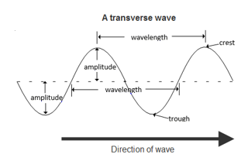
A transverse wave is a wave where the direction of oscillation is perpendicular to the direction in which the wave travels.
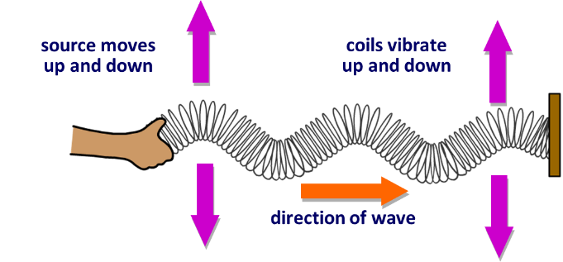
Examples
- Light waves
- Radio waves
- Waves on a rope
- Water waves

Longitudinal Waves
A longitudinal wave is a wave where the direction of oscillation is parallel to the direction in which the wave travels.

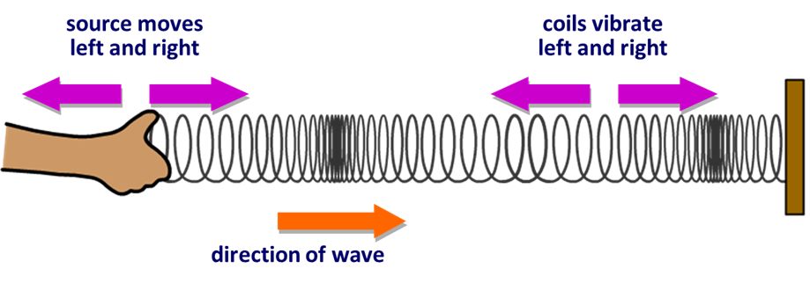
compression
rarefaction
wavelength

Examples
- Sound waves in a solid, liquid or a gas.
- Compression waves on a spring.

Terms used to describe a wave

The wavelength (λ pronounced “lamda”) of a wave is the distance from one point on the wave to the corresponding point on the next cycle.
Wavelength is a length so the unit of wavelength is the metre.

The frequency (f) of a wave is a measure of the number of oscillations (full cycles) of the wave per second.
The unit of frequency is the hertz (symbol is Hz).

The periodic time of a wave is the time it takes to complete one full cycle.

Relationship between periodic time and frequency
If three waves pass a fixed point per second (f = 3 Hz), it follows that the time for one wave to pass (known as the periodic time) is $\frac{1}{3}$ seconds.

Relationship between frequency, velocity and wavelength | Relationship between periodic time and frequency
c = f λ | $T=\frac{1}{f}$

Maths relationship between speed, frequency and wavelength

variable | symbol | unit | symbol for unit
frequency | f | hertz | Hz
wavelength | λ | metres | m
velocity | v (or c) | metres per second | m/s or m s⁻¹
periodic time | T | second | s

Speed, frequency and wavelength – maths questions

2005 Question 5 [Ordinary Level]  A wave motion has a frequency of 5 hz and a wavelength of 200 m.  Calculate the speed of the wave. | f = 5 Hz  λ = 200 m  c = f λ c = (5)(200) = 1000 m s⁻¹
2014 Question 12 (c) [Ordinary Level]  20 waves pass a fixed point every second.  What is the frequency of the wave?  Calculate the velocity of the wave if the wavelength is 1.5 m. | f = 20 Hz  λ = 1.5 m  c = f λ  c = (20)(1.5) = 30 m s⁻¹
2022 Question 10 [Ordinary Level]  The frequency of a sound wave is 2800 Hz and it has a wavelength of 0.12 m.  Calculate the speed of the wave. | f = 2800 Hz  λ = 0.12 m  c = f λ c = (2800)(0.12) = 336 m s⁻¹
2010 Question 7 [Ordinary Level]  If the frequency of a string is 250 Hz calculate the wavelength of the sound wave produced  (speed of sound = 340 m s⁻¹). | f = 250 Hz  c = 340 m s⁻¹  c = f λ $=\frac{c}{f}=\frac{340}{250}=$1.36 m
2007 Question 7 [Ordinary Level]  A tin-whistle produces a note of 256 Hz. Calculate the wavelength of this note.  The speed of sound in air is 340 m s⁻¹. | f = 256 Hz  c = 340 m s⁻¹  c = f λ $=\frac{c}{f}=\frac{340}{256}=$1.33 m
2004 Question 8 [Ordinary Level]  A note of wavelength 1.4 m is produced from a stretched string. If the speed of sound in air is 340 m s⁻¹ calculate the frequency of the note. | λ = 1.4 m  c = 340 m s⁻¹  c = f λ $f=\frac{c}{}=\frac{340}{1.4}=$242.86 m s⁻¹
2006 Question 8 [Ordinary Level]  A ship detects the seabed by reflecting a pulse of high frequency sound from the seabed.  The speed of sound in water is 1500 m s^{–1}.  Calculate the wavelength of the sound pulse when its frequency is 50 000 Hz. | f = 50000 Hz  c = 1500 m s⁻¹  c = f λ $=\frac{c}{f}=\frac{1500}{50000}$ λ = 0.03 m
2009 Question 5 [Ordinary Level]  Calculate the wavelength of a radio wave whose frequency is 252 kHz.  Speed of a radio wave = 3.0 × 10⁸ m s⁻¹. | f = 252 kHz = 252000 Hz  c = 3.0 × 10⁸ m s⁻¹  c = f λ  $=\frac{c}{f}=\frac{{3×10}^{8}}{252000}$ λ = 1190.48 m
2020 Question 9 [Ordinary Level]  Orange light has a frequency of 5 × 10¹⁴ Hz.  The speed of light is 3 × 10⁸ m s^{–1}.  Calculate the wavelength of the orange light. | f =$5×{10}^{14}$ Hz c = 3.0 × 10⁸ m s⁻¹  $c=fλ$ $λ=\frac{c}{f}$ $λ=\frac{3 ×{10}^{8}}{5 × {10}^{14}}$  $λ$ = 6 × 10⁻⁷ m
2021 Question 8 [Ordinary Level]  The frequency of a certain radio station is 10⁷ MHz.  It broadcasts waves of length 2.804 m.  Calculate the speed of the radio waves. | f = 107 × 10⁶ Hz  λ = 2.804m  c = f 𝜆 = (107 × 10⁶)(2.804) = 3 × 10⁸ m s⁻¹

Characteristics of a wave

- Reflection is the bouncing of waves off of an obstacle in their path.

- Refraction is the changing of direction of a wave as it travels from one medium to another.
Note that when a wave travels from one medium to another its frequency does not change.

- Diffraction is the spreading of waves around a slit or an obstacle.
This effect is only significantly noticeable if the slit width is approximately the same size as the wavelength of the waves.

- Interference occurs when waves from two sources meet to produce a wave of different amplitude.

Diffraction of water waves
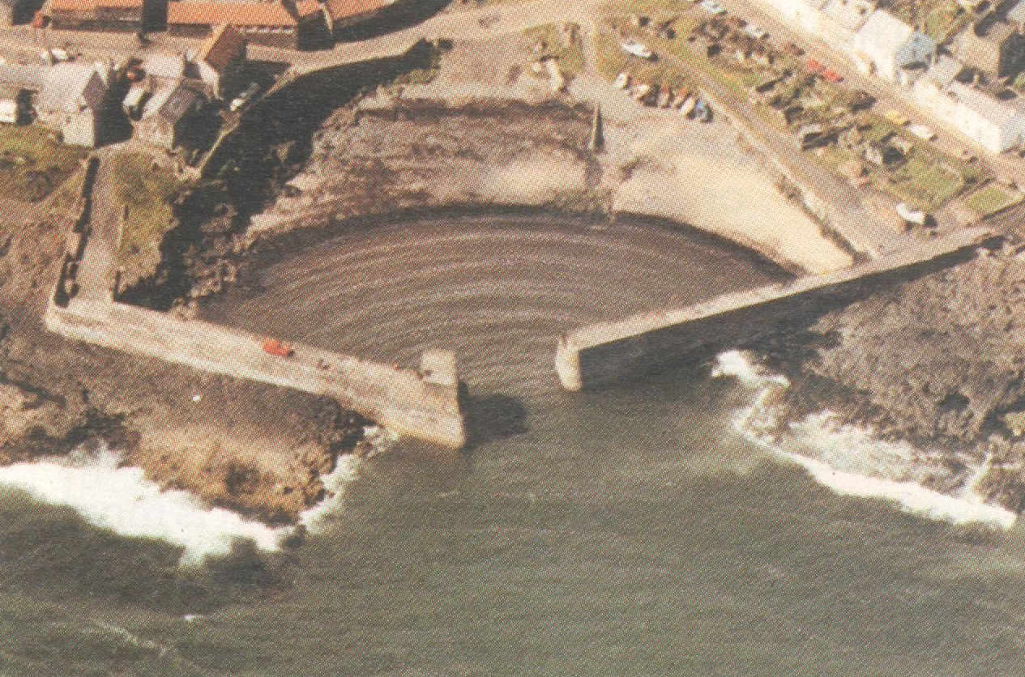

Constructive and destructive interference

Coherent waves
Two waves are said to be coherent if they have the same frequency and are in phase (or have a constant phase difference between them).

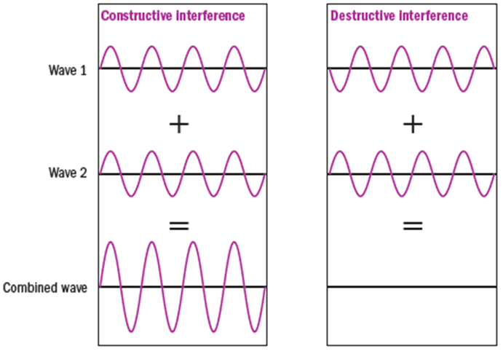
Constructive interference occurs when waves from two coherent sources meet to produce a wave of greater amplitude.
(Total constructive interference occurs when the crests of one wave are over the crests of another wave).

Destructive interference occurs when waves from two coherent sources meet to produce a wave of lower amplitude.
(Total destructive interference occurs when the crests of one wave are over the troughs of the second wave.
This will happen if one wave is half a wavelength out of phase with respect to the other).

When light goes from one medium to another the speed and wavelength change but the frequency remains constant.

2022 Deferred Physics exam Higher Level 14 (b)
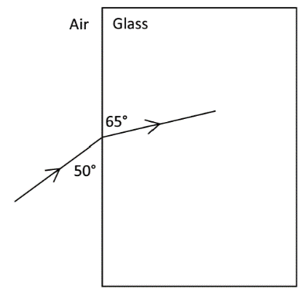
A ray of blue light with a wavelength of 480 nm in air is incident on a rectangular glass block, as shown in the diagram.

- Calculate the refractive index of the glass for blue light.
- Calculate the speed of this light in the glass.
- Calculate the wavelength of this light in the glass.

- Calculate the refractive index of the glass for blue light.
The diagram is set likely to cause confusion. The angle of incidence and the angle of refraction are all relative to the normal, so in this case angle of incidence = 40° and the angle of refraction is 25°,
$n=\frac{\sin{i}}{\sin{r}}=\frac{\sin{40}}{\sin{25}}$ = 1.52
- Calculate the speed of this light in the glass.
Refractive index = $\frac{speed of light in air}{speed of light in glass}$ 1.52 = $\frac{3×{10}^{8}}{speed of light in medium}$

Speed of light in medium = 1.97 × 10⁸ m s⁻¹
- Calculate the wavelength of this light in the glass.
Speed and wavelength change but the frequency remains constant.

So we can rearrange the relationship c = f λ to give $f=\frac{c}{λ }$
$$f=\frac{c_{air}}{λ_{air}}=\frac{c_{glass}}{λ_{glass}}$$

C_{air} = 3 × 10⁸ m s⁻¹ λ_{air} = 480 nm = 480 × 10⁻⁹ m c_{glass} = 1.97 × 10⁸ m s⁻¹

$\frac{3 ×{10}^{8}}{480 ×{10}^{-9}} =\frac{1.97 ×{10}^{8}}{λ_{glass}}$ λ_{glass} = 315 × 10⁻⁹ m

Stationary (standing) waves

Stationary (or standing waves) are formed when two periodic waves of the same frequency and amplitude travelling in opposite directions meet.

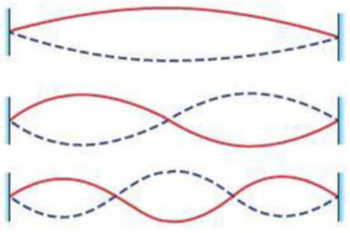
One way to do this is to vibrate one end of a string (slinkys work much, much better!) while getting a student to hold the other end steady. At certain frequencies you can generate the patterns shown on the right. These are known as stationary waves and the shape is formed as a result of the ‘returning’ wave meeting/interfering with the outgoing wave forming points of constructive and destructive interference.

If the stationary wave is forming the simplest pattern then it is said to be vibrating at its fundamental frequency or its first harmonic.
It if is vibrating at twice that frequency then it is said to be vibrating at its second harmonic and so on.

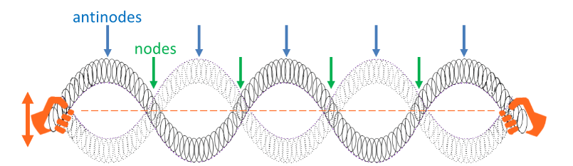
Nodes and antinodes
- The locations at which the amplitude is minimum (where the waves destructively interfere) are called nodes (“nodes” = “no” movement).

- The locations where the amplitude is maximum (points of maximum disturbance) are called antinodes.

2022 Question 11 [Higher Level]  Draw a labelled diagram to represent a stretched string vibrating at its third harmonic. | Solution  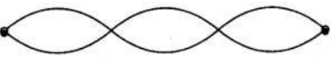  node at both ends  three anti-nodes



Relationship between internodal distance and wavelength for stationary waves

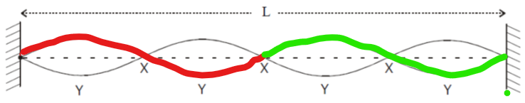

From the diagram we can see that:
- There are two full wavelengths contained within the distance marked L
- The distance between two consecutives nodes is $\frac{}{2}$
- The distance between two consecutive antinodes is $\frac{}{2}$
- The distance between an anti-node and the next node is $\frac{}{4}$

2004 Question 8 [Ordinary Level]  The diagram shows a stationary wave (standing wave) on a vibrating stretched string  What is the name given to the points on the string marked (i) X, (ii) Y?  How many wavelengths are contained in the distance marked L in the previous question? | Solution  X = node, (ii) Y = antinode  There are two full wavelengths contained in the waveform.

Stationary waves – maths questions

2018 Question 7 [Higher Level]  A stretched string of a violin has a length of 328 mm.  The string emits a note of 660 Hz when it vibrates at its fundamental frequency.  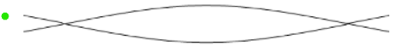  Calculate the speed of sound in the string. |  | A violin string is tied (and so has a node) at both ends, so when plucked it sets up a standing wave whose length corresponds to half a wavelength.  Distance between nodes = $\frac{λ}{2}$ = 328 mm = 0.328 m.  λ = 2(0.328) = 0.656 m and f = 660 Hz  v = fλ v = (600)(0.656) = 433 m s⁻¹
2021 Question 14 (d) [Ordinary Level]  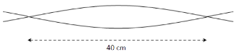  Waves on a stretched string travel at a speed of 380 m s⁻¹.  When a stationary wave is set up on a string, the distance between two adjacent nodes is 40 cm.  - Calculate the wavelength of the wave.  - Calculate the frequency of the wave. |  | Distance between nodes = $\frac{λ}{2}$  = 0.4 m  λ = 0.8 m  c = 380 m s⁻¹  c = f λ  $f=\frac{c}{}=\frac{380}{0.8}=$475 Hz
2005 Question 12 (c) [Higher Level]  The diagram shows a guitar string stretched between supports 0.65 m apart.  The speed of sound in the string is 500 m s^{–1}. What is the frequency of vibration of the string? |  | Distance between nodes = $\frac{λ}{2}$  = 0.65 m  λ = 1.3 m  c = 500 m s⁻¹  c = f λ  $f=\frac{c}{}=\frac{500}{1.3}=$384.6 Hz

The Doppler effect
Definition
The Doppler effect is the apparent change in the frequency of a wave due to the relative motion between the source of the wave and the observer.
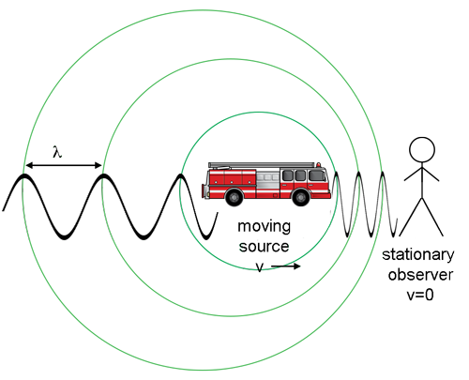
Explanation
Consider the soundwaves emitted from a fire engine with crests as shown as it moves to the right:

Ahead of the fire engine (the source or the waves) the crests are closer together than crests from the stationary source would be.
This means that the wavelength is smaller and the frequency is greater (more crests per second passing over the observer).

Behind the moving source, the crests are further apart.
This means that the wavelengths are greater and therefore the frequency is less.

Explaining how the Doppler effect occurs (for exam purposes)
Note that the marking schemes usually look for 4 separate points here:
- A series of non-concentric circles.
- Direction of motion of source and position of observer must be indicated.
- Reference to apparent change in wavelength.
- Reference to resulting apparent change in frequency.

Demonstration of the Doppler effect
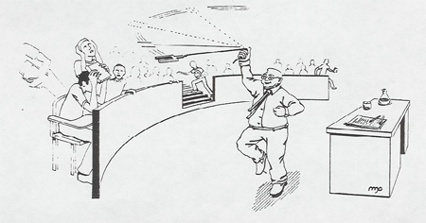
The Doppler effect for sound waves is dramatically demonstrated by tying a piece of string to an electronic buzzer.
Swing it around your head as shown.
Don’t let go!

Applications of the Doppler effect
- Police speed traps
- Using ultrasound to monitor the blood movement or heartbeat of a foetus.
- Weather forecasting
Note:
The noise from a racing car as it approaches and then moves away from an observer is an example of the Doppler effect – but it is not an application!

Maths questions on the Doppler effect

We can work out apparent frequency of the wave using the following formula

f” = apparent frequency
f = actual frequency
c = speed of the wave
u = speed of the moving source

‘Minus Is Towards’ (MITS)
The sign below the line is negative if the source is moving towards the observer:

Practice re-arranging the variables in the formula to make both f and u the subject of the formula.
Note that these questions are arranged by order of difficulty.

2018 HL Question 5 [Higher Level]  A fire‐engine travelling at a speed of 30 m s^{–1} emits a sound of frequency 2.3 kHz as it approaches an observer.  Calculate the frequency observed.  (speed of sound in air = 340 m s^{–1}) | c = 340 m s^{–1}  u = 30 m s^{–1}  f = 2.3 kHz = 2300 Hz $f^{'}=\frac{(f)(c)}{c-u}$  $f^{'}=\frac{(2300)(340)}{340-30}$ $f^{'}$ = 2523 Hz
2015 HL Question 5 [Higher Level]  What frequency would be detected by an observer when a source emitting a sound of frequency 512 Hz approaches at a velocity of 28 m s^{–1}?  Speed of sound in air = 340 m s^{–1} | f = 512 Hz  u = 28 m s^{–1}  c = 340 m s^{–1} $f^{'}=\frac{(f)(c)}{c-u}$  $f^{'}=\frac{(512)(340)}{340-28}$ $f^{'}$ = 557.95 Hz
2016 Question 12 (c) [Higher Level]  A buzzer moves at a speed of 13 m s^{–1} in a vertical circle.  The buzzer emits a note of frequency 1.1 kHz.  An observer stands in the plane of motion of the buzzer, as shown in the diagram. Calculate the maximum and minimum frequency of the note detected by an observer.  speed of sound in air = 340 m s^{–1} | u = 13 m s^{–1}  f = 1.1 kHz = 1100 Hz  c = 340 m s^{–1}  For maximum frequency the number below the line needs to be as small as possible so we use the minus sign.  $f^{'}$ _{max} = 1143.7 Hz  For minimum frequency we use the positive sign:  $f^{'}$ _{min} = 1059.5 Hz
2008 Question 12 (b) [Higher Level]  A rally car travelling at 55 m s^{–1}and is emitting a note with a pitch of 1520 Hz.  What is the difference between the car’s actual frequency and its apparent frequency as the car moves away from the observer?  (speed of sound in air = 340 m s^{–1}) | f = 1520 Hz  u = 55 m s^{–1}  c = 340 m s^{–1} $f^{'}=\frac{(f)(c)}{c+u}$  $f^{'}=\frac{(1520)(340)}{340+55}$ $f^{'}$ = 1308.35 Hz  ⇒ change in frequency = 1520 – 1308.35  = 211.65 Hz.

2014 Question 10 [Higher Level]  An ambulance siren emits a sound of frequency 750 Hz.  When the ambulance is travelling towards an observer, the frequency detected by the observer is 820 Hz.  What is the speed of the ambulance?  (speed of sound in air = 340 m s^{–1}) | f = 750 Hz  f’ = 820 Hz  c = 340 m s⁻¹  820(340 – u) = (750)(340)  278800 – 820u = 255000  278800 – 255000 = 820u  23800 = 82u  u = 29 m s⁻¹
2021 Question 14 (b) [Higher Level]  Hydroacoustics is the study of sound in water. The Doppler effect is observed in hydroacoustics.  A moving underwater source emits a sound of frequency 800 kHz while travelling towards an underwater detector, which detects a frequency of 806 kHz.  Calculate the speed of the source.  (speed of sound in water = 1480 m s^{–1}) | f = 800000 Hz  f’ = 806000 Hz  c = 1480 m s⁻¹  $$806000=\frac{(800000)(1480)}{1480-u}$$  806(1480 – u) = (800)(1480)  1192880 – 806u = 1184000  1192880 – 1184000 = 806u  8880 = 806u  u = 11.02 m s⁻¹


SLOP
Speed of sound = 340 m s⁻¹
Speed of light = 3 × 10⁸ m s⁻¹

The diagram shows the waveform of a musical note.  What is the name given to (i) the distance A, (ii) height B? | - A = wavelength  B = amplitude
Explain what is meant by the frequency of a wave. | The frequency of a wave is the number of waves passing a fixed point per second.
What is meant by the amplitude of a wave? | Amplitude corresponds to the height of the wave.
Explain the difference between longitudinal and transverse waves. | A Transverse wave is a wave where the direction of vibration is perpendicular to the direction in which the wave travels.  A Longitudinal Wave is a wave where the direction of vibration is parallel to the direction in which the wave travels.
Explain the term diffraction. | Diffraction is the spreading of waves around a slit or an obstacle.
Explain the term interference. | Interference occurs when waves from two sources meet to produce a wave of different amplitude.
Why does diffraction not occur when light passes through a window? | The window is too wide (relative to wavelength of light).
A sound wave is diffracted as it passes through a doorway but a light wave is not. Explain why. | Diffraction only occurs when the width of the gap is approximately equal to the wavelength of the wave. This is the case for a sound wave but the wavelength of a light-wave is very small compared to the size of a doorway.
Explain the term constructive interference. | Constructive Interference occurs when waves from two coherent sources meet to produce a wave of greater amplitude.
Explain the term coherent sources. | Two waves are said to be coherent if they have the same frequency and are in phase.
What is the condition necessary for destructive interference to take place when waves from two coherent sources meet? | They must be out of phase by half a wavelength (this means that the crest of one wave will be over the trough of the other.
The diagram shows a stationary wave (standing wave) on a vibrating stretched string  What is the name given to the points on the string marked (i) X, (ii) Y? | X = node, (ii) Y = antinode
How many wavelengths are contained in the distance marked L in the previous question? | Answer: 2
The Doppler effect
The pitch of a note emitted by the siren of a fast moving ambulance appears to change as it passes a stationary observer. Name this phenomenon. | The Doppler effect.
What is the Doppler effect? | The Doppler effect is the apparent change in the frequency of a wave due to the relative motion between the source of the wave and the observer.
Describe a laboratory experiment to demonstrate the Doppler effect. | See notes
Explain, with the aid of labelled diagrams, how the Doppler effect occurs.

Give an example of the Doppler effect. | The pitch of an ambulance changes as it goes past.
Give two applications of the Doppler effect. | Calculate speeds of stars or galaxies, speed traps.landing aircraft, ultrasound (blood movement or heartbeat of foetus), weather forecasting.
Rearrange the Doppler effect formula to make u the subject of the formula (using the ‘minus’ version). | $$u=\frac{f^{'}c-fc}{f^{'}}$$
Rearrange the Doppler effect formula to make f the subject of the formula (using the ‘minus’ version). | $$f=\frac{f^{'}(c-u)}{c}$$

2: Vibrations and Sound

“If you want to find the secrets of the universe, think in terms of energy, frequency and vibration.”
Nikola Tesla

Questions to think about
- Why does sound (usually) travel more quickly in a solid than in a gas?

- Why does sound (usually) travel more quickly if the temperature is hot?
- Why does your voice sound different when you hear it played from a recording compared to when you hear yourself speak, and why are we always so uncomfortable when we hear what we sound like to others?

Student Notes
We know from the last chapter that sound is a wave motion. We know this because sound undergoes
- Reflection (echoes)
- Diffraction (you can hear around corners)
- Refraction Explains why sometimes we don’t hear thunder from far-away lightning
- Interference (see next demonstration)

To demonstrate interference of sound

Use a signal generator and loudspeakers

- Walking slowly from A to B, you will notice the loudness of the sound increasing and decreasing at regular intervals.
- This is because sound waves from the two speakers will interfere both constructively and destructively, along the path AB.
- Note that you must make reference to the signal generator or sound from each speaker having the same frequency.

To show that sound needs a medium to travel through
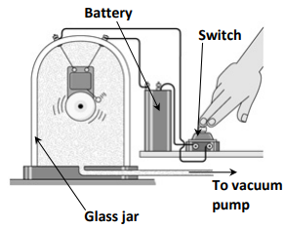
- Set up the bell-jar as shown – the bell can be heard ringing.
- Remove the air from the bell-jar using a vacuum pump.
- Result: While the bell can still be seen to be ringing, the sound gets quieter until eventually nothing can be heard

Natural frequency and resonance
The natural frequency of an object is the frequency at which the object will vibrate if free to do so.
{Note that few sounds vibrate at one frequency only – most vibrate at a fundamental frequency plus a combination of overtones – see the reference to ‘quality of a note’ at the end of the chapter’.

Factors which determine the natural frequency of a stretched string
- Frequency is inversely proportional to the length of the string: f ∝ 1/L
- Frequency is directly proportional to the square root of the tension in the string; f ∝ √T
- Frequency is inversely proportional to the square root of the mass per unit length of the string; f ∝ 1/√µ.
µ (pronounced “mew”) represents ‘mass per unit length’ and is a bit like saying ‘the density of the string material’)
- Putting these together, and letting the proportional constant = ½ (well why not?) we get:

Density and mass per unit length are related but are not the same: take two identical strings (equal densities), then stretch one out; it now has the same density as before but has a lower mass per unit length.}

Sample question  If the tension in a string increases by a factor of 9, by what factor does the frequency change? | Solution  f $∝$ $\sqrt{T}$  If the tension gets 9 times bigger (“increases by a factor of 9”) then the frequency increases by a factor of $\sqrt{9}$ .  The frequency therefore increases by a factor of 3, which is another way of saying that it gets 3 times bigger.
2023 Deferred Question 6 [Higher Level]  A stretched string vibrates at a fundamental frequency of 205 Hz when the tension applied is 5 N. Calculate the fundamental frequency of the string when the tension applied is 10 N. | 𝑓 ∝ √𝑇  The tension has increased by a factor of 2 (from 5 N to 10 N) so the frequency increases by a factor of √2.  𝑓_{new} = √2 × 205 = 290 𝐻𝑧
2015 Question 9 [Higher Level]  What effect does increasing the tension of the string from 36 N to 81 N have on the frequency of the string? | Solution  This one is very tricky.  81$÷36$=2.25.  Therefore the tension increased by a factor of 2.25.  If the tension gets 2.25 times bigger (“increases by a factor of 2.25”) then the frequency increases by a factor $\sqrt{2..25}$ .  $\sqrt{2..25}$ = 1.5 so the frequency increases by a factor of 1.5 (the frequency gets 1.5 times bigger)

Frequency and tension maths questions

2013 Question 7 [Higher Level]
A sample of wire has a mass per unit length of 0.004 kg m⁻¹.
A 64 cm length of the wire was fixed at both ends and plucked. The fundamental frequency of the sound produced was found to be 173 Hz. Calculate the tension in the wire.

Solution
l = 64 cm = 0.64 m
f = 173 Hz
µ = 0.004 kg m⁻¹
T =?

We need to rearrange the equation above to get T on its own:
⇒

4l²f² = $\frac{T}{µ}$ ⇒ T$= µ$ 4l²f²

T = (0.004)(4)(0.64)²(173)² Answer: T = 196 N

2018 Question 7 [Higher Level]
A stretched string of a violin has a length of 328 mm and a mass of 0.126 g.
The string emits a note of 660 Hz when it vibrates at its fundamental frequency.
- Calculate the tension in the string,
- Calculate the speed of sound in the string.

Solution
Calculate the tension in the string
f = 600 Hz
l = 0.328 m

First we need to calculate the mass per unit length by dividing the mass of the sample by its length.
Note however that mass has to be in kg and the length has to be in m.

µ = mass per unit length = $\frac{0.126×{10}^{-3}}{0.328}$ = 3.84 × 10⁻⁴ kg m⁻¹

As with previous question we rearrange to get T$= µ$ 4l²f²

T = (3.84 × 10⁻⁴)(4)(0.328)²(600)² Answer: T = 72 N

Resonance
Resonance is the transfer of energy so that a body vibrates at its natural frequency.
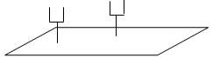
To demonstrate resonance
- Use two identical tuning forks (same frequency) and a sound-board.
- Set one fork vibrating and place it on the sound-board.
- Place the second tuning fork on the sound-board and then stop the first tuning fork from vibrating.
- The second fork can now be heard vibrating.
Explanation:
The vibrations were passed from the first tuning fork via the sound-board to the second tuning fork.
NB: you must make reference to the fact that both tuning forks are of the same frequency

Examples of resonance
- Most damage caused to buildings during earthquakes happens because the frequency of the earthquake’s vibrations matches the natural frequency of the walls of the building.
- Resonance is often something that causes problems and mechanical engineers usually need to ensure that the natural frequency of an engine component does not match the driving frequency of the engine.

Sound intensity
Sound intensity is defined as power per unit area.
The unit of sound intensity is therefore the watt per metre squared (W m⁻²)
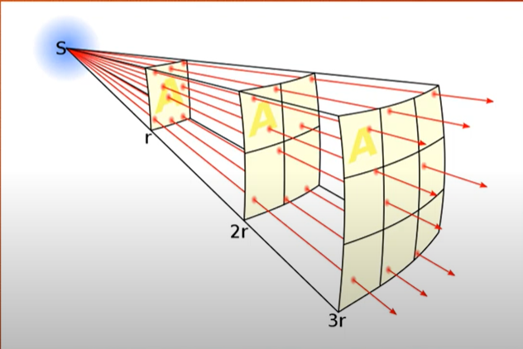
The sound energy from the speaker dissipates in 3 dimensions, similar to an expanding (spherical)l balloon. The area which the energy is passing through therefore corresponds to the surface area of a sphere.

Formula for the surface areas of a sphere = 4πr²
$$Sound intensity = \frac{Power}{Area}= \frac{Power}{4πr^{2}}$$

Note that the relationship between radius and sound intensity is $S.I. ∝\frac{1}{d^{2}}$ so if the radius or distance increases by a factor of 2 (doubles) then the sound intensity will decrease by a factor of 4 (gets 4 times smaller).

Sound intensity maths questions

2021 Question 5 [Higher Level]  Calculate the sound intensity 6 m from a loudspeaker of power 20 mW. | r = 6 m  P = 20 mW = 20 ×10⁻³ W  $$Sound intensity = \frac{Power}{Area}=\frac{20 ×{10}^{-3} }{4π{(6)}^{2}}$$  S.I. = 4.4 × 10^{–5} W m⁻²
2007 Question 12 (b) [Higher Level]  A loudspeaker has a power rating of 25 mW.  What is the sound intensity at a distance of 3 m from the loudspeaker? | r = 3 m  P = 25 mW = 25 ×10⁻³ W  $Sound intensity = \frac{Power}{Area}=\frac{25 ×{10}^{-3} }{4π{(3)}^{2}}$  S.I. = 2.21 × 10⁻⁴ W m⁻²
2022 Question 5 [Higher Level]  The sound intensity is 0.18 mW m^{–2} at a distance of 3 m in any direction from a source of sound. Calculate the power of the source. | r = 3 m  Sound intensity = 0.18 mW m^{–2}  = 0.18 × 10⁻³ W m⁻²  $$Sound intensity = \frac{Power}{Area}$$  Power = (sound intensity)(area)  Power = (0.18 × 10⁻³)(4π3²)  P = 0.02 W
2018 Question 7 [Higher Level]  A source emits sound in all directions.  Describe the effect of doubling the distance from the source to an observer on the sound intensity measured | Sound intensity $∝\frac{1}{d^{2}}$ so if the radius or distance increases by a factor of 2 (doubles) then the sound intensity will decrease by a factor of 4 (get 4 times smaller)

The threshold of hearing
The threshold of hearing is the smallest sound intensity detectable by the average human ear at a frequency of 1000 Hz.
Its value is 1 × 10⁻¹² W m⁻²

Frequency limits of audibility
These are the highest and lowest frequencies that can be heard by a normal human ear.
The range is 20 Hz – 20,000 Hz.

Sound intensity level and the decibel scale
Human hearing falls between approximately 10 W m⁻² and 1 W m⁻².
The former is known as the threshold of hearing and the latter is known as the threshold of feeling.
The size of this range is enormous and very impractical so instead we use a more compact version of this scale called the sound intensity level scale.
The numbers are called sound intensity levels and are measured in decibels (dB) so the scale is called the decibel (dB) scale.

Examples of sound intensity levels
Whisper  20 dB | Conversation  60 dB | Rock concert  110 dB | Threshold of pain  130 dB | Explosion/perforation of eardrum = 160 dB

The decibel adjusted dB(A) scale
The ear/brain is most sensitive to frequencies between 2000 Hz and 4000 Hz.
This means that if we have two sources of sound which have the same sound intensity but one is at a frequency of 3000 Hz and the second is at a frequency of 13000 Hz then the 3000 Hz sound will seem – to humans - much louder.

The decibel adjusted scale is used because it is adapted to the ear’s frequency response.
The image is that of a sound level meter.

Sound intensity and sound intensity level: exam questions

Note: doubling the sound intensity increases the sound intensity level by 3dB
I presume this concept is on the syllabus because it gives a sense of how the log scale (which the decibel scale is an example of) can contract a scale which has a much wider range.
Example 1  The sound intensity doubles as a person approaches a loudspeaker.  What is the increase in the sound intensity level? | Sound intensity doubled so sound intensity level increased by 3 dB
Sample question  If the sound intensity increases by a factor of 8, what is the increase in sound intensity level? | If the sound intensity gets two times bigger (doubles) then the sound intensity level increases by 3 dB.  In this case the sound intensity got 8 times bigger which corresponds to 2×2×2 so the sound intensity level increased by 3 dB + 3 dB + 3 dB or 9 dB in total.
2009 Question 5 [Higher level]  The sound intensity level at a concert increases from 85 dB to 94 dB when the concert begins.  By what factor has the sound intensity increased? | When the sound intensity level increased from 85 to 88 dB, it meant that the sound intensity doubled (or was multiplied by 2).  Sound intensity level then increased from 88 dB to 91 dB which corresponds to another doubling in sound intensity and finally from 91 to 94 dB.  New S.I. = Original S.I. ×2×2×2  So if the original sound intensity level has increased by 9 dB then the sound intensity must have increased by a factor of 8.

2007 Question 12 (b) [Higher Level]  A loudspeaker has a power rating of 25 mW.  What is the sound intensity at a distance of 3 m from the loudspeaker?  The loudspeaker is replaced by a speaker with a power rating of 50 mW.  What is the change in the sound intensity level? | r = 3 m  P = 25 mW = 25 ×10⁻³ W  $S.I. = \frac{Power}{Area}=\frac{25 ×{10}^{-3} }{4π{(3)}^{2}}$ = 2.21 × 10⁻⁴ W m⁻²  Change in the sound intensity level  $New S.I.=\frac{50 ×{10}^{-3} }{4π{(3)}^{2}}$ = 4.42 × 10⁻⁴ W m⁻²  The sound intensity doubled so the sound intensity level increased by 3 dB.
2011 Question 8 (b) [Higher Level]  An audio speaker at a concert emits sound uniformly in all directions at a rate of 100 W.  Calculate the sound intensity experienced by a listener at a distance of 8 m from the speaker.  The listener moves back from the speaker to protect her hearing.  At what distance from the speaker is the sound intensity level reduced by 3 dB? | r = 8 m  P = 100 W  $Sound intensity = \frac{Power}{Area}$ $=\frac{100 }{4π{(8)}^{2}}$ = 0.124 W m⁻²  If the sound intensity level decreased by 3dB it means sound intensity went down by a factor of two/got two times smaller so it went from 0.124 W m⁻² to 0.062 W m⁻².  $0.062=\frac{100}{4πR^{2}}$ $R^{2}=\frac{100}{4π(0.062)}$ R = 11.33 m

Harmonics
Harmonics
Most objects will vibrate not only at their natural frequency but also at integer multiples of that frequency.
Frequencies which are integer multiples of the fundamental frequency f are called harmonics.
The basic frequency is called the fundamental frequency or first harmonic, 2f is the second harmonic etc.

Sound waves in open and closed pipes
We have seen standing (stationary) waves created by a string tied at both ends vibrating at its natural frequency. We can also set up a standing wave pattern using sound waves but rather than a string vibrating it’s the air itself that’s responsible for the pattern. In this case the nodes represent places where the air molecules are stationary (no movement) and antinodes represent places where they are vibrating at maximum amplitude. Of course our bigger issue is that we can’t see these waves, but if we were to spread pressure gauges all along the inside of the pipes we would notice variations in pressure in locations similar to those outined below.

You need to be able to draw each of the following. Begin by marking out where the nodes and antinodes should be and then join these up with curved lines.
You should also be able to say (similar to stretched string questions) what faction of a wavelength each harmonic corresponds to.

Harmonics in a pipe open at one end  (closed pipes)  A closed pipe will always have a node at the closed end and an antinode at the open end. | Harmonics in a pipe open at both ends  (open pipes)  An open pipe will always have an antinode at both ends.
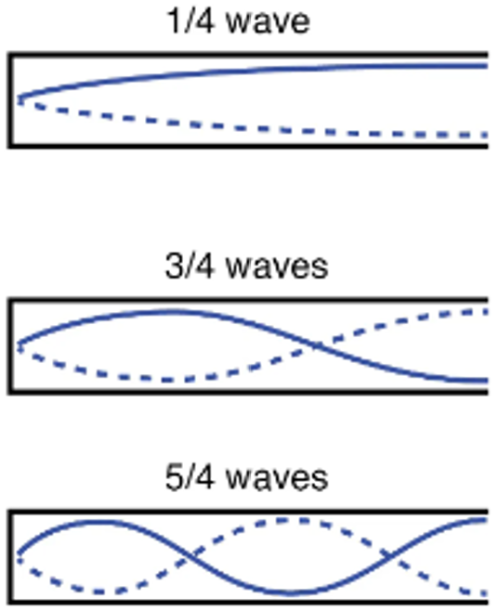 | 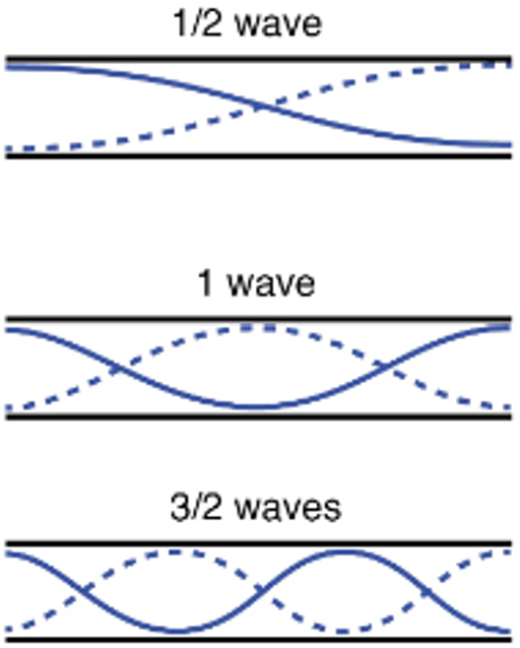

Sound waves in open and closed tubes: exam questions
2022 Question 10 [Ordinary Level]    The ear canal can be thought of as a pipe open at one end.  Draw a labelled diagram to show the first position of resonance for a sound wave in a pipe open at one end. | 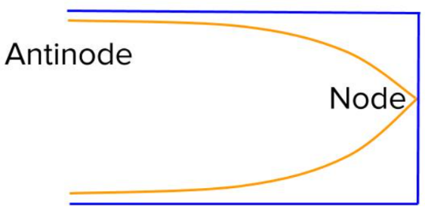
2016 Question 5 [Higher level]  The ear canal acts as a cylindrical pipe closed at one end.  It is of average length 2.3 cm.  The speed of sound in air is 340 m s^{–1}.  What is the fundamental frequency of the ear canal? | The shape of the wave in this case corresponds to ¼ of a wavelength.  λ = 4l = (4)(.023) = 0.092 m  c = fλ $f=\frac{c}{λ}$ $f=\frac{340}{0.092}$ = 3696 Hz
2019 Question 10 [Higher Level]  A certain musical instrument can be modelled as a cylindrical pipe that is closed at one end and whose length can be changed.  Draw diagrams to show the first two harmonics of this instrument. | 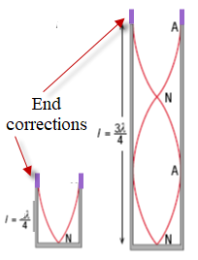  Note that the frequency is fixed so the only way to find the harmonics is to vary the length.  Ignore the reference to end corrections
2011 Question 8 (a) [Higher Level]  The diagram shows a standing wave in a pipe closed at one end.  The length of the pipe is 90 cm.  Speed of sound = 340 m s⁻¹  Calculate the frequency of the standing wave. | We have encountered this question already.  In this case there are 1¼ wavelengths in the waveform  $\frac{5λ}{4}=0.90 m$  λ = 0.720 m  c = 340 m s⁻¹  c = fλ $f=\frac{c}{λ}=\frac{340}{0.720}$  f = 472.2 Hz

2015 Question 9 [Higher Level]  A tin whistle consists of a pipe which is open at both ends.  A particular tin whistle has a fundamental frequency of 587 Hz when all of the holes on it are covered.  How long is the pipe?  (speed of sound in air = 340 m s^{–1}) | 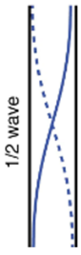  Length of tube corresponds to λ/2, so if we can work out the wavelength we can calculate the length from there.  c = 340 m s^{–1}  f = 587 Hz  c = fλ ⇒ $=\frac{v}{f}$ ⇒ $=\frac{340}{587}$  λ = 0.58 m Length of tube = λ/2  Length of tube = 0.29 m
2013 Question 7 [Higher Level]  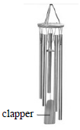  A set of wind chimes, as shown in the diagram, is made from different lengths of hollow metal tubing that are open at both ends. The sound from one of the tubes was analysed.  The following frequencies were identified in the sound:  550 Hz, 1100 Hz and 1651 Hz.  Draw labelled diagrams to show how the tube produces each of these frequencies. | 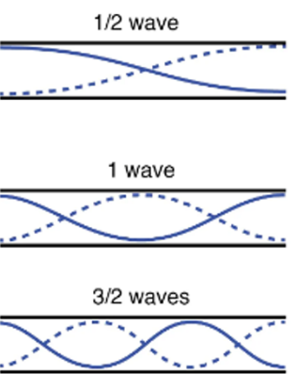  Note how three different frequencies were found coming from the one tube. We visit this again in the next section.
The length of the metal tube in the previous questions is 30 cm. Use any of the above frequencies to calculate a value for the speed of sound in air. | l = 30 cm = 0.3 m  This distance corresponds to the distance between two consecutive antinodes = $\frac{}{2}$  Take f = 550 Hz  $0.3=\frac{}{2}$ λ = 0.60 m  c = fλ c = (550)(0.60) = 330 m s⁻¹

Characteristics of notes
- Loudness: The loudness of a note depends upon the amplitude of the sound wave.
- Pitch: The pitch of a note depends upon the frequency of the sound wave
- Quality:
Few sounds vibrate at one frequency only – most vibrate at a fundamental frequency plus overtones.
The quality of a note depends upon the number of overtones present in the note and the relative strengths of those different overtones.
This explains why a middle C note sounds different when played on different musical instruments.
(sometimes gets asked as an exam question).

Does sound travel fastest in air, water or metal?
Turns out that this is one of the biggest misconceptions in physics so write down your guess before reading the answer in the footnote below.


By the way, did you know that if you hold a feral cat up to your ear, you can hear what it sounds like to be attacked by a feral cat?

Mandatory experiments
- Measurement of the speed of sound in air.
- Investigation of the variation of fundamental frequency of a stretched string with length.
- Investigation of the variation of fundamental frequency of a stretched string with tension.

Acoustic mirrors
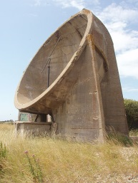
Prior to World War II and the invention of radar, acoustic mirrors were built as early warning devices around the coasts of Great Britain, with the aim of detecting incoming enemy aircraft by the sound of their engines.

TO MEASURE THE SPEED OF SOUND IN AIR

APPARATUS
Graduated cylinder, resonance tube open at both ends, tuning forks of known frequency, metre stick, digital callipers
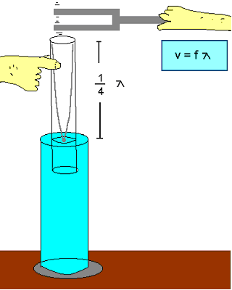
DIAGRAM – see diagram

PROCEDURE
- Set up the apparatus as shown in the diagram

- Strike one of the tuning forks on a block of wood and hold it over the resonance tube.

- Move the inner-tube slowly until the first loud resonant sound is heard.

- Measure the distance from the top of the resonance tube to the top of the water (l ). This is approximately one quarter of the wavelength.

- Measure the inner-diameter of the resonance tube (d) using the digital callipers.

- Note the frequency of the tuning fork; this corresponds to the frequency of the vibrating air column in the resonance tube.

- The wavelength of sound is calculated using the formula: c = 4f (l+0.3d)

- Repeat the procedure with tuning forks of different frequencies. Tabulate the results and get an average value for the speed of sound in air.

RESULTS
 | Frequency (f)  (Hz) | Length (l)  (m) | c =(f)(4l)  (m/s)  approximate value for the speed of sound | diameter d (m) | 0.3 d  (m) | (l+0.3d) | c = 4f(l+0.3d)  (m s⁻¹⁾
Run 1
Run 2
Run 3

Average value for speed of sound in air = ___________________
CONCLUSION:

PRECAUTIONS
- Ensure that your eye is level with the top of the tube when measuring the length to avoid parallax error.

- Start with the inner tube fully in the water and slowly raise it so that you don’t get a harmonic by mistake.
- Repeat your efforts to find the loudest resonance position for each tuning fork. Take the average of the attempts.
Where does the formula c = 4f(l+0.3d) come from?
You don’t need to know this but it may help to clear up some confusion

From our notes we know that for a standing wave the length from node to anti-node is one quarter of the wavelength.
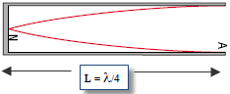
⇒ Length from node to anti-node is = λ/4

Now it’s not at all obvious from this diagram that the wave shape is merely a mathematical representation of the relative size of the disturbance of the air molecules, but that’s what it is. On the left hand side (the node) there is almost no disturbance, while on the right hand side (the anti-node) there is maximum disturbance.

Now this is all fine in theory, but in practice we have a 3-dimensional tube, and it turns out that the maximum displacement of the air molecules is not just at the top of the pipe, but a little outside it. This extra distance is approximately 0.3 times the diameter. Exactly why it’s 0.3 is beyond the scope of this discussion (which is another way of saying I have no idea). I guess it just is. At any rate that would be the engineering response.

In Physics we try to go for the underlying explanation; Engineers really just don’t care. That is why physicists have nothing but contempt for engineers and everything they stand for. So it doesn’t really seem fair that for every student of mine who goes on to study Physics in college, ten go on to do Engineering - a fact which continues to haunt me every day of my life.
But I digress . . .
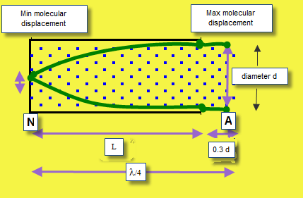

In this case that means
(Length of tube plus correction term) = λ/4
⇒ λ = 4(length of tube plus correction term)
⇒ λ = 4(l + 0.3d)
Now we know c = fλ
⇒ c = f [4 (l + 0.3d)]
⇒ c = 4f (l + 0.3d)

I’m not mad about students having to remember this formula, but dem’s de rules.

Theory questions

Draw a labelled diagram of the arrangement of the apparatus used in this experiment. | 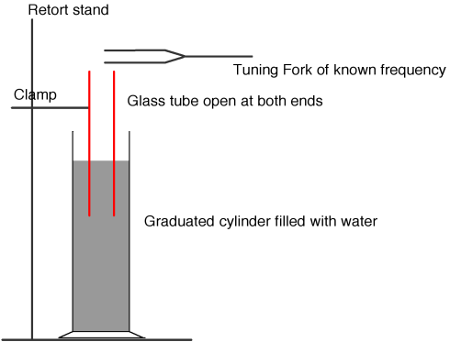  Resonance tube  Tuning fork  Ruler / metre stick  Detail e.g. fork over the mouth of tube
Describe how the length of the column of air was adjusted. | The inner pipe was raised while immersed in water.
Describe how the first position of resonance was found. | Hold (vibrating) fork over inner column  Increase length of column (from zero)  Until (loudest) sound is heard (from column)
Describe how the frequency of the column of air was measured. | The frequency was read from the tuning fork / signal generator which caused the vibration.
Describe how the diameter of the column of air was measured. | By using a digital calipers
How was it known that the air column was vibrating at its first harmonic? | The inner tube was raised from its lowest position the until a loud sound could be heard.
How was the wavelength of the sound wave measured? | Measure length of vibrating air at resonance and diameter  Equation λ = 4[l + (0.3d)]
How did the student calculate the speed of sound in air? | c = 4f (l+0.3d)
State one precaution which the student might have taken to get an accurate result. | Avoid no parallax, quiet background, use a tuning fork of high frequency as it is easier to hear
Why was it necessary to measure the diameter of the air column? | Because of the correction term; the wave exists partially above the top of the tube
Another student carried out the experiment. She measured the length of the column of air for each of the first two positions of resonance but she did not measure the diameter of the air column.  Explain how this second student would find the speed of sound in air. | Find distance between first two positions of resonance: L₂ – L₁  {this takes out the end correction factor}  Double this distance for wavelength  λ = 2 (L₂-L₁)  c = fλ

Related exam questions
HL: 2014, 2006 OL: 2016, 2011, 2008, 2003

[2014]
A student used a cylindrical column of air closed at one end and a tuning fork of frequency 512 Hz in an experiment to measure the speed of sound in air.
The following data was recorded:

Length of column of air for first position of resonance = 16.2 cm
Diameter of air column = 1.15 cm

- Draw a labelled diagram of the apparatus used in the experiment.
- Describe how the first position of resonance was found.
- Using the recorded data, calculate the speed of sound in air.
- Why was it necessary to measure the diameter of the air column?

[2006]
A cylindrical column of air closed at one end and three different tuning forks were used in an experiment to measure the speed of sound in air. A tuning fork of frequency f was set vibrating and held over the column of air.
The length of the column of air was adjusted until it was vibrating at its first harmonic and its length l was then measured. This procedure was repeated for each tuning fork.
Finally, the diameter of the column of air was measured. The following data was recorded.

f/Hz | 512 | 480 | 426
length/cm | 16.0 | 17.2 | 19.4

Diameter of column of air = 2.05 cm.
- Describe how the length of the column of air was adjusted.
- Describe how the frequency of the column of air was measured.
- Describe how the diameter of the column of air was measured.
- How was it known that the air column was vibrating at its first harmonic?
- Using all of the data, calculate the speed of sound in air.

Worked solutions

[2014 HL]

c = 4f(l + 0.3d)
c = 4f(0.16545)
c = 338.8 m s^{–1}

[2006 HL]

v = f λ
λ = 4(l +0.3 d)
v₁ = 340(.3) m s⁻¹; v₂ = 342(.0) m s⁻¹ ; v₃ = 341(.1) m s⁻¹
v_{ave} = 341(.13) ms⁻¹

TO INVESTIGATE THE VARIATION OF FUNDAMENTAL FREQUENCY OF A STRING WITH LENGTH

APPARATUS: Sonometer, newton-meter, tension key, signal generator, u-magnet

DIAGRAM
PROCEDURE
- Set up as shown on the diagram.

- Fix the tension at a constant value.

- Place the bridges as far apart as possible and measure the length of the wire l between the bridges with a metre stick.

- Slowly increase the applied a.c. frequency from 0 Hz until the paper-rider vibrates the most.

- Note the value of this (fundamental frequency) and the length of the wire.

- Repeat this procedure for different lengths of wire by varying the distance between the bridges.

- Record the measurements in a table.

- Plot a graph of frequency f against 1/length.

RESULTS
f (Hz)
l (m)
1/length (m⁻¹⁾

CONCLUSION
We obtained a straight line through the origin which verifies that frequency is inversely proportional to the length.

PRECAUTIONS / SOURCES OF ERROR
- Determining exactly where the resonance point is can be tricky so for each length repeat a few times and get an average.
- Avoid parallax errors when using a metre stick to measure the length of the wire.

Graph of frequency (Hz) against 1/length (m⁻¹) for a stretched string
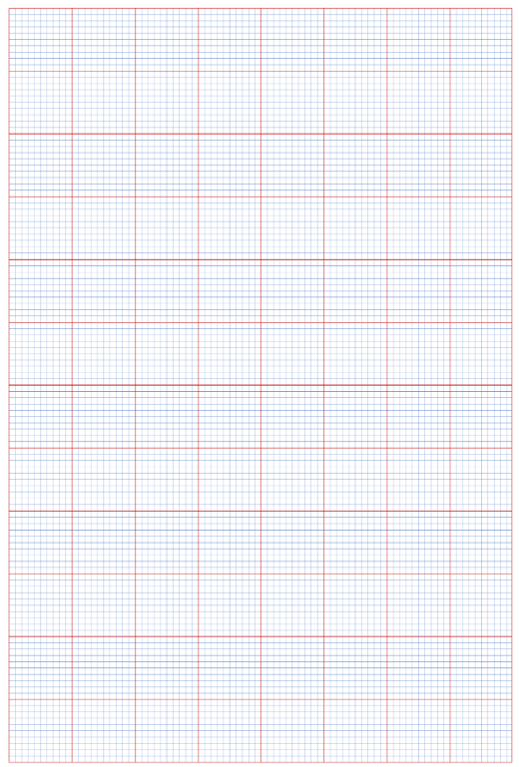
NOTES
- The signal generator
Instead of using the signal-generator and U-magnet, you could just use a tuning fork to generate a vibration of a set frequency (set it vibrating and then stand it either on the sonometer or on one of the bridges). You then vary the position of the second bridge until you reach resonance. In theory this is simpler; in practice it is more difficult to detect the resonance position because the string doesn’t vibrate as vigorously.

You may find the signal generator cutting out quite often if you have the current (amplitude) setting up quite high, so if you need a high current just use that setting for as brief a time as possible.

If you do go with the signal generator in the exam, you must remember to include the magnet also.
Exactly why this method works is conveniently ignored for now but we do go into the theory later when we study current in a magnetic field.

- The paper rider
If a paper rider is used to locate resonance, place it mid-way between the bridges.

Keep the paper rider as light as possible. Use a small piece of cellotape to hold the paper in the form of a loop.

A short length of drinking straw can also be used as a very light rider. This rider can be moved along the string to detect the positions of nodes and antinodes when the string is vibrating at resonance.

- Instead of using a newton-metre and a tension-control key you could use weights which hang off of one end.

- Wear safety goggles in case the sonometer wire snaps and you lose an eye. Because as everybody knows, it’s all fun and games until someone loses an eye.

Theory questions

Draw a labelled diagram of the arrangement of the apparatus used in this experiment. | Arrangement showing string, means of changing l , pulley and pan / newton balance / fixed at both ends  vibrating fork placed on bridge
Describe how the student set the string vibrating. | Place a vibrating tuning fork on one of the bridges
How was the length determined? | Adjust length until standing wave formed / resonance occurs /rider falls  Measure length (between nodes / bridges)  Repeat with forks of different frequencies --- stated/implied
How was the frequency determined? | The frequency corresponds to the frequency of the tuning fork / it was read off the signal generator
Why was the tension in the string kept constant during the experiment? | Tension can also affect the natural frequency and you can only investigate the relationship between two variables at a time.
How did the student know that the string was vibrating at its fundamental frequency? | The paper rider on the string falls off.
State the relationship and explain how the graph verifies it. | f ∝ ¹/l  Straight line through origin
Name two other factors that affect the fundamental frequency of a stretched string and give their relationships with the fundamental frequency. | Tension in the string / mass per unit length of the string  f ∝ √T  f ∝ 1/√µ

Related exam questions
HL: 2016, 2012, 2004 OL: 2014, 2009, 2006, 2002

[2014 OL]
An experiment was set up to investigate how the fundamental frequency of a stretched string varied with its length. The length, l, of the string and its fundamental frequency, f, were recorded.
The procedure was repeated for different values of f and l.
- Draw a labelled diagram of the apparatus used in the experiment.
- Indicate on your diagram the length of the string that was measured.
- Describe how the string could have been set vibrating.
- How was the frequency determined?
f (Hz) | 256 | 288 | 320 | 341 | 384 | 480
l (m) | 0.80 | 0.71 | 0.64 | 0.60 | 0.53 | 0.43
1/l (m⁻¹)

The following results were recorded during the experiment.

- Copy and complete the table into your answer book.
- Draw a graph on graph paper of f on the X-axis against 1/l on the Y-axis.
- What conclusion can be drawn from your graph?

[2016 HL]
A student investigated the variation of f, the fundamental frequency of a stretched string, with its length l. The string was kept at a constant tension of 8.5 N.
- Draw a labelled diagram of the arrangement of the apparatus used in this experiment.
Indicate on your diagram the measured length of the string.

The following data were recorded.
f (Hz) | 256 | 288 | 320 | 341 | 384 | 427 | 480 | 512
l (cm) | 51.3 | 42.6 | 39.2 | 37.7 | 34.5 | 30.3 | 26.0 | 25.0

- Draw a suitable graph to illustrate the relationship between f and l.
- State the relationship and explain how the graph verifies it.
- Use your graph to calculate the length of the string at a frequency of 192 Hz
- Use your graph to calculate the mass per unit length of the string.

Worked solutions

[2014 OL]

f (Hz) | 256 | 288 | 320 | 341 | 384 | 480
l (m) | 0.80 | 0.71 | 0.64 | 0.60 | 0.53 | 0.43
1/l (m⁻¹) | 1.25 | 1.41 | 1.56 | 1.67 | 1.89 | 2.33

[2016 HL]
- Use your graph to calculate the length of the string at a frequency of 192 Hz
Value read from graph $1/l$ ≈ 1.52 m^{–1}
l ≈ 0.66 m

- Use your graph to calculate the mass per unit length of the string.
General formula:
Compare to y = m x
So plotting f on the y axis and $1/l$ on the x axis means that the slope corresponds to
We were told in the question that the tension was 8.5 N.

Slope = μ ≈ 1.3 × 10^{–4} kg m^{–1}

TO INVESTIGATE THE VARIATION OF FUNDAMENTAL FREQUENCY OF A STRING WITH TENSION

APPARATUS
Sonometer, newton-meter, tension key, signal generator, u-magnet

DIAGRAM

PROCEDURE
- Set up as shown on the diagram.

- Fix the length at a constant value.

- Set the tension to a low value.

- Slowly increase the applied a.c. frequency from 0 Hz until the paper-rider vibrates the most.

- Note the value of this frequency and the tension on the wire.

- Repeat this procedure for different tensions by varying the tension-control key.

- Record the measurements in a table.

- Plot a graph of frequency against the square root of tension.

RESULTS
f (Hz)
T (N)
√T (N^{1/2})

CONCLUSION
A straight line through the origin will verify that frequency is proportional to the square root of tension.

PRECAUTIONS / SOURCES OF ERROR
Determining exactly where the resonance point is can be tricky so for each tension repeat a few times and get an average.

Graph of frequency (Hz) against √tension (N^{½}) for a stretched string

Theory questions
Draw a labelled diagram of the apparatus used. | String, bridge(s), tuning fork/signal generator with magnet, paper rider, tension key/pan with weights
Show on your diagram how the tension was measured. | Newton balance/pan with weights
How was the fundamental frequency determined? | Change tuning fork / adjust signal generator / adjust tension until resonance observed
How did the student know that resonance occurred / how did the student know that the string was vibrating at its fundamental frequency? | Paper rider vibrated vigorously/ the string vibrated at maximum amplitude
Why was the length of the string kept constant during the investigation? | Length also affects the natural frequency and you can only investigate the relationship between two variables at a time.
State this relationship and explain how your graph verifies it. | f against $\sqrt{T}$  A straight line through the origin
Write an expression for μ in terms of l and m (where m represents the slope). | $f=\frac{1}{2l}\frac{\sqrt{T}}{\sqrt{μ}}$ $f=\frac{1}{2l\sqrt{μ}}\sqrt{T}$  Compare this to the general equation for a line (through the origin): y = mx  $\frac{1}{2l\sqrt{μ}}=m=slope$  $\frac{1}{2lm}=\sqrt{μ}$  $μ=\frac{1}{4l^{2}m^{2}}$

Related exam questions
HL: 2017, 2009, 2004, 2002

[2009]
A student investigated the variation of the fundamental frequency f of a stretched string with its tension T.
The following is an extract of the student’s account of the experiment.
“I fixed the length of the string at 40 cm. I set a tuning fork of frequency 256 Hz vibrating and placed it by the string.
I adjusted the tension of the string until resonance occurred. I recorded the tension in the string. I repeated the experiment using different tuning forks.”
- How was the tension measured?
- How did the student know that resonance occurred?

The following data were recorded.
f /Hz | 256 | 288 | 320 | 341 | 384 | 480 | 512
T /N | 2.4 | 3.3 | 3.9 | 4.3 | 5.7 | 8.5 | 9.8

- Draw a suitable graph to show the relationship between the fundamental frequency of a stretched string and its tension.
- State this relationship and explain how your graph verifies it.
- Use your graph to estimate the fundamental frequency of the string when its tension is 11 N
- Use your graph to calculate the mass per unit length of the string.

[2002]
T/N | 15 | 20 | 25 | 30 | 35 | 40 | 45
f /Hz | 264 | 304 | 342 | 371 | 402 | 431 | 456
A student obtained the following data during an investigation of the variation of the fundamental frequency f of a stretched string with its tension T.
The length of the string was kept constant.

- Describe, with the aid of a diagram, how the student obtained the data.
- Why was the length of the string kept constant during the investigation?
- Plot a suitable graph on graph paper to show the relationship between fundamental frequency and tension for the stretched string.
- From your graph, estimate the tension in the string when its fundamental frequency is 380 Hz.

Solutions

[2009 HL]
- Use your graph to estimate the fundamental frequency of the string when its tension is 11 N
If tension is 11 N ⇒ √T = 3.32
Use the graph to get f = 542 Hz

- Use your graph to calculate the mass per unit length of the string.
$f=\frac{1}{2l\sqrt{μ}}\sqrt{T}$
Compare this to the general equation for a line (through the origin): y = mx

$\frac{1}{2l\sqrt{μ}}=m=slope$
$\frac{1}{2l(slope)}=\sqrt{μ}$

$μ=\frac{1}{4l^{2}{slope}^{2}}$

l = 0.4 m

Mass per unit length (μ) = 5.86 × 10^{–5} kg m^{–1}

[2002 HL]
From your graph, estimate the tension in the string when its fundamental frequency is 380 Hz.
At a frequency of 380 the square root of tension = 5.6  T = 30.3 N

Background reading

Nikola Tesla and his mechanical hammer
…With George Scherff present, Tesla placed one of his mechanical oscillators on the centre support beam in the basement of the Heuston Street building where his laboratory was located and adjusted the frequency to the point where the beam began to hum. “While he was attending to something else for a few moments, it attained such a crescendo of rhythm that it started to shake the building, then it began shaking the earth nearabout [and other buildings with support beams in resonant frequencies] … The fire department responded to an alarm frantically turned in; four tons of machinery flew across the basement and the only thing which saved the building from utter collapse was the quick action of Dr. Tesla in seizing a hammer and destroying his machine.”
“The device could be a Frankenstein’s monster,” Tesla confided many years later. “If not watched, no substance can withstand the steadily applied rhythm when its resonant point is reached. Skyscrapers could easily be destroyed with the steady building up of resonance from the timed strokes of a five-pound hammer.”
In another rendition to the story, told at another time, Tesla claimed that he had taken his alarm clock-sized oscillator to a building site “in the Wall Street district.” Finding one under construction, about “ten stories high of steel framework …” he clamped the vibrator to one of the beams and fussed with the adjustment until he got it.
“In a few minutes I could feel the beam trembling,” Tesla told a reporter. “Gradually, the trembling increased in intensity and extended throughout the whole great mass of steel. Finally, the structure began to creak and weave, and the steelworkers came to the ground panic stricken, believing that there had been an earthquake. Rumours spread that the building was about to fall, and the police reserves were called out. Before anything serious happened, I took off the vibrator, put it in my pocket and went away. But if I had kept it on ten minutes more, I could have laid that building flat in the street. And, with the same vibrator, I could drop the Brooklyn Bridge into the East River in less than an hour.”Tesla told the reporter that he could split the Earth in the same way, putting and end to mankind.
“The vibrations of the Earth,” he said, “have a periodicity of approximately one hour and forty-nine minutes. That is to say, if I strike the earth this instant, a wave for contraction goes through it that will come back in one hour and forty-nine minutes in the form of expansion. As a matter of fact, the Earth, like everything else, is in a constant state of vibration. It is constantly contracting and expanding.
Now suppose that at the precise moment when it begins to contract, I explode a ton of dynamite. That accelerates the contraction, and in one four and forty-nine minutes, there comes an accelerated wave of expansion. When the wave of expansion ebbs, suppose I explode another ton … and suppose this performance be repeated time after time. Is there any doubt as to what would happen? There is no doubt in my mind. The Earth would be split in two. For the first time in man’s history, he has the knowledge with which he may interfere with cosmic processes.”
Tesla calculated that this procedure might take more than a year to succeed, “but in a few weeks,” Tesla said, “I could set the Earth’s crust into such a state of vibration that it would rise and fall hundreds of feet, throwing rivers out of their beds, wrecking buildings, and practically destroying civilisation. The principle cannot fail.”
Taken from Wizard; A biography of Nikola Tesla (pps 190, 191)
See also ‘The man who invented the twentieth century, available from the physics library.
Tesla was indeed one of the most important scientists of the 20th century, but one who has been mostly forgotten.
He now has what could be described as a ‘cult following’ on the internet.
Apparently Mythbusters tried this and found that while they weren’t able to collapse a building, there was actually a noticeable effect!!

SLOP

Describe an experiment to demonstrate that sound requires a medium to travel. | See notes
The speed of sound depends on the medium through which the sound is travelling.  Explain how sound travels through a medium. | The molecules vibrate and as a result the energy is then passed from particle to particle.
Why is the speed of sound greater in water than in air? | Because the molecules of water are closer together than are the molecules of air, so the energy can be transferred more quickly.
Describe an experiment to show that sound is a wave motion. | See notes
Describe an experiment to demonstrate the interference of sound. | See notes
Explain the term natural frequency. | Natural frequency is the frequency at which an object will vibrate if free to do so.
Explain the term resonance. | Resonance is the transfer of energy so that a body vibrates at its natural frequency.
Describe an experiment to demonstrate resonance. | See notes
An opera singer, singing a high pitched note, can shatter a glass. Explain why. | Energy is transferred due to resonance because the singer is singing at the natural frequency of the glass.
What is the relationship between the frequency of a vibrating stretched string and its length? | Frequency is proportional 1/ length
What is the relationship between frequency and tension for a stretched string? | Frequency is proportional to the square root of tension.
Give three factors that affect the frequency of a stretched string. | Length, tension and mass per unit length of the string
Name the property on which the pitch of a musical note depends. | Frequency
State the wave property on which the loudness of a note depends. | Loudness depends on amplitude
State the physical property on which the quality of a note depends. | Quality/timbre: harmonics / overtones
Explain why a musical tune does not sound the same when played on different instruments. | Different instruments emit (a fundamental frequency plus) different
What are the audible frequency limits for sound waves? | 20 Hz to 20 000 Hz
Sound intensity and sound intensity level
Define sound intensity. | Sound Intensity is defined as power per unit area.
The sound intensity doubles as a person approaches a loudspeaker.  What is the increase in the sound intensity level? | 3 dB
What physical quantity is measured in decibels? | Sound intensity level
Sound intensity level can be measured in dB or dB(A).  What is the difference between the two scales? | The dB(A) is adjusted so that it is suitable for the human ear.
The human ear is more sensitive to certain frequencies of sound.  How is this taken into account when measuring sound intensity levels? | By using a sound level meter which is most sensitive to sounds between 2kHz and 4 kHz / just like the ear /dBA / decibel adapted / a frequency weighted scale is used
What are overtones? | Overtones are multiples of the fundamental frequency
What is meant by the frequency limits of audibility | These are the lowest and highest frequencies which humans can hear
What is meant by the threshold of hearing? | The threshold of hearing is the smallest sound intensity detectable by the average human ear at a frequency of one thousand Hertz.
The clarinet is a wind instrument based on a pipe that is closed at one end.  What type of harmonics is produced by a clarinet? | Odd harmonics

3: The wave nature of light

“Sometimes I think I’d gladly be locked up in a dungeon ten fathoms below ground, if in return I could find out one thing: What is light?”
Galileo, from the play Life of Galileo, by Bertolt Brecht

Something to think about

The aether
There is an ethereal medium pervading all bodies. The parts of this medium are capable of being set in motion by electric currents and magnets.
James Clerk Maxwell.

“The ather is not a fantastic creation of the speculative philosopher; it is as essential to us as the air we breathe ... The study of this all-pervading substance is perhaps the most fascinating and important duty of the physicist. “
JJ Thomson (Thompson discovered the existence of the electron)

[The aether] must necessarily be universally diffused and must interpenetrate all matter
The admiralty handbook of wireless telegraphy vol 11 1938!!!

These quotes are significant because they reflect (geddit?) how difficult it is to understand light. The belief was that if light is a wave (which had already been established beyond doubt) and if a wave is a vibration then there must be some thing vibrating. But what can vibrate in a vacuum? So they had to invent a substance – and they called it aether. Einstein was instrumental in showing that the aether does not exist and that light was very, very different to anything scientists had imagined.
You don’t hear too much about aether these days – I think perhaps scientists are a little embarrassed when they think about it; best if we all just act as though this little boo-boo never happened. But it is definitely worth mentioning because it just highlights that if this concept is difficult for the brightest boffins to comprehend then don’t be surprised if mere mortals like you and I struggle at times also.

Questions to make you go hmmmm . . .
- In what circumstances is it possible to see a complete (i.e. circular) rainbow?
- How does an infra-red thermometer work, i.e. how does it detect the temperature of the object you point it towards?

- What makes a blue object blue?
- Why is grass green?
- Why is the sky blue?
- Why is glass transparent?
- Why does glass absorb (most) ultra-violet light?
- Why do you see lots of colours in bubbles or in oil lying on the ground?
- How can light travel through a solid object like glass and yet gets blocked by almost all other solid objects?

- Can you think of a way to find out if any two people ‘see’ the same colour when they look at the same image? It’s not as easy as you think!
- When you think about, it the colour of an apple is precisely the color it doesn't have. Explain.

- Why is blue associated with cold and red with hot when we now know from the electromagnetic spectrum that blue (and UV) is more energetic than red (and IR)?

- Given that Richard of York’s name is now known by millions of science students worldwide, maybe he didn’t die in vain after all?
- When you look at me you don’t see me as I am now, you see me as I was when the light that is now reaching your eye left me. You are in effect seeing me as I was, not as I am. You are looking back in time. When you look at the sun you don’t see it as it is now, you see it as it was 8 minutes ago. When you look at the stars you are looking at objects which may not even exist anymore – some may have blown up millions of years ago.
Welcome to science.
- It takes 8 minutes for light from the sun to reach the Earth. So if the sun were ever to suddenly blow up we would remain in blissful ignorance of our impending doom for those 8 minutes.
But what if the sun blew up 7 minutes and 50 seconds ago?
10, 9, 8 . . .
- Many foods are sterilised by gamma radiation to improve their shelf-life. Does this make the food radioactive? Why? / Why not? And why is gamma radiation used rather any of the other types?

Congratulations
You have a reached a topic whose roots lie deep underground but which, if exposed, can be seen to connect every other concept on the course (the only other concept to do this is Energy, but in the latter case the connections are not as subtle).

Light represents all that is wonderful about Physics and all that is rotten with our syllabus. Words literally do not exist in the English language to explain all its mysteries, but what is unforgiveable is that we do not even try. We present the various concepts as if it’s all straightforward; like the English bobby telling the onlookers that ‘there’s nothing to see here people, let’s all just move it along’ we teachers ‘get through’ the concepts in Light in a fashion that suggests that it’s just another day at the office.
Obviously I believe that the syllabus is partly responsible for this miscarriage of justice, but textbooks play their part also, paying at most little more than lip-service to the wonder that permeates through the very pores of this topic.
I’m not sure whether we as teachers make up for this terrible neglect. I can’t imagine too many taking the time to tease out each of the concepts or find resources to help. I have been teaching for many years and as often as not I just touch on the bigger picture.

So what should we be doing?
Well let’s start by looking at what’s so weird about Light
Everything to do with light is baffling,
The single greatest source of debate among physicists in the early decades of the last century was to do with the nature of light. This concept has probably caused more angst than any other to scientists and philosophers right back to the ancient Greeks.
To take just one aspect; we can prove that light is a particle (via the photoelectric effect) and we can prove that light is a wave (via interference, or the famous ‘double slit’ experiment) yet particles and waves are two completely different phenomena. Particles are ‘things’ and are therefore supposed to be localised in space and have mass. And while there are different varieties of wave, they are not supposed to be ‘in just one place’ or have mass.
So what gives?
Answer: nobody knows. To this day there are different interpretations, but none that is accepted by all. The YouTube clip entitle ‘Solvay Institute’ shows some of the world’s greatest physicists coming together for one of a series of conferences to try to make sense of it all back in the 1920′s. They did not reach a consensus. There is wonderful book called QUANTUM which describes in great detail the history of this debate at the beginning of the last century.

Now in leaving cert physics we need to know the evidence for light being both a particle and a wave. But there is no mention in the syllabus or any of the textbooks that I have come across which highlight the bizarre nature of this. It lies at the heart of one of the greatest problems scientists have ever faced, and our response is to simply pretend that there is nothing of note here.

By the way, did you notice anything unusual in the title? When we studied sound we didn’t call the topic ‘The wave nature of sound’. This is because there is only one ‘nature’ to sound - it is a wave - but when it comes to light we can not only prove that it is a wave (which is what we focus on in this chapter) but somewhat bizarrely we can also prove that it is a particle - and therefore definitely not a wave (we look at this later in the course). And then there’s the ‘Geometrical Optics’ chapters which we covered at the beginning of the year where we pretend that light always travels in a straight line.
Physics is definitely easier when you don’t think about it too much.

Student Notes

To demonstrate the wave nature of light (Young’s slits experiment)

The English physicist Thomas Young proved that light was made of waves.

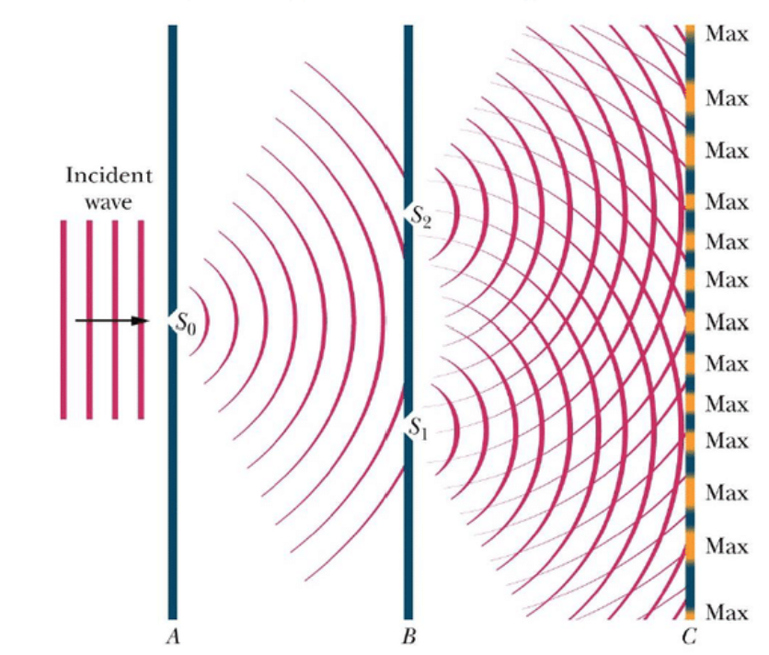

- Young set up three screens A, B and C as shown above. Screen A had one slit in it while screen B had two.
- Light passes through the first slit at S₀. Diffraction occurs at this point and as a result the light moving towards slits S₂ and S₃ is monochromatic (one wavelength).

- The light now passes through the slits at S₁ and S₂ and undergoes further diffraction at each opening.
- This light from one source now interferes both constructively and destructively with light from the second source. The result is a series of bright lines on the final screen.

Conclusion: The fact that light undergoes interference tells us that light travels as a wave.

We now use lasers as a more convenient source of monochromatic light which can pass through narrow slits producing the same pattern of bright lines on a screen.
.

The diffraction grating

A diffraction grating consists of a piece of transparent material on which a very large number of opaque (black) parallel lines are engraved.
The distance between two adjacent slits is referred to as ‘the slit width’ or ‘the grating constant’.
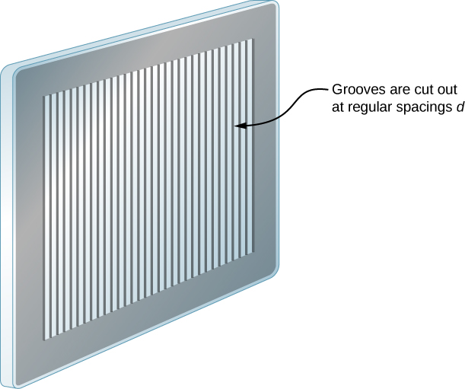
Its symbol is d.



If a grating has N lines per m ⇒ d = $\frac{1}{N}$ metres

Note: you will usually be told in a question that the grating has something like 600 lines per mm,
So multiply by 1000 to get the number of lines per metre.
Then get the reciprocal of this answer to find d, the grating constant.

2002 Question 5 [Higher level]  A diffraction grating has 200 lines per mm.  What is the value of d ? | $d=\frac{1}{number of lines per metre}$ $d=\frac{1}{200000}$  d = 0.000005 m = 5 × 10⁻⁶ m
Exam question  A diffraction grating has 300 lines per mm.  What is the value of d ? | If the grating has 300 lines per mm then it must have 300000 lines per m (because 1 m = 1000 mm)  $d=\frac{1}{number of lines per metre}$ $d=\frac{1}{300000}$  d = 0.00000333 m = 3.33 ×10⁻⁶ m

Relationship between wavelength and colour

Newton incorrectly believed that the spectrum of visible light consisted of the following seven colours:
Red, orange, yellow, green, blue, indigo, violet (Richard Of York Gave Battle In Vain).
Today this misconception is firmly ingrained just about everywhere, and even got asked in the 2016 HL paper. Read why Newton made this error in the ‘Extra Credit’ section at the end.

Each wavelength (and therefore frequency) of visible light corresponds to one of the colours in the visible spectrum, for example yellow has a wavelength of 7 × 10⁻⁷ metres (often written as 700 nm).


red | orange | yellow | green | blue | indigo | violet
Frequency increases as you go from red (extreme left) to violet (extreme right)
Wavelength increases as you go from right to left

Formula for a diffraction grating

nλ = d Sin θ

λ = wavelength
θ = angle between straight-through position and the order in question.

n is the order of the image; n = 1 corresponds to the first order (above and below the central image, n = 2 corresponds to the second order (above and below the central image) etc.

Note that n in this context is not related to the number of lines on the diffraction grating (it’s just unfortunate that they are both given the same letter to represent them).

d = distance between lines (slit width) in the diffraction grating.

This equation tells us that constructive interference will take place only at specific positions on a screen corresponding to specific angles for a given wavelength or colour or light.

2021 Question 8 [Higher Level]
Blue light is incident on a diffraction grating.
What changes would be observed if the blue light was replaced with red light.

From nλ = d Sinθ $Sin= \frac{n}{d}$
Sin θ is proportional to the wavelength of the light, so if increases then Sin θ (and θ itself) will increases.
Red light has a longer wavelength than blue light so in this case wavelength increases therefore the images will be further apart.
What changes would be observed if the blue light was replaced with white light.
If we used white light (composed of all colours or wavelengths of visible light) we would find that for each order constructive interference would occur at a slightly different position for each colour of wavelength of light producing a spectrum of light instead of an individual colour at each order (apart from the straight-through position). At this position we would get a white spot because all of the wavelengths of the incident light continue to travel together so produce white light on the screen.

Exam questions based on nλ = d Sin θ
2009 Question 7 [Higher Level]
An interference pattern is formed on a screen when green light from a laser passes normally through a diffraction grating. The grating has 80 lines per mm and the distance from the grating to the screen is 90 cm. The distance between the third order images is 23.8 cm.
Calculate the wavelength of the green light.
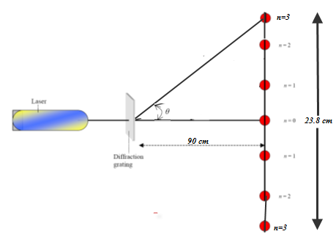
Solution
d = $\frac{1}{80000}$ = 1.25 × 10⁻⁵ m

θ =$\tan^{-1}{\frac{opposite}{adjacent}}$

Note that the angle in question corresponds to the angle between the order in question and the straight-through position. In this case it corresponds to the angle shown which means that the opposite corresponds to half of the overall length or 0.238 divided by 2.

From the diagram we can see that the adjacent is 0.90 m, while the opposite is $\frac{0,238}{2}$ = 0.119 m

θ =$\tan^{-1}{\frac{0.119}{0.9}}$ = 7.531⁰

n = 3
nλ = d sin θ ⇒ λ = $\frac{d \sin{ }}{n}$ = $\frac{(1.25 × {10}^{-5})(sin{) }}{3}$ ⇒ λ = 546× 10⁻⁹ m.

2019 Question 10 [Higher Level]
In 1801 Thomas Young performed an experiment to demonstrate that light is a wave.
The experiment was repeated in the school laboratory.
The slits were 0.5 mm apart and were placed at a distance of 1.25 m from the screen. The distance across 13 bright fringes on the screen was found to be 1.65 cm.
Calculate the wavelength of the monochromatic light.

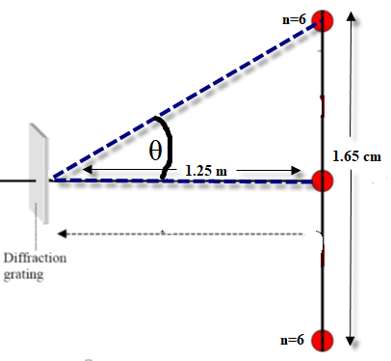
Solution
The slits are 0.5 mm apart: d = 0.5×10⁻³ m
Note that if there are 13 fringes this means that we have 6 fringes above the central fringe, 6 fringes below the central fringe and the central fringe itself.
Distance between central (n=0) image and n = 6 is $\frac{1.65 }{2}$ = 0.825 cm
We can leave everything in cm in order to find θ.

$\tan{θ=\frac{opposite}{adjacent}=\frac{0.825}{125}}$ θ = $\tan^{-1}{\frac{0.825}{125}}$ = 0.378⁰

$nλ=d\sin{θ}$ $λ=\frac{d\sin{θ}}{n}$

$λ=\frac{({0.5×10}^{-3} )(sin{0.378)}}{6}$ λ = 5.5×10⁻⁷ m

2014 Question 7 [Higher Level]
A laser produces a beam of red light with a wavelength of 709 nm. The beam is incident on a diffraction grating, as shown in the diagram. A diffraction pattern is formed on a screen. A second order image is detected at an angle of 34.6° from the central image.
Calculate the number of lines per millimetre on the grating used in the experiment.

Solution
- nλ = d Sinθ $d=\frac{nλ}{\sin{θ}}$ $d=\frac{(2)(709×{10}^{-9})}{\sin{34.6}}$ d = 0.000002497 m

Now if a grating has n lines per m ⇒ d = $\frac{1}{n}$ metres ⇒ n = $\frac{1}{d}$
- n = $\frac{1}{0.000002497}$ = 400000 lines per m = 400 lines per mm

2017 Question 9 [Higher Level]
Sodium emits visible light with a wavelength of 589 nm. This light is passed through a diffraction grating of 300 lines per mm.
Calculate the angular separation between the first line to the left of the central image and the first line to the right of the central image.

Solution
If the grating has 300 lines per mm then it must have 300000 lines per m (because 1 m = 1000 mm)
d = $\frac{1}{300000}$ = 3.33 ×10⁻⁶ m
λ = 589 × 10⁻⁹ m
n = 1

nλ = d sin θ $\sin{θ= \frac{λ }{d}}$ $\sin{θ= \frac{589×{10}^{-9} }{3.33×{10}^{-6}}}$ θ = 10.2⁰ Angular separation = 20.4⁰
2021 Question 8 [Higher Level]
- Calculate the angular separation between the two 3rd order images formed when blue light of wavelength 442 nm is incident on a diffraction grating of 600 lines per mm.
- Calculate the distance between these images on a screen placed 50 cm from the grating.

Solution
- Calculate the angular separation
600 lines per mm = 600000 lines per m. d = $\frac{1}{600000}$ = 1.67 × 10⁻⁶ m
λ = 442 × 10⁻⁹ m
n = 3

nλ = d sin θ $\sin{θ= \frac{nλ }{d}}$ $\sin{θ= \frac{(3)({442×10}^{-9}) }{{1.67×10}^{-6}}}$ $\sin{θ= 0.7956}$

$θ= \sin^{-1}{0.7956}$ θ = 52.7°

Angular separation = 2θ = 105.4°
- Calculate the distance between these images on a screen placed 50 cm from the grating.
$$\tan{θ}=\frac{opposite}{adjacent}$$

opposite = x
adjacent = 0.5 m
θ = 52.7°

$\tan{52.7°}=\frac{x}{0.5}$ x = (0.5)(tan 52.7) = 0.656 m

Distance between these 3rd order images = 2x = 1.31 m

Maximum number of images formed

The maximum number of images that can be formed is determined by the maximum angle of θ.
From the diagram we can see that the maximum value of θ is 90⁰ (technically 89.99 recurring but you see where we’re going here).

So nλ = d sin θ
For maximum number of images θ = 90⁰ so sin θ = 1

So nλ = d sin θ becomes So n_{max}λ = d n_{max} = $\frac{d}{}$

The maximum order n that can be obtained is determined from n_{max} = $\frac{d}{}$
2013 Question 12 (b) [Higher Level]
Yellow light of wavelength 589 nm is produced in a low-pressure sodium vapour lamp.
Calculate the highest order image that could be produced when a beam of light of this wavelength is incident perpendicularly on a diffraction grating that has 300 lines per mm.
Solution
The maximum that θ could be is 90⁰, so Sin θ = 1 so the formula becomes nλ = d, n_{max} = $\frac{d}{}$
$d=\frac{1}{300000}$ = 3.33 ×10⁻⁶ m n_{max} = $\frac{{3.33 ×10}^{-6}}{{589×10}^{-9}}$ = 5.65
The highest order image is 5

Maximum number of images = 2n_{max} + 1
This value for n only represents the maximum number of images on one side of the central image.
To calculate the maximum number of images we need to multiply this by 2 (because there are images on both sides) plus add 1 to include the central image.

2009 Question 7 [Higher Level]
An interference pattern is formed on a screen when green light from a laser passes normally through a diffraction grating. The grating has 80 lines per mm and the wavelength of the green light is 546 × 10⁻⁹ m.
Calculate the maximum number of images that are formed on the screen.

d = $\frac{1}{80000}$ = 1.25 × 10⁻⁵ m

For maximum number of images θ = 90⁰ n_{max} = $\frac{d}{}$ = $\frac{1.25 × {10}^{-5} }{551 × {10}^{-9} }$ n_{max} = 22.7

So the greatest whole number of images is 22.
But this is on one side only.
In total there will be 22 on either side, plus one in the middle, so total = 45

Relationship of pattern on the screen to changing wavelength or grating distance

Let’s look again at nλ = d Sin θ $Sin = \frac{n}{d}$
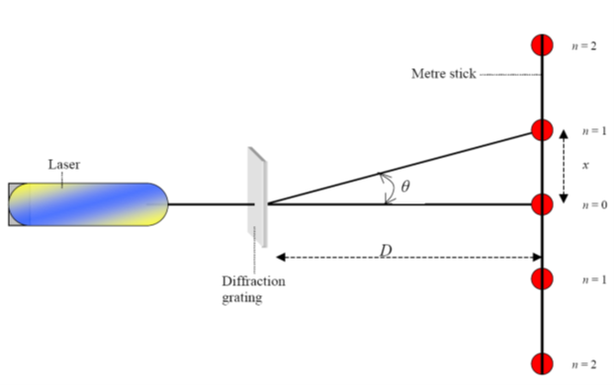
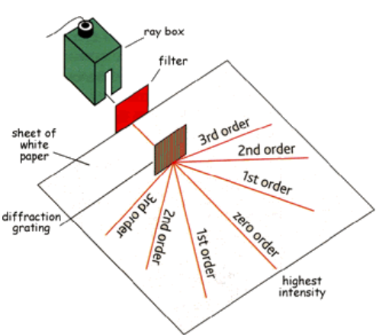

Relationship between image separation and wavelength | Relationship between image separation and distance between lines on diffraction grating
$$Sin = \frac{n}{d}$$  Sin θ is proportional to the wavelength of the light, so if increases then Sin θ (and θ itself) increases also.  So the images will be spread further apart. | $$Sin = \frac{n}{d}$$  Sin θ (and therefore θ) is inversely proportional to d (distance between lines) so if d increases then Sin θ (and θ itself) decreases.  So the images get closer together
Related exam questions
2005 Question 7 [Higher Level]
- What is the effect on the pattern when the wavelength of the light is increased?

- What is the effect on the pattern when the distance between the slits is increased?

Solution
- If increases then Sin θ (and θ itself) increases also.
So the images will be spread further apart.

- If distance between the slits (d) increases then Sin θ (and θ itself) decreases.
So the images get closer together

2019 Question 10 [Higher Level]
List two adjustment to any part of the apparatus that could be made to increase the distance between the bright fringes.
Solution
- Increase distance between screen and diffraction grating.
- Use a diffraction grating with more lines per mm, decreasing slit width d)
Increase the wavelength of the incident light.

The spectrometer and the function of its parts
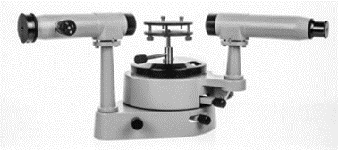
A spectrometer is used to measure the wavelength of light.

In its simplest form it is nothing more than a prism (or diffraction grating) and a protractor. However because of the need for very sensitive measurement we need to add in a few more parts. The three basic components are therefore a collimator, a diffracting element, and a telescope.

Main components
Slit: The slit determines how much visible light enters the spectrometer.
Collimator: To ensure that the light which reaches the prism or diffraction grating from just outside the slit is a parallel beam.
Telescope: The telescope is used to view the light after it has passed through the prism or diffraction grating.

Exam Question:
Draw a labelled diagram showing the principal parts of a spectrometer. (2017 Question 6)

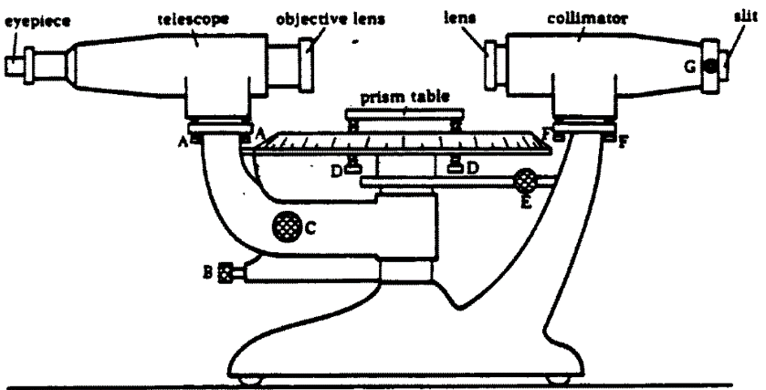
Solution

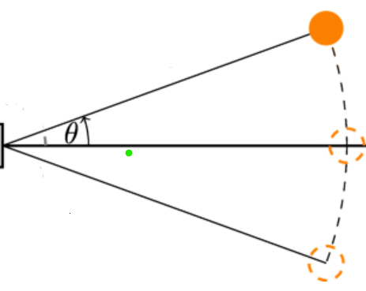

2023 Deferred Question 8
State three adjustments that should be made when setting up a spectrometer. (2023 Deferred Question 8)

Solution
Adjust the width of the slit, level the table, focus cross hairs, focus the telescope to accept parallel rays.

The coolest experiment in physics

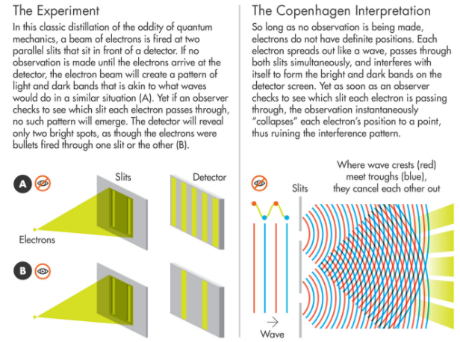
https://www.quantamagazine.org/pilot-wave-theory-gains-experimental-support-20160516

Derivation of formula
Note that the following in no way constitutes a full explanation. For that you need a teacher, a blackboard and a lot of pretending that we know what we’re talking about on the teacher’s part.

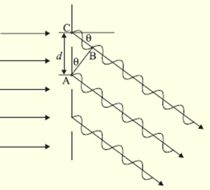
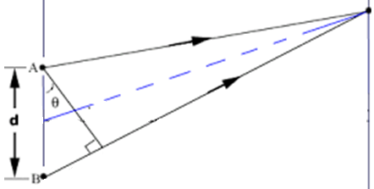

From the diagram we can see that
(i) For constructive interference to occur, the extra path length that the top ray travels must be a whole number of wavelengths (nλ) {Eqn (1)}

(ii) Using trigonometry, this extra path length is equal to d sin θ, where d is the slit width {Eqn (2)}

Equating (1) and (2) gives us nλ = d Sin θ
This derivation is very short to write, but each line involves quite an amount of (sometimes tricky) concepts.
- Understanding that the extra path wavelength travelled by the upper wave is a whole number of wavelengths greater than the lower waves, for constructive interference to occur.
- Understanding that the angle θ on top is equal to the angle θ at the bottom.
- Understanding that the extra path length is represented by the opposite side of a right-angled triangle, and therefore is equal to (d)(Sin θ).
Each of these concepts needs to be teased out.

Polarisation

A polarised wave is a wave which vibrates in one plane only

Light from an incandescent source (something which emits light when heated) is unpolarised, i.e. the electric and magnetic fields are oscillating in many different planes.

If light from such a source is passed through a substance called a polaroid the emerging rays are now polarised, i.e. oscillate in one plane only.

Demonstrating polarisation using two polaroids
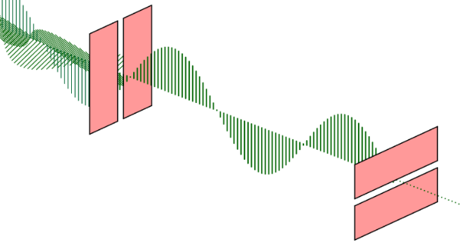
The first filter will only allow waves which are vertically polarised to pass through it.
These waves will only pass through a second polaroid if the second polaroid is parallel to that of the first.

- Hold a piece of polaroid material up to the light.
- If this light is then passed through a second polaroid, it only gets through if the second polaroid is orientated parallel of the first.
- If the second polaroid is then rotated through 90⁰, no light gets through.
NB: only transverse waves can be polarised so the fact that light can be polarised shows that light is a transverse wave.
Applications: Sunglasses, stress polarisation (used to detect faults or stresses in materials)

2023 Deferred Question 6 [Higher Level]  Explain the principle of operation of polaroid sunglasses and how they help the wearer. | Light coming directly from the sun is unpolarised but generally becomes horizontally polarised upon reflection from a smooth surface (I have no idea why).  This polarised light causes glare (I have no idea why).  The vertically oriented polaroid in sunglasses blocks this horizontally polarised light (I have no idea why – see footnote below) and thus reduces the glare.

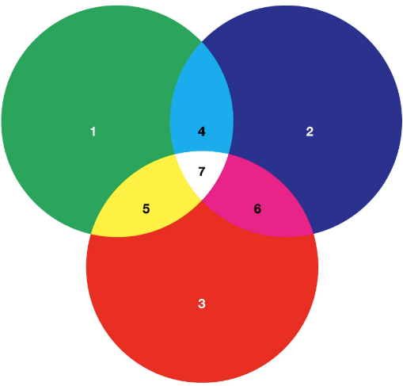
Primary and secondary colours
****Obviously you can’t show colours on black-and-white paper so make sure to check out the links on the website thephysicsteacher.ie, in particular see the link entitled ‘Colour Mixing’.****

Primary colours
The primary colours are three colours such that when combined in equal intensity produce white light.
The three primary colours are Green (1), Blue (2), Red (3).

Secondary colours
When two primary colours are mixed in equal intensity, the colour formed is a secondary colour.
The three secondary colours are Cyan (4), Yellow (5) and Magenta (6).

Complementary colours
Complimentary colours are pairs of colours consisting of a primary and a secondary colour, such that when combined they give white light.
These colours are: blue & yellow, green & magenta, red & cyan

I find it really (and I mean ‘really’) odd that so few textbooks include the role of the eye and brain system here. It is as if the theory about colour is independent of humans, as though it were of a similar nature to all the other ‘laws’ of physics we encounter. In reality each human may be ‘seeing’ a different colour while looking at the same light source and there isn’t even any way to know (although if you are colour-blind and I’m not then we can be pretty sure that we are each experiencing something different). I would guess that Newton is partly to blame here. While he discovered so much that we now know about optics and colour we shouldn’t be surprised that he got some things wrong (although he didn’t help his cause by believing that he was infallible). A neat example of this is the belief that there are seven colours in the rainbow. Not only is this incorrect but it also lives on in most textbooks today (and even continues to get asked in exam papers). And there’s the rather odd issue of cyan and magenta – they’re not in the set of colours in the rainbow but yet they pop up mysteriously with the complementary colours. What’s that about? (see the Green frogs, Welsh rainbows short story below for more on this). On the other hand he must have had some inkling that the eye played a role
I would love to know if that was a conscious decision or not. Interestingly in sound we do make reference to the brain when it comes to detecting sound (students have to know about the decibel 'adjusted' scale) but then new findings in that field didn’t have to compete with the writings of Newton so perhaps that made it easier to get accepted.

Why are there just seven colours in the rainbow?
There are actually an infinite number of colours in the rainbow. But what we can identify is determined by our eyes and our brain. If you show somebody a rainbow and ask them to count the colours it is unlikely that they will come up with seven. It is even more unlikely that they will come up with the same seven colours as Newton. To try and find out why Newton came up with seven colours we must first note that although Newton is regarded as one of the first great scientists, he was also one of the world’s last alchemists. As such he was steeped in superstition. From ancient times the number seven was always considered to be special (particularly by the Ancient Greeks, from whom so many of our ideas originate)
Consider the following list:
Seven seas
Seven day week
Seven years bad luck
Seventh heaven
God created the world in seven days
Seven deadly sins (remember the film SEVEN?)
Seven wonders or the world
Seventh son of a seventh son
5 planets plus sun and moon
Seven distinct notes in a scale

These last two points are related in that the Greeks believed that there was a one-to-one correspondence between each of the notes in the scale and the individual planets/sun/moon. We would now consider all this to be rubbish but you must remember that this was a time when Truth and Beauty were considered absolute, not concepts that were ‘merely’ in the eye of the beholder.
So Newton had all this background information in his head so it simply made sense from Newton’s perspective that there were seven colours. Of course the next problem was identifying them. Interestingly when Newton first wrote about the phenomenon he went with just five colors – red, yellow, green, blue, and violet. He later changed this to seven when he published in his treatise on light, “Opticks” where he argued that there was a direct link between his colours and the notes in a musical scale. Newton later acknowledged that he could, at most, only identify 6 colours (indigo was ditched). But it was too late. We’re still learning the seven colours today as if these are the only colours which exist.

By the way, the colour ‘orange’ didn’t even exist until the 1540s.
Before then, folk would have used something like "yellow-red," (by the way, did you know that there is no word in the English language that rhymes with ‘orange. Languages also differ in how they divide up the color spectrum - the visual world. Some languages have lots of words for colors, some have only a couple words, "light" and "dark." And languages differ in where they put boundaries between colors. So, for example, in English, there's a word for blue that covers all of the colors that you can see on the screen, but in Russian, there isn't a single word. Instead, Russian speakers have to differentiate between light blue, "goluboy," and dark blue, "siniy." So Russians have this lifetime of experience of, in language, distinguishing these two colors. When we test people's ability to perceptually discriminate these colors, what we find is that Russian speakers are faster across this linguistic boundary. They're faster to be able to tell the difference between a light and dark blue. And when you look at people's brains as they're looking at colors -- say you have colors shifting slowly from light to dark blue -- the brains of people who use different words for light and dark blue will give a surprised reaction as the colors shift from light to dark, as if, "Ooh, something has categorically changed," whereas the brains of English speakers, for example, that don't make this categorical distinction, don't give that surprise, because nothing is categorically changing.
See “ Flowers are red”, one of my favourite songs by Harry Chapin for a slightly different perspective on this.

Green frogs, Welsh rainbows
By Brian Davies

“It was a greeny-yellow frog. Denny lobbed it back into the sluice. "That Newton must have had bad eyes" he puffed, as we ran across the road. "Couldn't count either". I agreed. We watched the frog hurtle out in the torrent from the underground pipe. It floated, yellow belly up, for a bit, then swam into the watercress. We climbed down and caught it.

Denny Murphy and I didn't rate Newton, though Miss Daniels said he was great. In the church hall next to the school she used Waldo Show's magic lantern and a piece of glass to make colours on the wall. "How many colours can you see?" she asked our class. Most of us saw about ten, except Godfrey Riddle, whose mother wouldn't let him pick blackberries, he was so helpless. "No, Isaac Newton showed there are really just seven" she told us, and we had to learn "Rees Of Ystrad Grows Beetroot In Vases" to remember which ones.

Seven! Miss Daniels was kind but she couldn't tell a tom-tit from a chiff-chaff and when she went on to say Newton's colours came in "opposite pairs" "COMPLEMENTARY" she chalked on the board Denny and I rolled our eyes. "You can't divide seven by two" piped Denny, "you need eight colours, four twos". After a bit Miss Daniels said "Seven colours in a rainbow but only six with paints". "She's hopeless" whispered Denny. Miss Daniels wasn't hopeless. She was, though, hopelessly confused, both by the nature of light and colour and, especially, by Newton.

With colour what we see depends only on our eyes and brains. However, what we then notice, and register in our minds, depends on our culture, our traditions - and our language. In Welsh, for example, there is no single word which carries the same meaning as the word "green" does for English people. To describe completely the range of colours found in a light spectrum between Newton's English "yellow" and his "blue", we need two words in Welsh, "glas" and “gwyrdd”, which also include between them some colours referred to as "grey" and "brown" in English.

It is an interesting co-incidence that the cones in our eyes which enable us to differentiate colours are the most sensitive to light in the "glas", "gwyrdd" and "blue" parts of the spectrum and not to light in the English "blue", "green" and "red" as suggested by Thomas Young and developed in Maxwell's colour theories. Indeed, there are no cones with maximum sensitivity in the "red". Our eye-brain systems apprehend the English "red" when the ratio of the number of signals from one type of green-sensitive cones to the number from the more yellow-green-sensitive cones is low.

Given that the colours "glas" and "gwyrdd" are both needed to describe "green", it follows that if Newton had been Welsh he might have chosen seven different colours from his rainbow palette. Of course, the Welsh Newton would only have chosen seven colours if he had also, as in reality, been sufficiently influenced by Pythagorean theories of universal harmony, and music, to want to find a colour to correspond to each of the seven intervals of a musical scale. If the Celtic Isaac had - again as in real life - also maintained a close interest in alchemy, with its centuries old Parmenidean concern with universal opposites, such as earth and air, fire and water, he would still have been looking for his pairs of "complementary" colours. This time, though, his choices might have been somewhat different.
Theories of colour and colour perception developed under his influence in the next three centuries would not have been the same, and even the development of European painting might have profoundly changed. At the very least, Miss Daniels would have been confused in a rather different way.

”Trouble with Newton" explained Denny's grandpa, after we'd complained on the way home, "was that he was too clever for our own good. Everyone believes him instead of their own eyes. But in his own way he was just as colour blind as Godfrey Riddle; 'cept he had the choice, Godfrey doesn't." We pretended to understand. In the village he was famous for talking like this, specially down the pit; and for his poems, which had won the Eisteddfod. "How many colours in a rainbow, then Grandpa?" asked Denny, hopefully. "At least as many as you can name, and then there are those you know you can't", he said. Denny and I started to walk off. "Where are you two going now?" "We're going to catch our frog" I said. "Oh. Is it a yellow frog or a green frog?" he asked. "Both", we answered together, without even thinking.



I took a bodkin [wooden needle] and put it betwixt my eye and the bone as near to the backside of my eye as I could, and on pressing my eye with the end of it, there appeared several white, dark, and colored circles. When I continued to rub my eye with the point of the bodkin, the circles would grow faint and often disappear until I renewed them by moving my eye or the bodkin.
Isaac Newton
#respect

Dispersion

Dispersion is the separating out of the different colours present in white light.
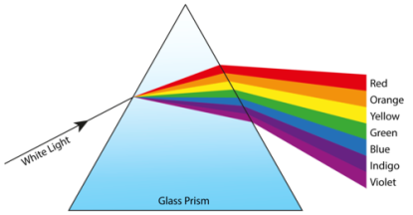

Dispersion can be brought about by (i) a prism and (ii) a diffraction grating
Dispersion is the principle behind the array of colours seen in rainbows, polished gemstones and on the surface of CDs.

Dispersion due to a prism
A prism causes dispersion because the refractive index of the medium is slightly different for different wavelengths, therefore each wavelength gets refracted (bent) by a different amount.
In this case violet gets deviated the most (“violet bents most violently”).

Dispersion due to a diffraction grating
A diffraction grating causes dispersion because from the formula nλ = d sinθ; if λ is different, θ will be different.
Therefore different colours are diffracted by different angles.
From this we can see that the colour with the largest wavelength (red) deviates the most.

Recombination
If a given prism is used to disperse white light, a second identical – inverted - prism can be used to recombine the components back into white light.

The electromagnetic spectrum

The electromagnetic spectrum is the full range of electromagnetic radiation divided by frequency/wavelength.

You are expected to know the relative positions of the different radiations in terms of their frequency and wavelength.
Frequency Increasing ⇒
Radio | Micro | Infrared | Visible | Ultraviolet | X-ray | Gamma

Whether you realise it or not, you are living in a sea of radiation. It is called electromagnetic radiation.


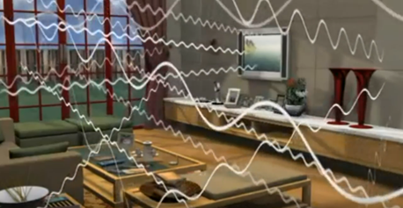

In the grand scheme of things, we’re all pretty much blind and deaf.

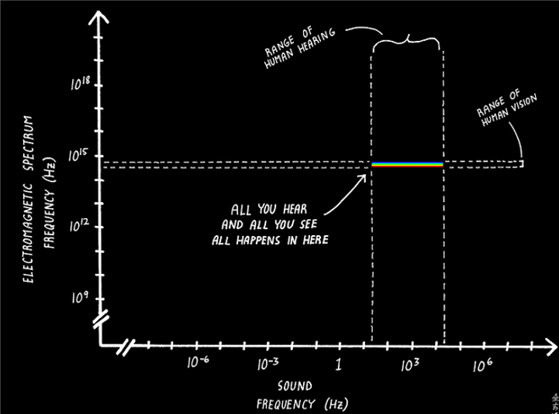

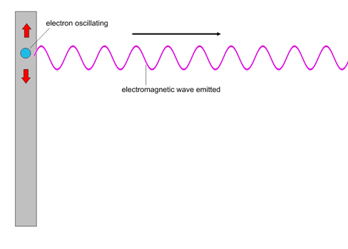
How do you create an electromagnetic wave?
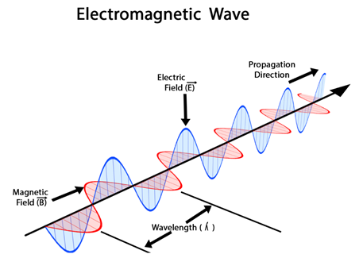
The answer depends on the category of electromagnetic wave you are talking about. Let’s consider visible light. Take that red biro in front of you. Some of the electrons in the atoms that are in the red paint rise up to a higher level when exposed to light. These electrons then fall back down to their original level in a series of steps, but only via specific pathways. Each time the electrons drop a level they emit electromagnetic radiation of a specific wavelength. So the level determines the wavelength which determines the colour (if it’s in the visible range). Greater levels (or energy gaps) result in ultraviolet or X-ray radiation.

Infra-red radiation on the other hand comes about as a result of the vibrations of the atoms and molecules in the object (and that’s all I know about it). Therefore every object in the universe emits IR radiation no matter how cold it is.

We next look at a few characteristics of infrared and ultraviolet radiation.
Infra-red radiation
Characteristics
- It is an electromagnetic wave, travels at speed of light, frequency less than visible light.
- Can be detected with a heat-sensitive camera e.g. ‘night-vision’ cameras.

Applications of Infra-Red technology
- Infra-red camera (used in night-vision goggles)
- Medical: an abnormal infrared image is the single most important marker of high risk for developing breast cancer.

Which of the following emit electromagnetic radiation?
- The Earth
- A living person
- A (very) dead person
- A hot stone
- An ice cube

Ultra-violet radiation
Characteristics
- It is an electromagnetic wave, travels at speed of light, frequency greater than visible light.
- Causes objects to fluoresce
- Can be detected by photographic plating
- Some ultra-violet light can damage skin which can lead to skin cancer.

Can you get a tan inside glass?
Yes you can tan through glass. Most UV is blocked by glass. So you needs LOTS of sun exposure to tan thru glass

Skin cancer

Ireland has the third highest rate of cancer in the world. Care to guess what form of cancer is the most common?
You know it baby - skin cancer - over 13,000 new cases diagnosed every year.

We have become accustomed to thinking that there is just one type of ultra violet radiation such that if we’re not getting a suntan (or sunburn) then there is no UV radiation. In fact the really dangerous radiation is the radiation that doesn’t give you a suntan (or sunburn) and it passes through clouds so once you are outside you are exposed to it.

Ultra-violet radiation can be sub-divided into UVA and UVB with UVA having the longer wavelength. We divide it into these bands because each type affects the human skin differently.
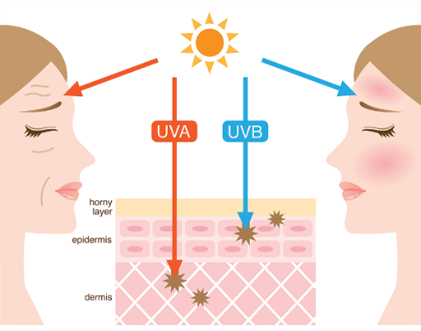


- UVB doesn’t really penetrate clouds, glass so you are unlikely to receive a suntan on a cloudy day or through a window. However if it’s a sunny day then UVB is likely to damage the outermost layers of your skin leading to suntan and sunburn.
This is why we put on sunscreen on sunny days.
- UVA can penetrate windows, clouds and skin itself.
These rays do not cause a skin to tan or burn but because they can penetrate skin they can induce genetic damage to cells resulting in premature aging and skin cancers.
UVA makes up 95% of all ultraviolet radiation.
This is why you should put on sunscreen even on cloudy days.
- If there is only one thing that you learn from this chapter please let it be the following: there is no such thing as a safe tan. When your skin is damaged by exposure to ultraviolet light it tries to minimise further damage by darkening its colour. We call this a suntan.

- A suntan in and of itself is damaged skin.
- If you can only have one BFF in your life, make it fake tan.

The Doppler effect revisited
Remember that Doppler effect? I didn’t think so. It is the apparent change of the frequency of a wave due to the relative motion between the source and the observer. Up to now we just looked at examples the Doppler effect as it relates to sound waves. Now we look at how it applies to light.
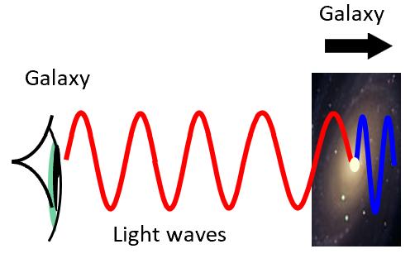
When American astronomer Edwin Hubble studied the light from distant galaxies he noticed something strange; it was a different wavelength than that which he was expecting. He realised that light seemed to be a different colour for the same reason that a passing ambulance seemed to make a different sound; the source of the wave must be moving!

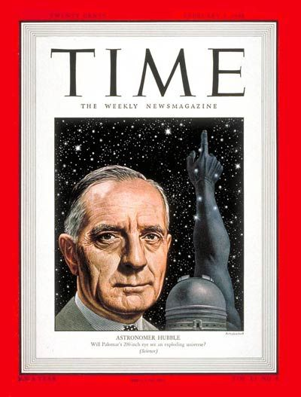


Edwin Hubble on the cover of TIME magazine, Feb 1948.

The Doppler effect: related exam questions
Before tackling the following you should go back and do a few of the Doppler effect with sound questions

The speed of light is 3 × 10⁸ m s⁻¹
Sometimes you may have to use c = fλ to get either f or f” before you can use it in the Doppler formula.

2010 Question 7 [Higher Level]
- What causes the red shift in the spectrum of a distant star?
- The yellow line emitted by a helium discharge tube in the laboratory has a wavelength of 587 nm.
The same yellow line in the helium spectrum of a star has a measured wavelength of 590 nm.
What can you deduce about the motion of the star?
- Calculate the speed of the moving star.

- What causes the red shift in the spectrum of a distant star?
Distant stars are moving away from us therefore the wavelengths increase.

- What can you deduce about the motion of the star?
The star is moving away from earth

- Calculate the speed of the moving star.

“The yellow line emitted by a helium discharge tube in the laboratory has a wavelength of 587 nm.”
This is the actual wavelength of the light and we can use this to calculate the actual frequency as follows: f = $\frac{c}{λ}$ = $\frac{3×10^{8}}{587×{10}^{-9} }$ f = 5.11073 × 10¹⁴

“The same yellow line in the helium spectrum of a star has a measured wavelength of 590 nm.”
The star is moving away from us so the wavelength that we detect isn’t going to be its actual wavelength but rather its apparent wavelength. We can use this to calculate the apparent frequency as follows:

f’ = $\frac{c}{λ’}$ = $\frac{3×10^{8}}{590×{10}^{-9} }$ f’ = 5.08475 × 10¹⁴
The star is moving away from earth therefore we use the ‘plus’ in the formula:

$(5.08475 ×{10}^{14})[(3×{10}^{8})+u]=$ 1.533219 $×{10}^{23}$

$(1.525425×{10}^{23})$ $+ (5.08475 ×{10}^{14})u=$ 1.533219 $×{10}^{23}$

7.794 $×{10}^{20}$ = $5.08475 ×{10}^{14}u$ $u=\frac{7.794 ×{10}^{20}}{5.08475 ×{10}^{14}}$

Answer: u = 1.5333 × 10⁶ m s⁻¹

So the star is moving away from us at 1.5 million metres per second, or 1.5 thousand km per second – almost as fast as a student leaving the classroom at lunchtime.

TO MEASURE THE WAVELENGTH OF MONOCHROMATIC LIGHT

APPARATUS
Laser, diffraction grating, 2 metre sticks.
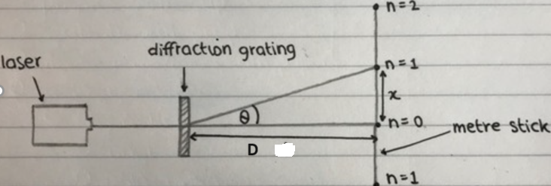
DIAGRAM

PROCEDURE
- Clamp a metre stick horizontally in a stand.
- Allow the laser beam to hit the metre stick normally (at 90°) on the 50 cm mark.
- Place the grating between the laser and the metre stick, at right angles to the beam.
- Observe the interference pattern on the metre stick – a series of bright spots.
- Calculate the distance x between the centre (n = 0) spot and the first bright spot (n =1) on one side.
- Measure the distance D from the grating to the metre stick.
- Calculate θ using tan θ = x/D.
- Calculate the distance d between the slits, using d =1/N, where N is the number of lines per metre on the grating.
- Calculate the wavelength λ using nλ = dsinθ.
- Repeat this procedure for different values of n and get the average value for λ.

RESULTS AND CALCULATIONS
diffraction grating has ___ lines per mm = ______ lines per m. d =

n | x (m) | D (m) | θ (degrees) | λ (m)
n = 1 (first image right hand side)
n = 1 (first image left hand side)
n = 2 (second image right hand side)
n = 2 (second image left hand side)

CONCLUSION

SOURCES OF ERROR / PRECAUTIONS
- The diffraction grating may not have been exactly at right angles to the beam of light; x should be the same on both sides. Measure x on both sides of the n = 0 position and take the average of the two readings. To reduce the percentage error further just measure the total distance between both points and divide by 2
- Determining the exact middle of the dot on the screen was difficult (repeat and get an average)

NOTE
Rather than giving lasers to students, a safer alternative is to take a school laser into a large darkened room (e.g. a gym) and get very large distances for D and x on either side under controlled conditions.

Note that there are two distances that need to be measured here; one is the diffraction constant (small d) and the other represents the distance between the grating and laser (capital D).

Theory questions

Name a source of monochromatic light. | A laser
How was a narrow beam of light produced? | By using a laser
Draw a labelled diagram of the apparatus you used.

Describe how the angle between the first order images was measured. | Measure distance x from central fringe for n = ±1, ±2, then the distance D between grating and screen.  $$=\tan^{-1}{\frac{x}{D}}$$  OR: vapour lamp , grating & spectrometer  measure angle on left, θL  measure angle on right, θR  θ = ½(θL ± θR)
What is the distance between each line on the diffraction grating? | $$d=\frac{1}{number of lines per metre}$$
Explain how the order of the images were identified. | The first bright image above and below (or left and right of) the centre image corresponds to the first order images and so on.
Explain how the first order images were identified. | They were the first bring images above and below (or left and right of) the centre image.
Which of the four angles is the most accurate? Suggest a reason for your answer. | The largest angle is the most accurate as it would have the smallest percentage error.
What formula did you use to calculate the wavelength of the light? | $$nλ=d\sin{θ}$$
The light source is replaced with a source of white light and a series of spectra are formed on the screen.  - Explain how the diffraction grating produces a spectrum.  - Explain why a spectrum is not formed at the central (zero order) image. | - Different colours have different wavelengths so constructive interference occurs at different positions for each separate wavelength.  - At central image θ = 0 so constructive interference occurs for all separate wavelengths at the same point so no separation of colours.
The values for the angles on one side of the central image can sometimes all be smaller than the corresponding ones on the right. Suggest a possible reason for this. | The incident light was not perpendicular to the screen.
Explain how using a diffraction grating with 100 lines per mm leads to a less accurate result.

What would be the effect of using a source of white light instead of monochromatic light? | There would be a spectrum formed instead of a single-coloured dot at each order
Give a way of improving the accuracy of this experiment / give one precaution that you took to get an accurate result. | Ensure that the diffraction grating is perpendicular to the (monochromatic) light, use a grating with a large number of lines, ensure D is large, repeat for different orders and take the average, etc.

Exam questions

[2008]
In an experiment to measure the wavelength of monochromatic light, a diffraction pattern was produced using a diffraction grating with 500 lines per mm. The angle between the first order images was measured. This was repeated for the second and the third order images.
Angle between first order images | Angle between second order images | Angle between third order images
34.2⁰ | 71.6⁰ | 121.6⁰
The table shows the recorded data:

- Draw a labelled diagram of the apparatus used in the experiment.
- Explain how the first order images were identified.
- Describe how the angle between the first order images was measured.
- Use the data to calculate the wavelength of the monochromatic light.

2004 Question 2
In an experiment to measure the wavelength of monochromatic light, the angle θ between a central bright image (n = 0) and the first and second order images to the left and the right was measured.
A diffraction grating with 500 lines per mm was used.
The table shows the recorded data.
n | 2 | 1 | 0 | 1 | 2
θ /degrees | 36.2 | 17.1 | 0 | 17.2 | 36.3
- Describe, with the aid of a diagram, how the student obtained the data.
- Use all of the data to calculate a value for the wavelength of the light.
- Explain how using a diffraction grating with 100 lines per mm leads to a less accurate result.
- The values for the angles on the left of the central image are smaller than the corresponding ones on the right. Suggest a possible reason for this.

[2009 Section B]
- An interference pattern is formed on a screen when green light from a laser passes normally through a diffraction grating. The grating has 80 lines per mm and the distance from the grating to the screen is 90 cm. The distance between the third order images is 23.8 cm.
Calculate the wavelength of the green light.
- Calculate the maximum number of images that are formed on the screen.
- The laser is replaced with a source of white light and a series of spectra are formed on the screen.
Explain how the diffraction grating produces a spectrum.
- Explain why a spectrum is not formed at the central (zero order) image.

Worked Solutions

[2008]
Angle between first order images | Angle between second order images | Angle between third order images
34.2⁰ | 71.6⁰ | 121.6⁰

$d=\frac{1}{number of lines per metre}$ $d=\frac{1}{500000} = {2×10}^{-6} m$

$nλ=d\sin{θ}$ $λ=\frac{d\sin{θ} }{n}$
Note that when using the formula, θ represents the angle between the image in question and straight through, whereas the angles given here are between the two first order images, so we need to divide those angles by 2 before using them.

n=1 | $λ=\frac{{(2×10}^{-6}) \sin{17.1} }{1}$ | = 5.8808 × 10⁻⁷ ≈ 5.88 × 10⁻⁷m
n=2 | $λ=\frac{{(2×10}^{-6}) \sin{35.8} }{2}$ | = 5.8496 × 10⁻⁷ ≈ 5.85 × 10⁻⁷m
n=3 | $λ=\frac{{(2×10}^{-6}) \sin{60.8} }{3}$ | = 5.8195 × 10⁻⁷ ≈ 5.82 × 10⁻⁷m
λ = 5.85 × 10⁻⁷ m = 5.85 × 10⁻⁷m

[2004]
A diffraction grating with 500 lines per mm was used.

$$λ=\frac{d\sin{θ} }{n}$$
n=1 | λ_{L}= 588.1 nm,
n=1 | λ_{R}= 591.4 nm
n =2 | λ_{L}= 590.6 nm
n=2 | λ_{R}= 592.0 nm
Average wavelength = 590 nm
nλ = d sinθ
$d=\frac{1}{number of lines per metre}$ $d=\frac{1}{500000} = {2×10}^{-6} m$

[2009 Section B]
The grating has 80 lines per mm:
$d=\frac{1}{number of lines per metre}$ $=\frac{1}{80000} = {1.25×10}^{-5} m$

The distance between the third order images is 23.8 cm.
We need to convert 23.8 cm to metres = 0.238 m. We then have to divide the 0.238 by 2 = 0.119 m.
The distance from the grating to the screen is 90 cm.

$=\tan^{-1}{\frac{0.119}{0.9}}$ = 7.53⁰

n = 3
nλ = d sin θ  $λ=\frac{d\sin{θ} }{n}$  λ = 5.462 × 10⁻⁷ m.

Solutions

- See diagram
- The laser
- Distance from grating to screen
Distance between dots on the screen
- 600 lines per mm = 600000 lines per metre.
d = (1/ number of lines per metre) = (1/600000) = 1.67 × 10⁻⁶ m.
- Using the formula nλ = d sin θ, where d was d was calculated above, n was the order of the dots on either side and θ corresponded to the angle shown in the diagram.
- Ensure that the diffraction grating is perpendicular to the (monochromatic) light, use a grating with a large number of lines, ensure D is large, repeat for different orders and take the average, etc.

- A laser or a sodium lamp.
- See diagram.
- Distance from grating to screen
Distance between dots on the screen
- nλ = d sin θ
- Ensure that the diffraction grating is perpendicular to the (monochromatic) light, use a grating with a large number of lines, ensure D is large, repeat for different orders and take the average, etc.

- Sodium lamp / laser

- Set up as shown on diagram above.
- Measure the distance between the n = 0 and the n= 1 images.
- Measure the distance D
- Tan ϴ = x/D
- Repeat for all orders on both sides
- nλ = d Sin θ
d = 1/400,000
λ_{avg} = 642.3 nm

- Larger ϴ therefore the images would be more spaced out.
- Smaller ϴ therefore the images would be closer together.
- Each image would be a spectrum of white light.

- d = 1/80000 = 1.25 × 10⁻⁵ m
θ = tan⁻¹ (0.238/0.90) Technically the .238 should have been divided by 2, because it represents the distance between the third order images either side of the central image, but they gave full marks either way).
n = 3
nλ = d sin θ  λ = d sin θ/n  λ = 551 (± 5) × 10⁻⁹ m.
- For maximum number θ = 90⁰  sin θ = 1
nλ = d sin θ  nλ = d  n = d/λ
- n = 22.7 so the greatest whole number of images is 22.
- But this is on one side only.
- In total there will be 22 on either side, plus one in the middle, so total = 45
- Different colours have different wavelengths so constructive interference occurs at different positions for each separate wavelength.
- At central image θ = 0 so constructive interference occurs for all separate wavelengths at the same point so no separation of colours.

- See diagram. Plus metre stick
- Nearest on either side of the central (zero order) image.
- Measure x between 1st order images
Measure D from screen to grating
θ = tan⁻¹ (x/D)
- Use nλ = d sinθ
(n=1) λ = sin (17.1)/[(5 × 10⁵)(1)] = 5.8808 × 10⁻⁷ ≈ 5.88 × 10⁻⁷m
(n=2) λ = sin (35.8)/[(5 × 10⁵)(2)] = 5.8496 × 10⁻⁷ ≈ 5.85 × 10⁻⁷m
(n=3) λ = sin (60.8)/[(5 × 10⁵)(3)] = 5.8195 × 10⁻⁷ ≈ 5.82 × 10⁻⁷m
λ = 5.85 × 10⁻⁷ m = 585 nm

- The apparatus was set up as shown.
To get a value for θ the distance x was measured between the centre image and the second order image, then the distance D between grating and screen was measured.
θ = Tan⁻¹ (x/D)
We did the same for the other side and got an average value for θ.
- Use a laser.
- nλ = d sin θ
n = 2
d = 1/(3.00 x10⁵) m = 3.33 x 10⁻⁶ m = 3.33 x 10⁻³ cm = 1/300 mm
θ = 20.3⁰
λ = 5.78 x 10⁻⁷ m (= 578 ≈ 580 nm)
- This would result in a greater angle for each order image and therefore a smaller percentage error in measuring the angle.
- Repeat and get average value for the wavelength , repeat for higher orders.

- See diagram, plus metre stick.
Measure distance x from central fringe for n = ±1, ±2
Measure distance D from grating to screen and calculate θ in each case using tan θ = x/D
- nλ = d sinθ
d = 1/500000  d = 2 × 10⁻⁶
n=1, λ_{L}= 588.1 nm, λ_{R}= 591.4 nm
n=2, λ_{L}= 590.6 nm, λ_{R}= 592.0 nm
Calculated average wavelength = 590 nm.
- It would result in a smaller value for θ which would mean larger percentage errors.
- The grating may not be perpendicular to the incident light

Section A exam questions
HL: 2018, 2016, 2015, 2011, 2009 (section B), 2008, 2006, 2004
OL: 2007, 2004

Use the data to calculate the wavelength of the monochromatic light.

[2008 HL]
In an experiment to measure the wavelength of monochromatic light, a diffraction pattern was produced using a diffraction grating with 500 lines per mm. The angle between the first order images was measured. This was repeated for the second and the third order images.
Angle between first order images | Angle between second order images | Angle between third order images
34.2⁰ | 71.6⁰ | 121.6⁰

[2009 HL Section B]
An interference pattern is formed on a screen when green light from a laser passes normally through a diffraction grating. The grating has 80 lines per mm and the distance from the grating to the screen is 90 cm. The distance between the third order images is 23.8 cm.
[2004 HL]
In an experiment to measure the wavelength of monochromatic light, the angle θ between a central bright image (n = 0) and the first and second order images to the left and the right was measured.
n | 2 | 1 | 0 | 1 | 2
θ /degrees | 36.2 | 17.1 | 0 | 17.2 | 36.3
A diffraction grating with 500 lines per mm was used.
The table shows the recorded data.
[2006 HL]
The angle between the second order image to the left and the second order image to the right of the central bright image in the pattern was measured.
The number of lines per mm on the diffraction grating = 300
The angle measured was 40.6⁰.
[2018 HL]
The angle between the two first order images = 34.1°
The number of lines per mm on the diffraction grating = 500

[2016 HL]
A source of monochromatic light and a diffraction grating of 500 lines per mm were used.
n | 2 (left) | 1 (left) | 1 (right) | 2 (right)
θ (degrees) | 36.2 | 17.2 | 17.1 | 36.1

[2015 HL]
The diffraction grating had 80 lines per mm.
order |  | 1 | 2 | 3 | 4
θ (degrees) |  | 4.60 | 9.18 | 13.81 | 18.44
The angle θ between the first order image to the left and the first order image to the right was measured.

[2011 HL]
Diffraction grating has 400 lines per mm.
 | 2nd image to left  of central image | 1st image to left  of central image | 1st image to right  of central image | 2nd image to right  of central image
θ / ° | 30.98 | 14.90 | 14.81 | 31.01

SLOP

Describe an experiment that demonstrates the wave nature of light. | Shine a laser through a diffraction grating; an interference pattern will be produced on a screen, caused by interference of the light waves
Name the two phenomena that occur when the light passes through the pair of narrow slits. | Diffraction and interference
A student used a laser, as shown, to demonstrate that light is a wave motion.  A pattern is formed on the screen. Explain how the pattern is formed. | The slits act as sources of two coherent waves which overlap to give areas of constructive interference (bright lines) and destructive interference (dark lines).
What is the effect on the pattern when the wavelength of the light is increased? | The pattern becomes more spread out.
What is the effect on the pattern when the distance between the slits is increased? | The pattern becomes less spread out.
In an experiment a beam of monochromatic light passes through a diffraction grating and strikes a screen.  Describe what is observed on the screen. | A series of bright dots.
Explain, with the aid of a diagram, how this phenomenon occurs. | See notes
What does this experiment tell us about the nature of light? | It tells us that light is a wave.
Name the property of light that can be determined in this experiment. | The wavelength of light can be determined
What measurements must be taken to determine the property you named? | The distance between bright dots, distance from the screen to grating.
Why does diffraction not occur when light passes through a window? | The window is too wide (relative to wavelength of light).
A sound wave is diffracted as it passes through a doorway but a light wave is not. Explain why | Diffraction only occurs when the width of the gap is approximately equal to the wavelength of the wave. This is the case for a sound wave but the wavelength of a light-wave is very small compared to the size of a doorway.
What is a diffraction grating? | A diffraction grating consists of a piece of transparent material on which a very large number of opaque (black) parallel lines are engraved.
Explain the term monochromatic light. | Monochromatic light is light of one wavelength only.
Derive the diffraction grating formula | See notes
Sound travels as longitudinal waves while light travels as transverse waves.  Explain the difference between longitudinal and transverse waves. | Longitudinal waves: the direction of the vibrations is parallel to the direction of propagation of the wave.  Transverse wave: the direction of the vibrations is perpendicular to the direction of the wave.
What is meant by polarisation of waves? | A polarized wave is one which vibrates in one plane only.
Which wave phenomenon can be used to distinguish between transverse waves and longitudinal waves? | Polarisation
Describe an experiment to demonstrate that light waves are transverse waves. | See notes
Give one difference between light waves and sound waves. | Light waves are transverse; sound waves are longitudinal.  Light waves can be polarised; sound waves cannot be polarised.  Light waves travel through a vacuum; sound waves cannot travel through a vacuum.
What is meant by the term dispersion? | Dispersion is the breaking up of white light into its constituent colours
Give an example of the dispersion of light occurring in nature. | Rainbow / oil film colours / soap bubble colours
What is meant by the term spectrum? | A spectrum is the range of colours present in white light.
Describe an experiment to demonstrate the dispersion of white light. | Shine white light through a prism and notice the spectrum of colour on a nearby screen.
What happens to the white light when it enters the prism at Z? | It changes direction.
Name the invisible radiation formed on the screen above at (i) region X, (ii) region Y. | X = infra-red, Y = ultra-violet
Name the three primary colours. | Red, green, blue
Only red, green and blue lights are needed to create most lighting effects. Explain why | All colours can be made by mixing red, green and blue.
How is the colour yellow produced on a TV screen? | Mix red and green
What are complementary colours? | Complementary colours are pairs of colours consisting of a primary and a secondary colour, such that when combined they give white light.
Name two radiations in sunlight that the eye cannot detect. | Infra-red and ultra-violet
The table shows the relative positions of electromagnetic radiations in terms of their wavelength.
Gamma rays | A | UV | light | IR | microwaves | B
Name the radiations marked A and B.
A = X-rays B = Radio-waves
Which one of the radiations has the shortest wavelength? | Gamma rays
Give one property which is common to all electromagnetic radiations. | Travel at the speed of light, can travel through vacuum, refraction, diffraction, polarisation, interference, etc.
Name three different electromagnetic radiations. | x-rays, microwaves, ultra-violet etc.
Which one of the following is not part of the electromagnetic spectrum?  sound waves microwaves ultraviolet radiation | Answer: sound
Give two properties of radio waves. | They travel at speed of light, electromagnetic radiation, travel through vacuum, can be reflected, refracted, polarized etc.
How is infra-red radiation detected? | Temperature sensor, photographic film, blackened thermometer, infrared camera.
How is ultra violet radiation detected? | The material fluoresces (glows) when it absorbs white light.
Give two uses of microwaves. | Radar, mobile phones, speed trap, microwave oven/ cooking, communications /satellite TV / weather radar / missile guidance etc.
Give a use for infra red radiation. | Infra Red: Source of heat, keep things warm, hatch chickens, heat treatment of muscles etc.
Give a use for ultra violet radiation. | Ultra-violet: detect forged currency, disco lights, used in insect removal device, sterilisation, suntan, forensics, etc.
Give one use of X-rays. | To photograph bones/ internal organs, to treat cancer, to detect flaws in materials.
State two properties of X-rays. | Electromagnetic waves, have high frequency/ short wavelength, cause ionisation, penetrate materials, no mass and no charge.
Name an electromagnetic wave which may induce cancer. Justify your answer. | Gamma rays / X-rays / UV - they can all cause ionization of body cells.
A satellite transmits radio signals to earth. At a particular time the satellite is 1.2 × 10¹² m from earth. How long does it take the signal to travel to earth? | v = s/t  (3.0 × 10⁸) = (1.2 × 10¹²)/t  t = 4000 s
What is the frequency of the radio waves? The speed of light is 3 × 10⁸ m s⁻¹. | c = fλ ⇒ f = c/ λ ⇒ f = (3 × 10⁸)/100 ⇒ f = 3 × 10⁶ Hz.
Why are radio frequency waves not very penetrating? | They have a low frequency / long wavelength / low energy
Calculate the wavelength of a radio wave whose frequency is 252 kHz. (c = f λ , c = 3.0 × 10⁸ m s⁻¹ ) | λ = c /f  ⇒ λ = 3.0 × 10⁸ / 252 × 10³  = 1.19 × 10³ m
Name the parts labelled A and B of the spectrometer shown in the diagram. | A = (turn)table, B = telescope
Give one use of a spectrometer. | Measure wavelength of light / demonstrate spectra / chemical analysis, etc.
What causes the red shift in the spectrum of a distant star? | Distant stars are moving away from us therefore the wavelengths increase.
It is noticed that the frequency of the received radio signal changes as the satellite orbits Saturn. Explain why. | Doppler Effect due to relative motion between source of signal and the detector

WAVES, SOUND AND LIGHT EXAM QUESTIONS 2002 – 2022
Higher and Ordinary Level

Waves and sound
2006 Question 8 [Ordinary Level]
- Describe, using diagrams, the difference between transverse waves and longitudinal waves.
- The speed of sound depends on the medium through which the sound is travelling.
Explain how sound travels through a medium.
- Describe an experiment to demonstrate that sound requires a medium to travel.
- A ship detects the seabed by reflecting a pulse of high frequency sound from the seabed. The sound pulse is detected 0.4 s after it was sent out and the speed of sound in water is 1500 m s^{–1}.
Calculate the time taken for the pulse to reach the seabed.
- Calculate the depth of water under the ship.
- Calculate the wavelength of the sound pulse when its frequency is 50 000 Hz.
- Why is the speed of sound greater in water than in air?

2014 Question 12 (c) [Ordinary Level]
The diagram shows a transverse wave.
- Name the distances labelled A and B.
- 20 waves pass a fixed point every second.
What is the frequency of the wave?
- Calculate the velocity of the wave if distance A = 1.5 m.
- Transverse waves can be polarised.
Name a type of wave that cannot be polarised.

2010 Question 7 [Ordinary Level]
The diagram shows a waveform.
- What is the name given to the distance X and Y?
- What is meant by the frequency of a wave?
- Explain the term natural frequency.
- If the natural frequency of a string is 250 Hz calculate the wavelength of the sound wave produced (speed of sound = 340 m s⁻¹).
- State the wave property on which the loudness, the pitch, of a musical note depends.
- An opera singer, singing a high pitched note, can shatter a glass. Explain why.
- Describe a laboratory experiment to demonstrate resonance.

2007 Question 7 [Ordinary Level]
Resonance occurs when a vibrating object causes vibrations in nearby objects which have the same natural frequency.
- Explain the underlined terms.
- Describe an experiment to demonstrate resonance.
- The diagram shows the waveform of a musical note.
- What is the name given to (i) the distance A, (ii) height B?
- Explain what is meant by the frequency of a wave.
- State the wave property on which (i) the loudness, (ii) the pitch, of a note depends.
- A tin-whistle produces a note of 256 Hz. Calculate the wavelength of this note.
The speed of sound in air is 340 m s⁻¹

Stationary (standing) waves

2004 Question 8 [Ordinary Level]
- Sound from a vibrating object can cause diffraction and interference.
Explain the underlined terms.
- Describe an experiment to demonstrate the interference of sound.
- The diagram shows a stationary wave (standing wave) on a vibrating stretched string.
What is the name given to the points on the string marked (i) X, (ii) Y?
- How many wavelengths are contained in the distance marked L?
- State two factors on which the natural frequency of a stretched string depends.
- A note of wavelength 1.4 m is produced from a stretched string. If the speed of sound in air is 340 m s⁻¹, calculate the frequency of the note.
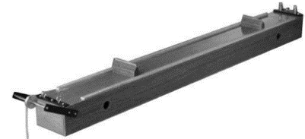

2021 Question 14 (d) [Ordinary Level]
Sounds are produced when something vibrates.
- What is the unit of sound intensity level?
- Resonance is the transfer of energy between two bodies with the same natural frequency.
Describe an experiment to demonstrate resonance.
- A sonometer, shown above, can be used to investigate the relationship between the frequency of a stretched string and its length. State this relationship.

Waves on a stretched string travel at a speed of 380 m s⁻¹.
When a stationary wave is set up on a string, the distance between two adjacent nodes is 40 cm.
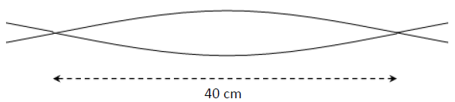
- Calculate the wavelength of the wave.
- Calculate the frequency of the wave.

2022 Question 10 [Ordinary Level]
When a person sings, their vocal chords vibrate. These vibrations travel through the air to the listener’s ears.

- Sound is an example of a mechanical wave which therefore needs a medium to travel through.
Describe an experiment to show that sound is a mechanical wave.
- Sound is also an example of a longitudinal wave. What is a longitudinal wave?
- Sound waves can undergo reflection, refraction, diffraction and interference.
A doorway may cause a sound wave to diffract but it will not cause a light wave to do so. Explain why.
- Describe an experiment to show that sound waves undergo interference.
- Sound waves do not undergo polarisation but light waves do. What is meant by polarisation?
- The human ear is most sensitive to sounds with frequencies between 2 kHz and 4 kHz.
One reason for this is that sounds in this range can cause resonance to occur in the ear canal.
What is meant by resonance?
- The ear canal can be thought of as a pipe open at one end.
Draw a labelled diagram to show the first position of resonance for a sound wave in a pipe open at one end.
- The frequency of a sound wave is 2800 Hz and it has a wavelength of 0.12 m.
Calculate the speed of the wave.

2023 Question 10 [Ordinary level]
The source of every sound is a vibration. Sound travels as a wave.
As a sound wave moves it interacts with its environment in four ways, one of which is reflection.

- What is meant by reflection?

- Sound also undergoes refraction as it moves from one medium to another.
What causes sound to refract as it moves from one medium to another?

- When two sound waves meet they can undergo interference.
Describe a laboratory experiment to show that sound waves undergo interference.

- Sounds waves can undergo diffraction as they pass through a doorway or a window.
This is why we can hear around corners.
What is meant by diffraction?

- Light waves can undergo polarisation but sound waves cannot.
Why do sound waves not undergo polarisation?

A standing wave is set up on a string as shown so that the distance between points A and B is 45 cm.
The waves on the string are travelling with a speed of 400 m s^{–1}.

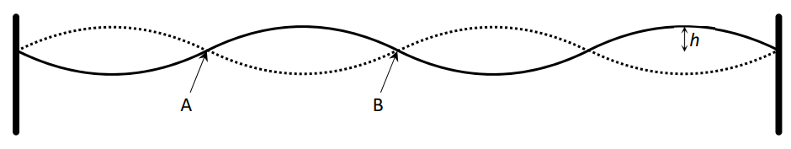
- What name is given to points A and B?
- What name is given to height h?
- Calculate the wavelength of the wave.
- Calculate the frequency of the wave.

2005 Question 12 (c) [Higher Level]
- The frequency of a stretched string depends on its length.
Give two other factors that affect the frequency of a stretched string.
- The diagram shows a guitar string stretched between supports 0.65 m apart.
The string is vibrating at its first harmonic. The speed of sound in the string is 500 m s^{–1}. What is the frequency of vibration of the string?
- Draw a diagram of the string when it vibrates at its second harmonic.
- What is the frequency of the second harmonic?

2011 Question 8 (a) [Higher Level] (speed of sound = 340 m s⁻¹)
Destructive interference can occur when waves from coherent sources meet.
- Explain the underlined term.
- Give two other conditions necessary for total destructive interference to occur.
- The diagram shows a standing wave in a pipe closed at one end.
The length of the pipe is 90 cm.
Name the points on the wave labelled P and Q.
- Calculate the frequency of the standing wave.
- What is the fundamental frequency of the pipe?
- The clarinet is a wind instrument based on a pipe that is closed at one end. What type of harmonics is produced by a clarinet?

2022 Question 11 [Higher level]
The earliest harps and lyres were produced in the Bronze Age.
Different strings in a lyre may have different lengths, different tensions and different diameters.
- Draw a labelled diagram to represent a stretched string vibrating at its third harmonic.
- A 65 cm string of mass 0.21 g is stretched between two points of a lyre which are 34.1 cm apart.
It is required to vibrate at a fundamental frequency of 440 Hz.
Calculate the tension that is applied to the string.
- Determine the frequency of the string if the tension is now reduced by a factor of four.

2013 Question 7 [Higher Level] (speed of sound = 340 m s⁻¹)
- What is meant by the term resonance?
- How would resonance be demonstrated in the laboratory?
- A set of wind chimes, as shown in the diagram, is made from different lengths of hollow metal tubing that are open at both ends. When the wind blows, the wind chimes are struck by a clapper and emit sounds.
The sound from one of the tubes was analysed.
The following frequencies were identified in the sound: 550 Hz, 1100 Hz and 1651 Hz.

- What name is given to this set of frequencies?
- Draw labelled diagrams to show how the tube produces each of these frequencies.
- The length of the metal tube is 30 cm.
Use any of the above frequencies to calculate a value for the speed of sound in air.
- A sample of wire, of length 12 m and mass 48 g, was being tested for use as a guitar string.
A 64 cm length of the wire was fixed at both ends and plucked. The fundamental frequency of the sound produced was found to be 173 Hz. Calculate the tension in the wire.

2015 Question 9 [Higher Level]
Musical instruments produce stationary (standing) waves.
Resonance also occurs in many instruments.
- What are stationary waves? How are they produced?
- What is resonance?
- Describe a laboratory experiment to demonstrate resonance.
A guitar is a string instrument.
The frequency of a stretched string depends on the tension of the string and on two other factors.
- What are the two other factors?
- What effect does increasing the tension of the string from 36 N to 81 N have on the frequency of the string?
- Explain, with the aid of labelled diagrams, why a pipe open at only one end produces half the number of harmonics as a pipe open at both ends.

- A tin whistle consists of a pipe which is open at both ends.
A particular tin whistle has a fundamental frequency of 587 Hz when all of the holes on it are covered.
How long is the pipe?
(speed of sound in air = 340 m s^{–1})

2002 Question 7 [Higher Level]
- “Constructive interference and destructive interference take place when waves from two coherent sources meet.”
Explain the underlined terms in the above statement.
- What is the condition necessary for destructive interference to take place when waves from two coherent sources meet?
- Describe an experiment that demonstrates the wave nature of light.

- Radio waves of frequency 30 kHz are received at a location 1500 km from a transmitter.
The radio reception temporarily “fades” due to destructive interference between the waves travelling parallel to the ground and the waves reflected from a layer (ionosphere) of the earth’s atmosphere, as indicated in the diagram.
Calculate the wavelength of the radio waves.

- What is the minimum distance that the reflected waves should travel for destructive interference to occur at the receiver?

- The layer at which the waves are reflected is at a height h above the ground.
Calculate the minimum height of this layer for destructive interference to occur at the receiver.
(speed of light, c = 3.0 × 10⁸ m s⁻¹)

The Doppler effect – sound waves
2012 Question 12 (c) [Ordinary Level]
The pitch of the sound emitted by the siren of a moving fire engine appears to change as it passes a stationary observer.
- Name this phenomenon.
- Explain, with the aid of a diagram, how this phenomenon occurs.
- Will the crew in the fire engine notice this phenomenon?
- Give a reason for your answer.
- Give an application of this phenomenon.

2017 Question 8 [Ordinary Level]
Frequency and wavelength are properties associated with waves.
- What is meant by the frequency of a wave?
- State the relationship between the frequency of a wave and its wavelength.

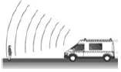
The diagram shows a person standing near an ambulance as it approaches with its siren on. As the ambulance passes, the person observes a change in the frequency of the siren.
- What name is given to this effect?
- Explain, with the aid of a labelled diagram, how this phenomenon occurs.
- Name one practical application of this phenomenon.

An electrical storm is seen before it is heard.
- What does this indicate about the difference between sound waves and light waves?
- State one other difference between sound waves and light waves.

When timing a 100 m sprint, a person stands at the finishing line and starts the stopwatch when he hears the starting gun fired at the starting line.
- Calculate the difference in time the runner would receive if the stopwatch was started at exactly the same time as the starting gun was fired, i.e. without any delay caused by the time taken for the sound to travel 100 m.

2016 Question 12 (c) [Higher Level]
{I have deleted parts of this question which deal with Circular Motion; those sections appear in the “Circular Motion and SHM” long questions}
- What is meant by the Doppler effect?
A buzzer moves at a speed of 13 m s^{–1} in a vertical circle.
The buzzer emits a note of frequency 1.1 kHz.
An observer stands in the plane of motion of the buzzer, as shown in the diagram.
- Calculate the maximum and minimum frequency of the note detected by an observer
(speed of sound in air = 340 m s^{–1})

2008 Question12 (b) [Higher Level]
- The pitch of a musical note depends on its frequency.
- On what does (i) the quality, (ii) the loudness, of a musical note depend?
- What is the Doppler Effect?
- A rally car travelling at 55 m s^{–1} approaches a stationary observer. As the car passes, its engine is emitting a note with a pitch of 1520 Hz. What is the change in pitch observed as the car moves away?
{The wording here is confusing; the question is looking for the difference between the car’s actual frequency and its apparent frequency as the car moves away)}
- Give an application of the Doppler Effect.
2014 Question 10 {first half} [Higher Level]
- What is the Doppler effect?
- Explain, with the aid of labelled diagrams, how the Doppler effect occurs.
- An ambulance siren emits a sound of frequency 750 Hz.
When the ambulance is travelling towards an observer, the frequency detected by the observer is 820 Hz.
What is the speed of the ambulance?
- State two other practical applications of the Doppler effect.
(speed of sound in air = 340 m s^{–1})

2021 Question 14 (b) [Higher Level]
Hydroacoustics is the study of sound in water. The Doppler effect is observed in hydroacoustics.
- What is the Doppler effect?
- Describe how the Doppler effect can be demonstrated in the laboratory.
- A moving underwater source emits a sound of frequency 800 kHz while travelling towards an underwater detector, which detects a frequency of 806 kHz.
Calculate the speed of the source.
- Sound travels faster in water than in air. When a sound wave travels from water into air, it undergoes refraction.
Draw a ray diagram to show the refraction of a sound wave as it travels from water into air.
(speed of sound in water = 1480 m s^{–1})

Question 14 (b) Higher Level 2023
A speaker emits a sound of fixed frequency. The speaker is moving at a constant velocity
towards an observer. The observer hears a frequency which is 20% greater than the frequency emitted.
- Name the effect which causes this increase in frequency.
- Calculate the speed of the speaker.
- Red shift in astronomy is also due to this effect. What does red shift tell us about our universe?
speed of sound in air = 340 m s^{–1}

2022 Question 14 (b) [Higher level]
- What is the Doppler effect?
- Describe, with the aid of labelled diagrams, how the Doppler effect occurs.
- Pierre drops a child’s toy which emits sound of fixed frequency 500 Hz from the top of the Eiffel tower.
Calculate the frequency Pierre observes after 3 seconds.
(speed of sound in air = 340 m s^{–1};
acceleration due to gravity = 9.8 m s^{–2})

2003 Question 7 [Higher Level]
- Describe an experiment to show that sound is a wave motion.
- What is the Doppler Effect?
- Explain, with the aid of labelled diagrams, how this phenomenon occurs.
- Bats use high frequency waves to detect obstacles. A bat emits a wave of frequency 68 kHz and wavelength 5.0 mm towards the wall of a cave. It detects the reflected wave 20 ms later.
Calculate the speed of the wave and the distance of the bat from the wall.
- If the frequency of the reflected wave is 70 kHz, what is the speed of the bat towards the wall?
- Give two other applications of the Doppler Effect.

2017 Question 7 {last 2 parts} [Higher Level]
- Speed cameras use the Doppler effect to calculate the speed of vehicles.
Describe, with the aid of a labelled diagram, how the Doppler effect occurs.

- A source that is emitting a sound wave of a certain frequency is approaching an observer.
The frequency observed is 15% more than the frequency of the sound wave emitted.
What is the speed of the source?
(speed of sound in air = 340 m s^{–1})

2020 Question 12 (c) [Higher level]
Speed cameras make use of the Doppler effect.
- What is the Doppler effect?
- Explain, with the aid of labelled diagrams, how the Doppler effect occurs.

- A source of sound approaches a stationary observer.
The source appears to have a frequency that is 20% greater than its frequency at rest.
Calculate the speed of the source.
- The Doppler effect is also used to detect the red‐shift of galaxies.

- What does the red‐shift tell us about the universe?
(speed of sound in air = 340 m s^{–1})

Interference of sound
2005 Question 12 (b) [Ordinary Level]
- What is meant by (i) diffraction, (ii) interference, of a wave?
- In an experiment, a signal generator was connected to two loudspeakers, as shown in the diagram. Both speakers are emitting a note of the same frequency and same amplitude.

- A person walks along the line XY.
Describe what the person hears.
- What does this experiment demonstrate about the nature of sound?
- What is meant by the amplitude of a wave?

2013 Question 8 [Ordinary Level]
- What is meant by the frequency of a wave?
- Give the relationship between the frequency and the wavelength of a wave.
- The diagram shows a student walking in front of two loudspeakers along the path between A and B.
A signal generator set at 500 Hz is connected to the loudspeakers.

- What will the student notice as he moves from A to B?
- Name this phenomenon.
- Explain with the aid of a diagram how this phenomenon occurs.
- Why should this phenomenon be taken into account in the placing of speakers in theatres or auditoriums?

The note produced by a guitar string depends on the fundamental frequency of the string.
The quality of the note depends on the number of overtones produced.
The loudness of a note is increased by resonance in the body of a guitar.
- Explain the underlined terms.
- How can the note produced by a guitar string be changed?
- What is resonance?

2008 Question 8 [Ordinary Level]
The diagram shows a signal generator connected to two loudspeakers emitting the same note.
A person walks slowly along the line AB.
- What will the person notice?
- Why does this effect occur?
- What does this tell us about sound?
- Describe an experiment to demonstrate that sound requires a medium to travel.
- The pitch of a note emitted by the siren of a fast moving ambulance appears to change as it passes a stationary observer.
Name this phenomenon.
- Explain how this phenomenon occurs.
- Give an application of this phenomenon.

2019 Question 7 [Ordinary Level]

When a musician moves his fingers up and down the strings of a guitar, the frequency of the note changes. When the strings are at their longest, the note heard has a low frequency. The characteristics of a musical note are pitch, loudness and quality.
- Which of these characteristics can be quantified as a frequency?
- Name the property of a wave that affects its loudness.
- When the musician plays the A string on his guitar, the frequency of the note is 110 Hz.
The speed of sound in air is 340 m s^{‐1}. What is the wavelength of the note?
- Describe an experiment to show that sound cannot travel through a vacuum.
The frequency of a sound wave appears to change when it moves past a stationary observer. This phenomenon is called the Doppler effect.
- Describe how to demonstrate the Doppler effect in a laboratory.
- Sound can be described as a longitudinal wave, whereas light is a transverse wave.
Distinguish between a longitudinal wave and a transverse wave.
A labelled diagram may help your answer.
- Waves can undergo reflection, refraction, diffraction, interference and polarisation. While light waves can undergo all five of these wave phenomena, sound waves can only undergo four of them.
Which one of these phenomena do sound waves not undergo?
Explain why.

2020 Question 9 [Ordinary Level]
Light travels as a wave of electromagnetic radiation. The colour of the light depends on its
frequency.
- Light is an example of a transverse wave. Explain what is meant by a transverse wave.
(A labelled diagram may help your answer.)
- Orange light has a frequency of 5 × 10¹⁴ Hz. The speed of light is 3 × 10⁸ m s^{–1}.
Calculate the wavelength of the orange light.
- Sound also travels as a wave. Sound is an example of a mechanical wave.
Describe an experiment to show that sound needs a medium to travel through.
- Sound waves undergo reflection, refraction, diffraction and interference.
What is meant by reflection?
- Describe an experiment to show the interference of sound waves.
- Sound waves do not undergo polarisation. Explain why.
- As an ambulance passes a stationary observer, its siren emits a sound of a particular frequency.
This frequency appears to change as the ambulance passes the observer.
This is caused by the Doppler effect.
Describe a laboratory experiment to demonstrate the Doppler effect.
- State one use of the Doppler effect.

2022 Question 10 [Ordinary Level]
When a person sings, their vocal chords vibrate. These vibrations travel through the air to the listener’s ears.
- Sound is an example of a mechanical wave which therefore needs a medium to travel through.
Describe an experiment to show that sound is a mechanical wave.
- Sound is also an example of a longitudinal wave. What is a longitudinal wave?
- Sound waves can undergo reflection, refraction, diffraction and interference.
A doorway may cause a sound wave to diffract but it will not cause a light wave to do so. Explain why.
- Describe an experiment to show that sound waves undergo interference.
- Sound waves do not undergo polarisation but light waves do. What is meant by polarisation?
- The human ear is most sensitive to sounds with frequencies between 2 kHz and 4 kHz.
One reason for this is that sounds in this range can cause resonance to occur in the ear canal.
What is meant by resonance?
- The ear canal can be thought of as a pipe open at one end.
Draw a labelled diagram to show the first position of resonance for a sound wave in a pipe open at one end.
- The frequency of a sound wave is 2800 Hz and it has a wavelength of 0.12 m.
Calculate the speed of the wave.

Frequency and tension

2020 Question 9 [Higher level]
A guitar string has length 2 m and mass 0.88 g. It is stretched across two fixed points which are 65.1 cm apart on a guitar. It is then plucked and it vibrates at a fundamental frequency of 330 Hz.
- Draw a labelled diagram to show a guitar string vibrating at its fundamental frequency.
- Calculate the tension in the string.
- Calculate the speed of sound in the string.

Question 8 Higher Level 2023

The strings of a guitar can be plucked so that they vibrate at certain frequencies.
The guitar and the air inside it also vibrate due to resonance.
- What is resonance?
- Describe a laboratory experiment to demonstrate resonance.
- The frequency f of a stretched string depends on its length l, tension T and linear density (mass per unit length) μ.
For each of the following pairs of variables, sketch a suitable graph to show the relationship between them.
  - f and T (b) f and l (c) f and μ

- For each of the following variables, state the effect on the frequency f if the variable is increased by a factor of four.
  - T (b) l (c) μ
A string is stretched between two fixed points which are 62 cm apart. The string vibrates with a
number of different harmonics. The speed of sound in the string is 380 m s^{–1}.
- What are harmonics?
- Draw a diagram to show the string vibrating at its third harmonic.
- Calculate the frequency of the string when it is vibrating at its third harmonic.

Sound intensity
2016 Question 7 [Ordinary Level]
- Sound and light travel as waves.
Sound travels as a longitudinal wave whereas light travels as a transverse wave.
Explain the underlined terms.
- Describe a laboratory experiment which demonstrates that sound requires a medium to travel through.
- Total internal reflection is the basis of operation of optical fibres.
With the aid of a labelled diagram, explain how total internal reflection occurs.
- State two uses of optical fibres.
- The refractive index of a material in an optical fibre is 1.44.
Calculate the minimum angle at which light can strike the sides of the fibre and still be transmitted through the fibre.
- The picture shows a sound-level meter, which is used to measure sound intensity level.What is the unit of sound intensity level?
- Why might a sound-level meter be used in a workplace?

2011 Question 8 (b) [Higher Level]
An audio speaker at a concert emits sound uniformly in all directions at a rate of 100 W.
Calculate the sound intensity experienced by a listener at a distance of 8 m from the speaker.
The listener moves back from the speaker to protect her hearing.
At what distance from the speaker is the sound intensity level reduced by 3 dB?

2007 Question 12 (b) [Higher Level]
- Define sound intensity.
- A loudspeaker has a power rating of 25 mW.
What is the sound intensity at a distance of 3 m from the loudspeaker?
- The loudspeaker is replaced by a speaker with a power rating of 50 mW.
What is the change in the sound intensity?
- What is the change in the sound intensity level?
- The human ear is more sensitive to certain frequencies of sound.
How is this taken into account when measuring sound intensity levels?

Question 14 (b) Higher Level 2023
A fixed speaker of power P is emitting sound. At a certain distance from the speaker, an observer can measure both the sound intensity and the sound intensity level due to the speaker.
- Distinguish between sound intensity and sound intensity level.
- The speaker of power P is replaced by a speaker of power 4P.
Calculate the increase in sound intensity level measured.

2018 Question 7 [Higher Level]
- Resonance is a phenomenon that is associated with musical instruments. What is resonance?
- Describe an experiment to demonstrate resonance.
- A stretched string of a violin has a length of 328 mm and a mass of 0.126 g.
The string emits a note of 660 Hz when it vibrates at its fundamental frequency.
Calculate the tension in the string,
- Calculate the speed of sound in the string.
- Draw a labelled diagram to represent the fundamental frequency of a stationary wave in a pipe that is closed at one end.
- Define sound intensity.
- A source emits sound in all directions.
Describe the effect of doubling the distance from the source to an observer on the sound intensity measured.
- Describe the effect of doubling the distance from the source to an observer on the sound intensity level measured.

Resonance and Characteristics of a musical note

2015 Question 7 [Ordinary Level]
- Explain the term resonance.
- Describe a laboratory experiment to demonstrate resonance.
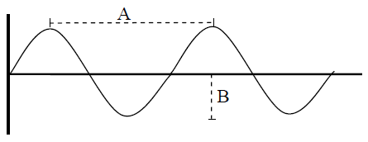
The diagram shows a waveform.
- What is length A called?
- What is length B called?
- What is meant by the frequency of a wave?
- List three characteristics of a musical note.

- What is meant by the term natural frequency of an object?
- The natural frequency of a stretched string is 250 Hz.
Calculate the wavelength of the sound wave produced.
(speed of sound in air = 340 m s⁻¹)

2011 Question 12 (b) [Ordinary Level]
- Loudness, pitch and quality are characteristics of a musical note.
Name the physical property of a sound wave on which each characteristic depends.
- A bat detector allows us to hear the sounds emitted by bats. The detector is needed as humans cannot hear the sounds emitted by bats as they are outside our frequency limits of audibility.
What is meant by the frequency limits of audibility?
- What name is given to a sound whose frequency is greater than our upper frequency limit of audibility?
- A bat emitted a sound wave and detected its reflection from a wall 0.02 s later.
Calculate the distance of the bat from the wall.
(speed of sound in air = 340 m s⁻¹)

2010 12 (c) [Higher Level]
- Explain the term resonance and describe a laboratory experiment to demonstrate it.
- Give two characteristics of a musical note and name the physical property on which each characteristic depends.
- Explain why a musical tune does not sound the same when played on different instruments.

The wave nature of light

$$nλ=d sin{ϑ}$$
2009 Question 7 [Ordinary Level]
- In an experiment a beam of monochromatic light passes through a diffraction grating and strikes a screen.
Explain the underlined terms.
- Describe what is observed on the screen.
- Explain, with the aid of a diagram, how this phenomenon occurs.
- What does this experiment tell us about the nature of light?
- Name the property of light that can be determined in this experiment.
- What measurements must be taken to determine the property you named?

2022 Question 13 [Higher level, first half]
- Diffraction is one of the wave properties of light.
What is meant by diffraction?
- Draw a labelled diagram of an experiment to demonstrate the wave nature of light.
- What is observed in this experiment?
- How do the observations demonstrate the wave nature of light?
- The eyepiece lens of Huygens’ telescope was a converging lens arranged so as to produce a virtual image. Draw a ray diagram to show how a converging lens can produce a virtual image.

2005 Question 7 [Higher Level]
A student used a laser, as shown, to demonstrate that light is a wave motion.
- Name the two phenomena that occur when the light passes through the pair of narrow slits.
- A pattern is formed on the screen. Explain how the pattern is formed.
- What is the effect on the pattern when the wavelength of the light is increased?
- What is the effect on the pattern when the distance between the slits is increased?
- Describe an experiment to demonstrate that sound is also a wave motion.
- Sound travels as longitudinal waves while light travels as transverse waves. Explain the difference between longitudinal and transverse waves.
- Describe an experiment to demonstrate that light waves are transverse waves.

2009 Question 7 [Higher Level]
- When light shines on a compact disc it acts as a diffraction grating causing diffraction and dispersion of the light. Explain the underlined terms.
- Derive the diffraction grating formula.
- An interference pattern is formed on a screen when green light from a laser passes normally through a diffraction grating. The grating has 80 lines per mm and the distance from the grating to the screen is 90 cm. The distance between the third order images is 23.8 cm.
Calculate the wavelength of the green light.
- Calculate the maximum number of images that are formed on the screen.
- The laser is replaced with a source of white light and a series of spectra are formed on the screen.
Explain how the diffraction grating produces a spectrum.
- Explain why a spectrum is not formed at the central (zero order) image.

2014 Question 7 [Higher Level]
- What is meant by the terms (i) diffraction and (ii) interference?
A laser produces a beam of red light with a wavelength of 709 nm. The beam is incident on a diffraction grating, as shown in the diagram. A diffraction pattern is formed on a screen. A second order image is detected at an angle of 34.6° from the central image.

- Calculate the energy of each photon in the laser beam. {Ignore this part until after you cover Atomic Physics}
- Sensors in the eye can respond to single photons. Where in the eye are these sensors located?
- State two differences between the electromagnetic radiation emitted from a laser and the electromagnetic radiation emitted from a vapour lamp.
- Derive, with the aid of a labelled diagram, the diffraction grating formula.
- Calculate the number of lines per millimetre on the grating used in the experiment.
- What would be observed on the screen if the laser was replaced by a ray of white light?

2013 Question 12 (b) [Higher Level]
- A narrow beam of light undergoes dispersion when it passes through either a prism or a diffraction grating.
What is meant by dispersion?
- Give two differences between what is observed when a narrow beam of light undergoes dispersion as it passes through a prism, and what is observed when a narrow beam of light undergoes dispersion as it passes through a diffraction grating.
- Give another example of light undergoing dispersion.
- Yellow light of wavelength 589 nm is produced in a low-pressure sodium vapour lamp.
What causes the sodium atoms to emit this light?
- Calculate the highest order image that could be produced when a beam of light of this wavelength is incident perpendicularly on a diffraction grating that has 300 lines per mm.

2017 Question 9 {last 2 parts} [Higher Level]
- Draw a labelled diagram of a spectrometer and describe how a spectrometer and diffraction grating can be used to observe (i) a line spectrum and (ii) a continuous spectrum.

- Sodium emits visible light with a wavelength of 589 nm. This light is passed through a diffraction grating of 300 lines per mm.
Calculate the angular separation between the first line to the left of the central image and the first line to the right of the central image.

2019 Question 10 [Higher Level]
- Explain the terms diffraction and interference.

In 1801 Thomas Young performed an experiment to demonstrate that light is a wave.
He passed monochromatic light through two narrow slits and observed a series of bright and dark fringes on a screen.
- Explain, with the aid of a labelled diagram, how a series of bright and dark fringes were produced.
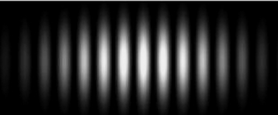
- How does this experiment demonstrate that light is a wave?

The experiment was repeated in the school laboratory.
The slits were 0.5 mm apart and were placed at a distance of 1.25 m from the screen. The distance across 13 bright fringes on the screen was found to be 1.65 cm.
- Calculate the wavelength of the monochromatic light.
- List two adjustment to the apparatus that could be made to increase the distance between the bright fringes.

Young was a polymath with many other interests, including the deciphering of Egyptian hieroglyphs, discovery of the purpose of the ciliary muscle in the eye, and the invention of the Young temperament which made use of harmonics to tune musical instruments.

- When the ciliary muscles contract the lens in the eye becomes thinner. What effect does this have on the power of the lens?
A certain musical instrument can be modelled as a cylindrical pipe that is closed at one end and whose length can be changed. The air column in the pipe vibrates at a frequency of 512 Hz.
- Draw diagrams to show the first two harmonics of this instrument.
- The lengths of the pipe at the first two positions of resonance are 16.7 cm and 49.8 cm.
Calculate the wavelength of the sound wave.
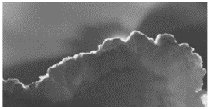
- Calculate the speed of sound in air.

2021 Question 8 [Higher Level]
The bright outline along the edge of a cloud – the ‘silver lining’– is an example of the diffraction of light in nature.
Diffraction is a wave phenomenon.
- What is meant by diffraction?
- A diffraction experiment can be used to demonstrate the wave nature of light. Describe such an experiment.
- What is a diffraction grating?
- Derive the diffraction grating formula, nλ = dsinθ.
- Calculate the angular separation between the two 3rd order images formed when blue light of wavelength 442 nm is incident on a diffraction grating of 600 lines per mm.
- Calculate the distance between these images on a screen placed 50 cm from the grating.
- What changes would be observed if the blue light was replaced with red light?
- What changes would be observed if the blue light was replaced with white light?
- Compare the wavelengths of radio waves with those of visible light.
- Why are radio waves not observed to undergo diffraction when incident on a diffraction grating of 600 lines per mm?

Dispersion of light

2015 Question 12 (b) [Ordinary Level]
- What is meant by dispersion of light?
- What does dispersion of light indicate about the nature of white light?
- Name two laboratory techniques that can be used to cause dispersion of light.
- Describe one example of dispersion of light occurring in nature.
- The diagram shows stage lighting similar to that found in most theatres.
Only red, green and blue lights are needed to create all the colours needed on stage.
Explain why this is so.

2010 Question 12 (b) [Ordinary Level]
- What is meant by dispersion of light?
- Describe an experiment to demonstrate the dispersion of light.
- Give an example of the dispersion of light occurring in nature.
- Only red, green and blue lights are needed to create most lighting effects.
Explain why

2012 Question 7 [Ordinary Level]
- Under certain conditions, light can undergo diffraction and interference.
Explain the underlined terms.
- Describe an experiment to demonstrate the wave nature of light.
- The photograph shows Polaroid sunglasses which reduce glare caused by sunlight.
Explain the term ‘polarisation’.
- Describe an experiment to demonstrate the polarisation of light.
- What type of wave motion does light have as indicated by the experiment in part (iv)?
- Why are Polaroid sunglasses more effective than non-Polaroid sunglasses at reducing glare?

2007 Question 8 [Ordinary Level]
Dispersion occurs when a beam of white light passes through a prism forming a spectrum on a screen, as shown in the diagram.
- What is meant by the terms dispersion and spectrum?
- What happens to the white light when it enters the prism at Z?
- Name the invisible radiation formed on the screen at (i) region X, (ii) region Y.
- Describe how to detect one of these invisible radiations.
- Give a use for one of these invisible radiations.
- The colour on a TV screen is made by mixing the primary colours.
Name the primary colours.
- How is a secondary colour (e.g. yellow) produced on a TV screen?

2018 Question 8 [Ordinary Level]
Diffraction and interference are properties associated with waves.
  - Explain the underlined terms.
  - Describe an experiment to demonstrate the wave nature of light.

The photograph shows a liquid crystal display (LCD) monitor, which may require a polaroid panel to allow the image on the screen to be seen clearly.
  - What is meant by polarisation?
  - Describe an experiment to demonstrate the polarisation of light.
  - Monitors of the kind shown use only three colours to form any image.
What three colours are used?
  - Describe how these colours can be used to create any image.

2016 Question 11 [Ordinary Level]
Read this passage and answer the questions below.
Experimentum crucis
Once he returned to Cambridge from the country in 1667, Newton began to gain honours with startling rapidity and became the second holder of the Lucasian Professorship in Mathematics, a position later held by Stephen Hawking. This new job obliged Newton to give occasional lectures but he was
also able to spend much more time on experiments.
To isolate a single colour (or at least what the eye sees as a colour – a spectrum in fact consists of an innumerable range of colours, each blending into the next), he put a card with a hole in it next to a prism, only letting through a narrow band of light. Not only did he confirm his view that when this beam was passed through a second prism no different colours were produced – red light remained red, blue remained blue and so on – he discovered that red coloured light was bent much less by the prism than blue light. The degree of bending, the refraction, varied as he moved through the different colours.
He later referred to this discovery as the experimentum crucis, the crucial experiment, emphasising its significance as a turning point in the understanding of the nature of light. He had found something fundamental and new - that light was made up of colours that were distinct entities, impossible to change from one into the other, each bent differently by a prism. For good measure, his experiment explained why a prism worked at all. When a beam of light hit an ordinary block of glass there was no rainbow produced. As the light passed from air to glass it was true that the blue light would bend further than the red, splitting it out, but when it reached the far side of the block it would move back the other way an equal amount and the result would be to recombine the colours. The prism’s triangular faces meant that the two opportunities to bend - towards the vertical of the first face and away from the vertical of the second - both resulted in movement in the same direction. The colours remained separate.
(Adapted from Light Years - The Extraordinary Story of Mankind’s Fascination with Light,
Brian Clegg, Icon Books, 2015)
  - What word is used to describe the bending of light by a prism?
  - What does the spectrum of light consist of?
  - Which colour of light is bent the most?
  - Draw a diagram to show how a spectrum can be produced using a prism.
  - What was the significance of Newton’s experiment?
  - Without using a prism, how else can a spectrum be produced?
  - Why is a spectrum not produced by an ordinary block of glass?
  - Name another field of physics for which Newton is famous.

2021 Question 8 [Ordinary Level]
A wave can be described as a travelling disturbance that transports energy from one point to another.
- Describe an experiment to show that sound waves need a medium to travel through.
- What type of waves do not need a medium to travel through?
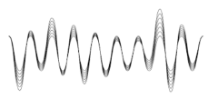
- Waves can be classified as either transverse or longitudinal.
Distinguish between transverse and longitudinal waves. (A labelled diagram may help your answer.)
- The frequency of a certain radio station is 107 MHz.
It broadcasts waves of length 2.804 m. Calculate the speed of the radio waves.

Light and sound waves both display the properties of reflection, refraction, diffraction and interference.
- Describe one example of the reflection of sound waves.
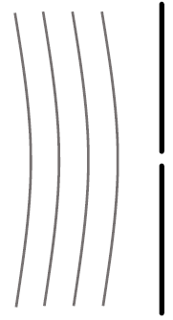
- Light strikes a glass block with an angle of incidence of 23°. The light undergoes refraction as it travels from the air into the glass. The angle of refraction is 15°.
Calculate the refractive index of the glass.
- The wave fronts shown below diffract as they pass through the gap.
Copy and complete the diagram to show this wave undergoing diffraction.
- Describe an experiment to show that sound undergoes interference.
- Light waves undergo polarisation but sound waves do not.
Explain with the aid of a labelled diagram what is meant by polarisation.

2017 Question 7{first part} [Higher Level]
Colour filters and polarising filters can be used to enhance photographs.
We see objects because light reflects from them.
- What is reflection?
- What primary colours of light (i) are absorbed and (ii) are reflected when white light shines on a red book?
- What colour would the red book appear to be if colour filters were used so that the book was illuminated (iii) with green light and (iv) with red light?
- What is polarisation?
- Describe how polarisation can be demonstrated in the laboratory.
- Give an application of stress polarisation.

2013 Question 12 (b) [Higher Level]
The diagram shows a beam of white light undergoing refraction and dispersion as it passes through a prism.
- What is meant by dispersion?
- What is observed on the screen between X and Y?
- What information does dispersion give about the nature of white light?
- Give another method for the dispersion of light.
- Give an everyday example of the dispersion of light.

2022 Deferred examination Question 14 (b)
- State Snell’s law of refraction.
A ray of blue light with a wavelength of 480 nm in air is incident on a rectangular glass block, as shown in the diagram.
- Calculate the refractive index of the glass for blue light.
- Calculate the speed of this light in the glass.
- Calculate the wavelength of this light in the glass.
- A ray of red light, incident at the same point on the glass block, takes a different path in the block.
Explain why this is happens.

The electromagnetic spectrum

2008 Question 12 (b) [Ordinary Level]
Sunlight is made up of different colours and invisible radiations.
- How would you show the presence of the different colours in light?
- Name two radiations in sunlight that the eye cannot detect.
- Describe how to detect one of these radiations.
- Give a use for this radiation.

2018 Question 12 (b) [Ordinary Level]
Sunlight is made up of visible light of different colours as well as many types of invisible radiation.
- How could you show the different colours present in visible light?
- UV radiation is also present in sunlight.
- What do the letters U and V stand for?
- Compare the wavelength of UV radiation to the wavelength of infra‐red (IR) radiation.
- Describe how to detect UV radiation.
- State one use of UV radiation.

2006 Question 12 (b) [Ordinary Level]
The diagram shows the relative positions of electromagnetic radiations in terms of their wavelength.
gamma rays | A | UV | light | IR | microwaves | B
(i) Name the radiations marked A and B.
(ii) Give one property which is common to all electromagnetic radiations.
(iii) Which one of the radiations has the shortest wavelength?
(iv) Describe how IR radiation is detected.
- Give one use for microwaves.

2003 Question 12 (b) [Ordinary Level]
- Name two primary colours.
- What are complementary colours?
- White light is made up of light of different colours. Describe an experiment to demonstrate this.
- The diagram shows a simple form of the electromagnetic spectrum, with wavelength increasing from left to right.
Copy this diagram and indicate on it the positions of the following:
microwaves; infrared; ultraviolet; X-rays.

2002 Question 7 [Ordinary Level]
- The dispersion of white light can be produced by refraction or diffraction. Explain the underlined terms.
- Describe an experiment to demonstrate the dispersion of white light.
- The following table gives examples of electromagnetic waves and their typical wavelengths.

- Name one property that all of these waves have in common.
- What is the frequency of the radio waves? The speed of light is 3 × 10⁸ m s⁻¹.
- Describe how infrared radiation can be detected.
- Give two uses of microwaves.

2022 Question 13 [Ordinary Level]
Read the following passage and answer the questions below.

Eclipses are among the most spectacular events in astronomy as they are events we can view without a telescope.

Total solar eclipses are the most dramatic of all eclipses.
This is when the light from the Sun gets blocked by the Moon for a few minutes and day turns quickly into night.
A lunar eclipse, when the Earth's shadow covers the Moon, is a gentler event. The full Moon gradually becomes fainter and redder over a period of a couple of hours. Both types of eclipse can be either total or partial. In a total eclipse, the Earth or the Moon gets completely in the way, while in a partial eclipse only a part of either the Earth or the Moon is in shadow.

Lunar eclipses are far more common than solar eclipses. This is because the Earth’s shadow is bigger than the Moon’s shadow. At the same time as the Earth’s shadow blocks the Moon, some of the light from the Sun will pass through the Earth’s atmosphere and then onto the Moon. The Sun’s light is refracted as it passes through the Earth’s atmosphere. The refracted light is then dispersed into the colours of the rainbow. These processes result in the Moon appearing red. A rather spectacular version of an eclipse is a Super Blood Moon. This happens when there is an eclipse of the full Moon when it is at its closest to the Earth.

Solar eclipses happen when the Sun, Moon and Earth line up exactly. Total solar eclipses are very rare and only occur when all of the light from the Sun is blocked by the Moon. The last total solar eclipse visible from Ireland was in 1727 and the next one won’t be until 2090.
Adapted from: rte.ie

- Describe what happens during a solar eclipse.
- Lunar eclipses are more common than solar eclipses. Explain why.
- The light from the Sun is refracted as it passes through the Earth’s atmosphere.
Explain what is meant by refraction.
- Name two pieces of laboratory equipment that can be used to disperse light.
- The Moon has a mass of 7.3 × 10²² kg and a radius of 1.7 × 10⁶ m.
Calculate g, the acceleration due to gravity on the Moon.
- An astronaut weighs less on the Moon than she does on Earth. Distinguish between mass and weight.
- Infrared radiation lies just beyond red light in the electromagnetic spectrum, with a slightly longer wavelength. How can infrared radiation be detected?
- Name the type of electromagnetic radiation that has a slightly shorter wavelength than visible light.

2012 Question 7 [Higher Level]

- The diagram shows a simplified version of the electromagnetic spectrum.
Name the sections labelled A and B in the diagram.
- Describe how to detect each of these radiations.
- An electromagnetic radiation has a wavelength of 4 m.
Name the section of the electromagnetic spectrum in which this radiation is located.
- Distinguish between interference and diffraction.
- Can a diffraction grating which diffracts light also diffract X-rays? Justify your answer.
- Light travels as a transverse wave.
Name another type of wave motion and give two differences between these two types of wave motion.

2010 Question 11 [Higher Level]
Read the following passage and answer the accompanying questions.

A person’s exposure to radiation when using a mobile phone is measured in terms of the Specific Absorption Rate (SAR). This is a measure of the rate at which radio frequency energy is absorbed by a person’s body during a phone call and is expressed in watts per kilogram.
A radio frequency wave penetrates the body to a depth that depends on its frequency. At mobile phone frequencies the wave energy is absorbed by about one centimetre of body tissue. The energy absorbed is converted into heat and is carried away by the body. Any adverse health effects from radio frequency waves are due to heating. Current scientific evidence indicates that exposure to radiation from mobile phones is unlikely to induce cancer.
(Adapted from a Dept. of Communications, Energy and Natural Resources Press Release of 22 March 2007.)

- Give two properties of radio waves.
- In a three-minute phone call, 10 g of head tissue absorbs 0.36 J of radio frequency energy.
Calculate the SAR value.
- What happens to the radio frequency energy absorbed by the body?
- Why are radio frequency waves not very penetrating?
- A mobile phone converts the received radio frequency waves to sound waves.
What are the audible frequency limits for sound waves?
- Give two safety precautions you should take when using a mobile phone.
- A mobile phone transmits at 1200 MHz from its antenna.
Calculate the length of its antenna, which is one quarter of the wavelength that it transmits.
- Name an electromagnetic wave which may induce cancer. Justify your answer.

The Doppler effect – light waves
2007 Question 7 [Higher Level]
- What is the Doppler Effect?
- Explain, with the aid of labelled diagrams, how this phenomenon occurs.
- The emission line spectrum of a star was analysed using the Doppler Effect.
Describe how an emission line spectrum is produced.
- The red line emitted by a hydrogen discharge tube in the laboratory has a wavelength of 656 nm.
The same red line in the hydrogen spectrum of a moving star has a wavelength of 720 nm.
Is the star approaching the earth? Justify your answer.
- Calculate the frequency of the red line in the star’s spectrum.
- Calculate the speed of the moving star.
(speed of light = 3.00 × 10⁸ m s^{–1})

2010 Question 7 [Higher Level]
- What is the Doppler effect?
- Explain, with the aid of labelled diagrams, how this phenomenon occurs.
- Describe a laboratory experiment to demonstrate the Doppler effect.
- What causes the red shift in the spectrum of a distant star?
- The yellow line emitted by a helium discharge tube in the laboratory has a wavelength of 587 nm.
The same yellow line in the helium spectrum of a star has a measured wavelength of 590 nm.
- What can you deduce about the motion of the star?
- Calculate the speed of the moving star.
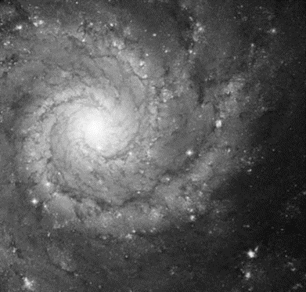
- Give another application of the Doppler effect.

2022 Deferred Question 8 [Higher Level]
- What is the Doppler effect?
- Explain how the Doppler effect occurs.

- The wavelength of the red line in the emission line spectrum of hydrogen was measured in the laboratory as 656 nm. Calculate its frequency.

In the 1920s, American astronomer Edwin Hubble, pictured, used the Doppler effect to study distant galaxies. He found that most galaxies were moving away from Earth.
He also found that the galaxies which were furthest away from Earth were the ones which were moving with the fastest speeds.

- A certain galaxy is moving at a speed of 3 × 10⁷ m s^{–1} away from the Earth.
Astronomers on Earth analysed the light from this galaxy and measured the frequency of the red line in the hydrogen emission line spectrum.
Calculate the frequency they observed.

SOLUTIONS TO ORDINARY LEVEL MATHS QUESTIONS 2002 - 2022

2006 Question 8
Calculate the time taken for the pulse to reach the seabed.
0.2 seconds.
Calculate the depth of water under the ship.
v= s/t ⇒ s = v × t ⇒ s = 1500 × 0.2 = 300 m.
Calculate the wavelength of the sound pulse when its frequency is 50 000 Hz.
c = fλ ⇒ λ = c/f ⇒ λ = 1500/50000 = 0.03 m.

2006 Question 12 (c)
What is the frequency of the wave?
20 Hz
Calculate the velocity of the wave if distance A = 1.5 m.
v = f λ = (20)(1.5) = 30 m s⁻¹

2007 Question 7
Calculate the wavelength of this note.
c = fλ ⇒λ = c/f ⇒ λ = 340/256 = 1.33 m.

2010 Question 7
Calculate the wavelength of the sound wave produced.
v = f λ λ = v/f λ = 340/250 λ = 1.36 m

2011 Question 12 (b)
Calculate the distance of the bat from the wall.
Velocity = distance ÷ time. distance = velocity × time = 340 × .01 = 3.4 m

2014 Question 12 (c)
What is the frequency of the wave?
20 Hz
Calculate the velocity of the wave if distance A = 1.5 m.
v = f λ = (20)(1.5) = 30 m s⁻¹

2015 Question 7
Calculate the wavelength of the sound wave produced.
v = f λ λ = v/f λ = 340/250 λ = 1.36 m

2017 Question 8
Calculate the difference in time the runner would receive
$time=\frac{distance}{speed}=\frac{100}{330}$ = 0.3 s

2019 Question 7
What is the wavelength of the note?
v = f λ $=\frac{v}{f}=\frac{340}{110}=3.09 m$

2019 Question 11
What is the focal length of this lens?
P_{corrected eye} = P_{defective eye} + P_{corrective lens}
38 = 32 + P_{corrective lens}

P_{corrective lens} = 6 m⁻¹ $f=\frac{1}{P}=\frac{1}{6}$ m = 16.7 cm
2020 Question 9
Calculate the wavelength of the orange light.
$c=fλ$ $λ=\frac{c}{f}$ $λ=\frac{3 ×{10}^{8}}{5 × {10}^{14}}$ $λ$ = 6 × 10⁻⁷ m

2021 Question 8
Calculate the speed of the radio waves.
v = f 𝜆 = (107 × 10⁶)(2.804) = 3 × 10⁸ m s⁻¹

2022 Question 10
Calculate the speed of the wave.
2800 × 0.12 = 336 m s^{–1}

Why λ for wavelength? Probably because λ is the Greek version of the letter l (for length).
Another way of defining frequency of a wave is to say it is the number of waves that pass a fixed point per second. This second definition is helpful in explaining the relationship T = 1/f
When a wave travels from one medium to another its frequency does not change Basically if a wave ‘wobbles’ so many times a second in air and then comes in contact with another medium like water, the water will wobble (move in and out) in response to the driving force and therefore it wobbles at the same frequency. The speed however will change, and because speed is directly proportional to wavelength (from v = fλ), if the speed of the wave were to double (and the frequency remain constant) the wavelength would double also. See Question 14 (b) 2022 Deferred Physics exam Higher Level
This effect is only significantly noticeable if the slit is approximately the same size as the wavelength of the waves. So if the slit width is of the order of cm to metres, then sound may well be noticeably diffracted, depending on the frequency of the sound, because the corresponding wavelength is likely to be similar to the slit width. However the same will not happen for light, because the wavelength for light is of the order of 10⁻⁷ metres, which doesn’t correspond to slits that one encounters every day.There are objects which are specifically designed to have these slit widths specifically so that light will diffract after passing through them. These are called ‘diffraction gratings’ and we will use them when studying The Wave Nature of Light. Similarly, compact dics have grooves in them which are approximately the same width as the wavelength of light, so shining white light on a CD gives a nice spectral pattern! So why is the effect only noticeable when the wavelength is the same size as the gap? Answer: I don’t know. It seems that there is no intuitive way of understanding this; it just falls out of the maths. I’m not happy about this but apparently I don’t make the rules.
Diffraction and interference are the most significant of the four characteristics. Newton was convinced that light was particle-like in nature and was able to explain reflection and refraction of light from that perspective but diffraction and interference couldn’t be explained with that model. So Newton was wrong. Until Einstein came along and proved that light was particle-like after all. But that’s for another time.
Strictly speaking the definition is a little more convoluted: two waves are said to be coherent if they have the same frequency (or wavelength) and are in phase (or have a constant phase difference between them). Another necessary condition (for waves to be coherent) is therefore that both waves travel at the same speed. “In phase” means crests stay over crests and troughs stay over troughs.
Stationary waves can also be formed via sound and light waves so we will return to this in the next two chapters. For now it’s important to note that the movement of air molecules can be represented by the diagrams above and when a flautist is playing different notes they are in affect creating variations of these patterns without ever realising what’s going on. They may even be able to generate a number of these patterns all at the same time and what you hear is the resultant of all of those waveforms added together. A guitarist can do the same thing with her guitar strings.
Papadams illustrate constructive and destructive interference quite well – see photo above. You can use this phenomenon to get a rough estimation for the speed of light. Heat a layer of marshmallows or cheese in a microwave until they re-create the pattern shown. The concentric circles correspond to the crests of a standing wave, so the distance between two crests is half a wavelength. You can read the frequency of the microwaves from the back of the oven, and then just use c = f λ to calculate the speed of the wave, which is also the speed of light (although not all microwave ovens will create a pattern this noticeable).
Different layers of air are at different temperatures, and sound travels at different speeds in the different layers (quicker in warmer air which is closer to the ground), as a result the sound wave bends away from the ground). The SOFAR (Sound Fixing and Ranging) Channel, is a naturally-occurring ocean "channel" that allows sound to carry great distances. The channel is found at a depth that rises from 1000 m at mid-latitudes, to close to the ocean’s surface in polar regions. Much like a fibre optic cable guides light rays, so the varying refractive index of sea water refracts sound waves along the channel’s axis. The channel enables blue whales to communicate over long distances. Researchers have found that the sound of small, underwater explosions can travel thousands of kilometres in the SOFAR channel.
Noise-cancelling headphones Noise-cancelling headphones are based on the physics of interference: These headphones have a tiny microphone and speaker built in. The microphone detects the external sound and the speaker then generates a sound wave that (in theory) is 180° out of phase with the external sound and cancels it out – this is an example of destructive interference. You can even get these for folk who operate noisy equipment like tractors or jackhammers which cancel out the loud sound but still enable the operator to hear co-worker’s voices. Now that’s cool.
Sound needs a medium to travel through Astronauts cannot speak to each other on the moon without the aid of radio waves because of the lack of air. In one film, when the microphones broke down, the two astronauts put their helmets together, thus transmitting the sound vibrations through the helmets. Sometimes in science fiction films we see and hear an explosion in space which is incorrect as the sound waves, unlike light, cannot travel through empty space. It’s usually included because the audience feel short-changed without it. By the way, who first discovered that sound needs a medium? – the Irishman Robert Boyle (of Boyle’s Law fame) - that’s who. The demonstration is very significant because it also demonstrates that light is very different than sound. While the sound can no longer be heard, the ringing bell itself can obviously still be seen so a medium is not required for light to travel. While the bell can still be seen to be ringing, the sound gets quieter until eventually nothing can be heard. In practice a little sound can still be heard – why? The main reason that the sound decreases in this demo is not because sound can’t travel in a vacuum (although this is indeed true), but rather due to a very different concept called impedance mismatch.
Resonance – What a wonderful concept! Resonance is one of my favourite topics in Physics. It explains such a wide range of different phenomena, from a swing pushed at its natural frequency to offering a possible explanation for the collapse of the Walls of Jericho, to tuning in radios. Tacoma Narrows bridge collapse Washington. The wind produced an oscillating resultant force in resonance with a frequency equal to a natural frequency of the bridge, causing it to vibrate with such large amplitude oscillations that it completely collapsed. Cooling towers and factory chimneys can also be set oscillating by the wind at their natural frequencies. Vibrations in washing machines Washing machines may vibrate violently at particular speeds because resonance occurs when the frequency of the rotating drum equals a natural frequency of the body of the machine. There are usually several natural frequencies at which resonance can occur. Some machines have a block of concrete attached to the outer drum and the consequent increase in mass reduces the amplitude of any vibrations that might build up during washing or spinning. Rattling windows Passing vehicles producing vibrations matching the natural frequency of a window in a nearby building can cause the windows to resonate. Does timber have a natural frequency? Drop two different pieces of metal onto the floor. They make different sounds. Why? Because they are vibrating at different frequencies. Or how about the following? Hang a lump of timber from a retort stand and give it a smack with a hammer. Hold up a frequency analyser to the timber as you make contact and you'll see it spike at a specific frequency. You'll also probably see lots of overtones. Sounds crazy? Check out the related links on thephysicsteacher.ie under the following heading: Resonant frequency test for concrete You can even measure the resonant frequency of a building; there’s a YouTube clip for that also.
“ … at a frequency of 1,000 Hz.” Why do we have to specify a frequency? Because just like we are more receptive to some electromagnetic frequencies than others, we are also more receptive to some sound frequencies. The human ear is very sensitive at the 1,000 Hz point. See also the note on the decibel adjusted scale. There’s a lot going on upstairs when you hear a sound. The air hitting your ear is vibrating and sets 25,000 nerve endings into motion. These then somehow get converted into electrical impulses which move along the auditory nerve to the brain, and then somehow the brain interprets those electrical signals as sound.
Frequencies below 20 Hz are known as ‘infrasonic’; elephants and whales communicate in this range, but not necessarily with each other. The other extreme is known as ‘ultrasonic’. This is the frequency that your mom chooses to broadcast at when she finds a wet towel on the bathroom floor. It is not yet known why they do this and for some reasons scientists have been reluctant to ask them directly.
It seems that all of our senses work in this (logarithmic) fashion. A sound which doubles in intensity is only perceived to have increased by about 10 per cent. Why would senses have evolved in this way? Presumably because it allows us to be sensitive to a wide range of sensations without being deafened or blinded etc.
A sound engineer checking out a noise complaint therefore needs to take into account both the sound intensity level and the frequency of the source. This leads to a new scale called the decibel adjusted scale which gives extra weighting to sounds which are at a frequency that we are particularly sensitive to.
Why do we have the decibel scale? The standard answer is that the range of sound intensities is so large that a second, much more compact scale is required to make the numbers more manageable; for sound this scale is based on multiples of ten and is called the decibel scale (and what it measures is called sound intensity levels). The old syllabus included a mathematical description of the decibel scale so the student could actually appreciate the significance of the numbers. When the new syllabus (2002 onwards) was being developed it must have seemed that this mathematical description was too taxing so it was scrapped, except for one very odd 'fact'; the student must know that a doubling of the sound intensity results in an increase of sound intensity level of 3 dB. This useless piece of trivia is probably only there as a sop to some university professor who was horrified that the detailed analysis was dropped in the first place. It’s a wonderful example of what happens when you get a committee to design anything. At least that’s what I used to think. Then I read a book on physics and music by John Powell entitled How Music Works. This is what he reckons happened: “I have no proof of this, but I think the decibel was invented in a bar, late one night, by a committee of drunken electrical engineers who wanted to take revenge on the world for their total lack of dancing partners.” You can see that this idea is much more plausible than mine. I respectfully withdraw my hypothesis.
In general, the speed of sound of sound in a solid is greater than in a liquid, which in turn is greater than that for a gas. Sound travels via collisions between atoms or molecules in the medium so the closer these atoms are to each other the faster the sound energy can travel. The speed of sound in air (at a temperature of 20 ⁰C) is 343 m s⁻¹. Animal communication Whales talk to each other by making a loud clicking noise. The sound waves travel extremely well underwater so they can hear each other from 100 miles away. Imagine never getting a break from the kids! On a more serious note we now know that some whale species (eg the blue whale) used to be able to communicate like this over thousands of kilometres but due to noise pollution this is now down to just one hundred kilometers. It is not known what effect this reduced distance has on the whales but it can’t be good. It also seems that some whales are now communicating at frequencies two thirds of an octave higher than they used to; this may be in an attempt to overcome artificial background noise.
“The experiment I am about to relate . . . may be repeated with great ease, wherever the sun shines.” Thomas Young. Yea right.
Students often have difficulty believing that an apparently clear piece of plastic can have 1,000 lines per cm etched on it. The spaces between the lines in a grating behave as slits and allow the light to pass through and diffract. The light which passes through then behaves as individual waves, which interfere both constructively and destructively.
While we might say that yellow has a wavelength of 7 × 10⁻⁷ metres (or 700 nm) it would be more correct to say that yellow covers a range of wavelengths and gradually cedes to orange on one side and green on the other. The statement also ignores the role played by our senses. Some colours may have a specific wavelength but for many (most) colours that we perceive the sensation of colour is formed as a result of the interplay between rods and cones in the back of our eye and how our brains interpret that data, so we might perceive an object to be yellow because the wavelength of the light is 700 nm OR because our eye receives a number of different colours which the brain perceives to be yellow. One of the most astonishing facts that I read recently is that 90% of what we ‘see’ is determined by factors other than what goes on in the eye itself. This is quite interesting and should be on the syllabus. Which is why it isn’t. It was actually our friend Thomas Young who was the first to realise this. He was quite the dude.
We describe the colours of light in terms of their wavelength rather than their frequency mainly because historically it was easier to measure wavelength. The concept of wavelength also appears to predate the concept of frequency when it comes to light.
From c = f λ where c represents the speed of light which is constant so if frequency increases then the wavelength decreases and vice versa. Therefore if red has the lowest frequency it will have the longest wavelength while violet has the highest frequency and shortest wavelength.
d in this context is not the distance between the screen and the diffraction grating. That distance is labelled D in the diagram here.
Now insert a third polariser at some intermediate angle between the first two and notice that the whole setup allows light to pass through again. But that doesn’t make any sense so maybe best if we just ignore that completely and pretend that that doesn’t happen.
And therefore is different in nature to sound (which is longitudinal).
Fun demonstration: Look at your mobile phone through polaroid sunglasses. Rotate the phone and note that the colours on the screen change (this also works for some data projectors in a classroom setting). LCD screens use polarized light and it is the interaction between that light and the polarizing filter in your glasses that produces this effect. The word ‘interaction’ does a lot of heavy lifting here so don’t be fooled into thinking that this is a full and complete explanation.
Yellow light can therefore be perceived as the result of two mechanisms: ‘pure yellow’ which results from light of roughly 600 nm wavelength hitting the eye and ‘mixed yellow which occurs when the eye detects equal amounts of red and green light. Your brain is not able to distinguish between these two different causes of the perception of yellow.
Complementary colours: for example if blue (primary) is mixed with yellow (secondary), the result is white light. But this shouldn’t be too surprising because yellow is nothing more than green and red combined, so indirectly the three primary colours are being combined. In fact any given colour can be produced from a combination of the three primary colours so only these colours are needed in televisions or in stage lighting kit (Thomas Young discovered this in 1802). Note the primary colours for light are different from the primary colours associated with pigments or paints. What’s going on in the eye when it receives yellow light (as a single colour) as opposed to when it receives red and green light (which it then ‘sees’ as yellow)? In both cases the red and green cones of the eye are being equally stimulated to produce the colour yellow in the mind. In the first case, the yellow photons are stimulating both the red and green cones equally and in the second case the red photons are stimulating the red cones, and the green photons the green cones. To the brain there is no difference - in both cases it is receiving the same message and doing the same thing. Here’s a nice activity to illustrate (sorry) this: Use a student’s mobile phones to take a picture of some yellow card. Place the yellow card under a microscope and illuminate it; they will see yellow. Place the student's mobile phone (showing the yellow card) under a microscope; they will see red and green lights. The mobile phone doesn’t have yellow lights – if it wants to project yellow it uses the red and green lights.
Note that this also has implications for calculating the refractive index of a material. Saying that that the refractive index of glass is 1.5 is not correct as glass has a slightly different refractive index for each of the constituent wavelengths within white light.
A mnemonic for remembering the order of the elements in the electromagnetic spectrum: Randy Men Inject Viagra Until eXplosive Growth
Radio waves Following his discovery of radio waves, Hertz commented: “I do not think that the wireless waves I have discovered will have any practical application.” When prompted by his students to consider the usefulness of his experiment, Hertz responded: “It’s of no use whatsoever. This is just an experiment that proves Maestro Maxwell was right —we just have these mysterious electromagnetic waves that we cannot see with the naked eye, but they are there.”
Microwave oven as described by a physicist: “2.45 GHz self-contained electromagnetic radiation bombardment chamber, appropriate for dielectrically heating polarized dihydrogen monoxide molecules by means of passing non-ionising radiation through organic, non-metallic substrate within the 122 mm range.”
Xray diffraction is a relatively unknown but nevertheless very important tool in chemistry today but historically it lead to the discovery of the structure of DNA, one of the most important achievements in biology over the last 100 years. Crick and Watson are the two household names associated with this discovery but once again we know now that there was a third scientist named Rosalind Franklin who was written out of the history of this discovery. Watson eventually owned up to what happened in a famous book which he wrote called The Double Helix. The book is famous not only for acknowledging how Franklin was cheated of her role but also because it was one of the first books which gave an accurate picture of how science operates, warts and all. It portrayed the pettiness, jealousies and pressure which scientists experienced and indeed which they still experience today. At that time science was usually portrayed as being above all that pettiness; the scientists themselves were supposed to only be interested in furthering scientific knowledge.
“Up to the twentieth century, reality was everything humans could touch, smell, see, and hear. Since the initial publication of the chart of the electromagnetic spectrum, humans have learned that what they can touch, smell, see, and hear is less than one-millionth of reality.” - R. Buckminster Fuller
Why the term ‘electromagnetic’? Because the falling electron creates a changing magnetic field, which in turn creates a changing electric field, which in turn creates another changing magnetic field and this continues forever or until the wave hits an object – like your eye. Doesn’t make sense to me either. It just is.
Polar bears (experts at conserving heat using their thick layer of fat under the skin) emit so little heat that apparently they are undetectable by thermal (infra-red) cameras.
From now on we should use the term electromagnetic radiation rather than light when referring to any part of the spectrum outside visible light. If we say ‘light’ it is not clear whether we are referring to visible light or other parts of the spectrum.
Why can’t we see infra-red radiation? The photons of radiation from those sources do not have enough energy to stimulate the retina (to excite the electrons that the material in the retina is made from). Some species of animals, for examples snakes have a special organ along with the normal eye that is capable of ‘seeing’ infrared light but the principle behind their functioning is as yet not fully known.
Point a tv remote at your camera phone and press a button on the remote – the phone picks up the IR signal (only with some remote models). Cool!
Pre-cancerous tissue has greater metabolic activity than healthy tissue so which results in a greater temperature and this can be detected with an infra-red camera.
Seeing in ultra-violet The lens in the eye absorbs ultra-violet radiation, which means that if your lens is removed the ultra-violet light goes straight to the retina and there is some evidence that aphakic patients (those whose lenses have been removed) have an increased sensitivity to ultraviolet radiation. In 1936 Professor Alfred Gaydon underwent surgery on his eyes after an accident. When his sight began to return he found that he could see ultra-violet light. Bees see lines called honey guides on flower petals. The lines show up only in ultra-violet light and they guide the bee to nectar in the centre of the flower.
Fortunately (or unfortunately), this colour change is only noticeable if the speed of the source is very fast, so only apparent for objects in the cosmos. Galaxies for instance are moving away from us at great speed and so appear ‘redder’ than would be the case if they were stationary. This is known as ‘red-shift’ and was first noticed by Edwin Hubble who in turn realised that all galaxies are therefore moving away from us. Of course as you all know, the fact that the universe itself is expanding (which increases the distance between crests) also plays a role here. We ignore this for now. This expansion of the universe was one of the results of Einstein’s general theory of relativity, but at the time it was generally believed that the universe was not expanding, so Einstein put in a fudge factor (called ‘the cosmological constant’) to make his equations come out in such a way that they ‘verified’ that the universe was not expanding. After Hubble’s discovery he described his fudge factor as ‘the greatest blunder of my life’. By this stage Hubble had also made the staggering discovery that our galaxy was just one of a very large number of galaxies that seemed to inhabit the heavens – fundamentally changing our view of the universe. We now know that there are at least 200 billion galaxies out there and that each galaxy contains 100 billion stars (give or take a few dozen here or there).What must it have been like to have made these discoveries? The history of astronomy is sometimes referred to as ‘a history of receding horizons’ which I think you will agree is pretty apt.
You spend your time in school just staring into space and your teacher considers you a problem child. You spend your adult life staring into space and you get your face on the cover of TIME magazine. Go figure.

